
Proposal In Response to Government EAGLS WebSphere Migration RFP
Bank of America

2/28/2003

 | Ajilon Consulting  Suite 410  6000 Fairview Road  Charlotte, NC 28210  Phone : 704-552-0868  Fax : 704-556-5902  www.ajilonconsulting.com

Mark C. Tucker, C.P.M.
Assistant Vice President, Bank of America Supply Chain Management
Card Services Sourcing Team
NC1-023-09-01
525 N. Tryon Street, 9th floor
Charlotte, NC 28255

Dear Mr. Tucker,

On behalf of Ajilon Consulting, I would like to thank you, Bank of America Supply Chain Management and BATO for the opportunity to respond to the Government EAGLS WebSphere Migration Request For Proposal (RFP). The Procuri.com web site and the live, net conferencing demo have proven quite helpful in developing this detailed document.

Ajilon Consulting understands that BATO is seeking the assistance of one of its TCMS partners to provide a quality, industry best-practices solution to meet its requirements for the EAGLS WebSphere migration effort within Bank of America’s Government Card Division. Through our North American application development capabilities (Appendix E) we are able to deliver a proven, high quality and cost effective solution to this unique and challenging effort.

The objectives of the EAGLS WebSphere Migration project that are included in this request are to migrate the existing EAGLS application code from Netscape proprietary to a J2EE compliant 3–tiered environment using the IBM WebSphere family of web products, and ensure that the architecture is designed for maximum flexibility and sustainability. The following factors have made Ajilon Consulting successful in our project engagements with our nationally recognized clients:

- Competitive Pricing – Ajilon Consulting is confident that BATO will find our pricing to be quite competitive. Specifically, our Canadian development center allows an experienced, proven team at cost effective pricing.
- Experienced Team – Our development team has developed engagements of similar size, scope and technology. WebSphere applications are a key competency for this dedicated Bank of America team.
- Application Development Framework – Ajilon utilizes a proven, sound CMM Level 3 compliant application development methodology. Part of our development tool set includes a proof of concept model. For this project, the Ajilon Consulting team has prepared a preliminary Proof of Concept (POC) to be demonstrated to Bank of America on Monday, March 3rd. Please look for details on the Procuri.com web site.
- Resources – Ajilon Consulting has the key team members on staff and available to start this engagement as soon as needed.
- Proven Track Record - Ajilon Consulting’s accomplishments are the result of a basic premise that is exemplified in our desire, willingness, and flexibility to work in cooperation with clients to develop solutions that are appropriate to their environment and satisfy their needs. Our client commitment is exemplified in our achievement of preferred vendor status in more than half of our active client base and the receipt of awards from clients including Ford Motor Company - Q1 Flag, Westinghouse - Excellence Award, Chrysler - Quality Excellence Award, and Eastman Kodak Q-1 Silver Award.

Should you have any comments or questions, please do not hesitate to contact me at (704) 552-0868. I look forward to working with you on this challenging and important engagement.

Regards,

Mark T. Stevens
Senior Account Manager
Ajilon Consulting
Mark.stevens@ajilon.com
704-552-0868

Table of Contents
Executive Summary 2
Supplier Profile 8
2 Ajilon Consulting 8
2.1 Supplier Corporate Overview 8
2.2 Future, Long Term Vision and Strategic Plans: 9
2.3 Supplier Experience Level and Customer References: 10
2.4 Performance Standards Methodology: 16
2.5 Supplier’s Organization Description: 19
2.6 Supplier Disaster Recovery Plan 22
2.7 Litigation: 24
Detailed Description of Proposed Solution(s) 26
3 Project Approach 26
3.1 Overview 26
3.2 Milestones 27
3.3 EAGLS Webshpere Migration 28
3.1.3 Project Activities Summary 28
3.2.3 Phase 1 -- Project Startup 28
3.3.3 Phase 2 -- Requirements and Design 29
3.4.3 Phase 3 – Tier 1 & 2 Framework 34
3.5.3 Phase 4 – Tier 1 & 2 Layer Construction 34
3.6.3 Phase 5 – Tier 3 Enhancements 35
4 Assumptions 37
5 Project Team Organizational Structure 39
Table of Contents (continued)
6 Project Management Rigor 41
6.1 Ajilon Consulting’s Project Management Methodology Overview 41
6.2 Management Approach 42
7 Project Schedule 47
8 Technical Approach 49
8.1 Overview 49
8.2 Architecture Design Considerations 49
8.3 Development Methods and Environment 50
8.4 System Architecture Model 51
8.5 Implementation View 52
8.6 Deployment View 69
8.7 Software Architecture 70
8.8 Architecture Patterns 73
9 System Design Model 75
9.1 Component Design 75
9.2 Security Design 84
Price Information 87
Appendices 88
Appendix A – Additional Financial Services Clients 89
Appendix B -- Adecco Financial Statements 92
Appendix C – Q/A Strategy 97
Appendix D – Key Staff Resumes 117
Appendix E -- Ajilon Consulting Services 142

Executive Summary

Project Summary
This document represents Ajilon Consulting’s response to the EAGLS WebSphere Migration RFP. It has been prepared according the specifications defined within the RFP.

Important Note: A working Proof-of-Concept for the EAGLS system has been provided as part of this proposal submission. BATO staff may contact Ajilon Consulting for a walkthrough of this important submission.

Ajilon Consulting is a $1.124 billion worldwide, ISO 9001 certified IT services and solutions firm headquartered in Baltimore, Maryland. We have been providing solutions to clients that create or improve their long-term competitive position through the appropriate application of IT for over 33 years. With over 12,000 employees working internationally, Ajilon Consulting is able to deliver its services and solutions to virtually any location.

We believe this distinction was achieved because of our ability to stay focused on our core competencies - 100% of Ajilon Consulting’s revenues are from the delivery of flexible delivery of IT services. When evaluating Ajilon Consulting’s capabilities, it is important to consider the following factors that have made Ajilon Consulting successful in its relationships with its clients:
Competitive Pricing – Ajilon Consulting is confident that BATO will find our pricing to be quite competitive. We are never the highest priced and rarely the lowest. We focus on quality and service and are most often measured on value of service. This can be attested to by the large customer list that we maintain (approximately 850 active customers today).
Appropriate Service Levels – Over Ajilon Consulting’s 32-year history, Ajilon Consulting has been successful, because stated simply, “We focus on what we do, so that our clients can focus on what they do.” Ajilon Consulting has made significant investments in an infrastructure that includes personnel, processes, information systems, and procedures. Our ISO 9001 certified Quality System defines industry best practices for every aspect of service delivery. Our professionals are woven into a close knit internal family bound by a code of ethical standards that stresses success through company-wide teamwork and a commitment to create win-win relationships with clients, peers, superiors, and subordinates. And finally, our office automation system, OSMO, which was developed at the same time we were pursuing ISO 9001, not only automates and integrates these practices, but also ensures their consistent application.
Dependable Technical Skills Coverage – Ajilon Consulting has more than 5,300 professionals throughout North America and more than 12,000 worldwide that that are capable of satisfying our client’s most unique information technology challenges. Our consultants have skills covering more than 125 technologies and have the necessary experience in each of those technologies to produce highly successful outcomes for our clients.
Broad Supplier Resources – Ajilon Consulting is a financially stable company with significant financial resources. Ajilon Consulting is financially funded and structured out of normal annual operating cash flow. In short, Ajilon Consulting does not have any short term or long term borrowings. It is a private company and therefore there is no tangible estimate for a market capitalization value. Additionally, Ajilon Consulting’s service delivery capabilities are second to none in the IT industry.
Strong Hiring/Placement Effectiveness – Ajilon Consulting’s ISO 9001 certified quality system contains a comprehensive recruitment process that is designed to ensure the provision of quality professionals with the appropriate skills in the appropriate numbers. However, without a proper infrastructure to implement it, the process is nothing more than a process. Therefore, Ajilon Consulting has made significant investments in an exemplary recruiting infrastructure that consists of local district recruiting personnel to identify local professionals; a Canadian Recruiting Department that identifies qualified professionals from Canada; and an office automation system that enhances our recruiting process by matching employees and applicants against specific requirements in a database that contains over 250,000 consultants and applicants.
Proven Track Record – Ajilon Consulting’s accomplishments are the result of a basic premise that is exemplified in our desire, willingness, and flexibility to work in cooperation with clients to develop solutions that are appropriate to their environment and satisfy their needs. Our client commitment is exemplified in our achievement of preferred vendor status in more than half of our active client base and the receipt of awards from clients including Ford Motor Company - Q1 Flag, Westinghouse - Excellence Award, Chrysler - Quality Excellence Award, and Eastman Kodak Q-1 Silver Award.
Commitment To Quality – Quality is a significant commitment and Ajilon Consulting was one of the first information technology services company to embrace it and launch the process in early 1990’s that culminated with our ISO 9001 certification. It was challenging and expensive for a services organization to undertake and complete this process successfully, but the result was well worth it. Ajilon Consulting is an organization that consistently delivers and manages our services to a diverse customer base. Moreover, the quality processes implemented have allowed Ajilon Consulting to manage growth, acquisitions, and differing business conditions effectively.

Ajilon Consulting has been successful because of our commitment to a client-oriented approach that addresses client needs, provides robust solutions, and mandates the delivery of solutions in a manner that accommodates our clients’ unique requirements. Our commitment to client satisfaction and quality is reflected in our ISO 9001 certification, receipt of Ford’s Q1 quality award, and other Quality awards from clients including DaimlerChrysler, and Verizon. Furthermore, Ajilon Consulting has qualified as a preferred vendor and now participates in such programs for several hundred clients, most of whom are household names (e.g., AT&T, JPMorgan Chase, Verizon, Daimler-Chrysler, Delta Airlines, Eastman Kodak, Wachovia, Ford Motor Company, General Motors, Prudential, Nortel, Harley Davidson, United Parcel Service, and Xerox, and Verizon.

Project Overview
Ajilon Consulting has constructed a fixed bid proposal which addresses all of BATO system requirements. The new EAGLS system will be fully J2EE compliant and have a suitable architecture to deal with 2008 lifecycle constraint. This system will be considerably cheaper to maintain than the current version of EAGLS.

Further, Ajilon Consulting is employing a sophisticated proprietary approach to system building. BATO will be given numerous Proof of Concepts (POC) prototypes during the requirements phase of the project. The POCs are fully J2EE compliant stand alone systems which do not required a runtime. This is an extremely powerful and important component of the project effort. BATO can rapidly stipulate, review, comment, and demonstrate a fully functional and interactive model of the intended application prior to any design or system building activities.

BATO can take the POCs to key BATO stakeholders and end users to solicit feedback and buy in very early in the project lifecycle. Because of the ease of POC development due to Ajilon Consulting process and tools, BATO can make numerous changes and test their vision within weeks of the project startup. Here are some additional benefits to this approach:

- The POC will allow BATO to see, interacted with, and make rapid changes to the system requirements prior to any detailed requirements development, design or construction. This will allow BATO to adjust the functionality and behavior of the intended system during the cheapest part of the project – requirements.
- BATO can perform “What If” scenarios. BATO has the option to have POCs constructed with differing sets of behavior and functionality. BATO can then compare the various systems to see if any of these new and different features are desirable. The result is that BATO can change direction if what was planned on paper doesn’t work in reality.
- By utilizing the POC approach, BATO knows with certainty what the final system will do and what it will look like. This also allows Ajilon Consulting to know precisely what it will take to construct the planned system very early in the project lifecycle.
- A working POC will allow BATO to review the intended system with a broader audience to facility feedback or to demonstrate to key end users. This is an important concept because it eliminates the surprise factor for end users. It goes a long way in mitigating issues for key stakeholders.
Ajilon Consulting will utilize our Toronto Development and Rapid Prototyping facility to conduct this engagement. Based on analysis of BATO’s requirements, it has been determined that this is the best fit for BATO’s needs for a number of reasons:
- Toronto staff created the IDEA process
- The Toronto based team are experts with this particular development model
- BATO can enjoy the exchange rate difference for project costing
- The team is established and has worked together for years reducing risk for project startup
The following section summarized the details found in related portions of this proposal. Please refer to the appropriate section for an in-depth discussion of those topics.

Technical Approach
The proposed architecture for EAGLS application is optimized for the WebSphere web and application server environments. The primary goals for architecture are modularization and flexibility. The environment initially is scaled for capacity needs forecasted through December 2008. The architecture is flexible enough to allow addition of low cost components to the presentation and application tiers with minimal system impacts. Section 3 – Technical Approach provides a very detailed discussion of the intended technical elements.

Architecture Design Considerations
The major system attributes addressed when designing the EAGLS WebSphere Migration Application architecture are listed below.
- Extensibility: The application functionality will be able to keep up with the future growth of the Application Domain and technological changes. It is expected for the customer base to grow, requiring new features to be added to the application. The migrated code will be flexible enough to allow simple integration of new features with minimal system impact.
- Security: The new EAGLS application will protect the confidential information from unauthorized access and guard the integrity, privacy, and access to information from unauthorized sources. The new EAGLS application will be consistent with Bank of America corporate information security guidelines. The application uses 128-bit encryption and is expected to comply with any future industry standard encryption improvement. User access is maintained through database-defined roles. The application will be accessible to both Bank of America associates and external customers via the Internet. All user sessions expire after a configurable period.

- Portability: The application code will be portable and be able to be moved from one environment to another without rewriting.
- Scalability: The application will be able to maintain the quality of service as the system load increases without changing the system. With the increasing load, the system will be able to respond within the specified response time.
- Modularity: The application will be broken down into application level modules (services) that interact through well-defined interfaces, to allow independent development and enhance maintainability and testability.
- Code Reuse: The application will have reusable components for code reuse.
- Reliability: The new system will achieve:
- 99% system availability
- No single point of failure in any application tier
- Single geographic location with disaster recovery plan

- Maintainability: The migration code will reduce code complexity and improve code modularization and re-usability.
- Minimize network traffic: The application will be designed so that a minimum amount of information is transferred between the database and the application, thus minimizing network traffic.
- Performance: The application will adhere to the performance goals required by Risk System Team.
- Usability and Accessibility Support: The application will be composed of technologies that make it more usable and user-friendly.

Project Approach
Ajilon Consulting has built an iterative project development cycle. As opposed to a waterfall approach, Ajilon Consulting will cycle repeatedly through the same tasks a number of times in each activity including improvements based on activities from previous iterations and BATO feedback.
Another important note is that Ajilon Consulting will address all of the requirements for each tier (1,2, and 3) during the requirements and POC phase. This was determined as the most efficient use of resources and will allow BATO to know what the predicted finished state of the application will be very early in the project lifecycle. BATO will have plenty of time to adjust plans and fine tune its message to end users; as well as, solicit feedback that may require project changes due to end user issues. It is far cheaper to make these types of changes during requirements than during Testing!
Ajilon Consulting also intended to complete Tier 1 & 2 requirements at the same time. During analysis, it was determined that a new architecture needed to be constructed to facilitate migration to WebSphere. The project approach addresses Tier 1 & 2 as one entity.
The EAGLS WebSphere Migration project will consist of five (5) phases which are:

- Phase 1: Project Start-Up
- Phase 2: Requirements and Design Tier 1, 2 & 3
- Phase 3: Tier 1 & 2 Framework
- Phase 4: Tier 1 & 2 Layer Construction
- Phase 5: Tier 3 Enhancements

Milestones
The milestones table below shows the major activities to be conducted:

Task | Duration | Start | Completion
BATO WebSphere migration | 147 Days | Mon 3/13/03 | Fri 10/3/03
Phase 1: Project Start-Up | 4 days | Thu 3/13/03 | Tue 03/18/03
Phase 2: Requirements and Design | 33 days | Wed 03/19/03 | Fri 05/02/03
Phase 3: Tier 1 & 2 Framework | 40 days | Mon 05/05/03 | Fri 06/27/03
Phase 4: Tier 1 & 2 Layer Construction | 35 days | Mon 06/30/03 | Fri 08/15/03
Tiers 1 & 2 UAT Ready ! |  | Fri 08/15/03
Phase 5: Tier 3 Enhancements | 35 days | Mon 08/18/03 | Fri 10/03/03

Pricing
Ajilon Consulting is providing BATO a fixed bid for the EAGLS WebSphere Migration effort to include all items listed in the RFP for tier 1, 2, and 3 with exceptions noted in the assumptions section of the proposal.

The effort is fixed bid to as a 147 day project with a cost of $793,384, not including estimated expenses. Expenses have been estimated and included for budgetary purposes only. Expenses will be billed as incurred and are not part of the fixed price.

Ajilon Consulting will provide a team of 23 to manage, design, build, and to assist BATO with deployment of the EAGLS WebSphere Migration application. The following table summarizes the pricing details:

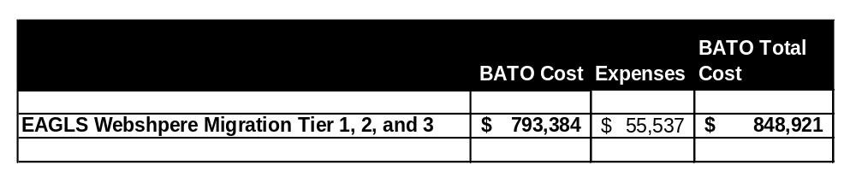

The above table includes estimated expenses for budgetary purposes only. Actual expenses will be billed as incurred.

Pricing is exclusive of BATO software, hardware, and licensing cost. Ajilon Consulting can assist BATO in the sizing and estimating of those costs. It is assumed that BATO has current relationships with software and hardware vendors.

Ajilon Consulting will bill BATO in seven equal increments based on the project schedule provide for the labor portion of the project. Expenses will be billed as incurred. Terms are net 30. The billing for labor will be as follows:
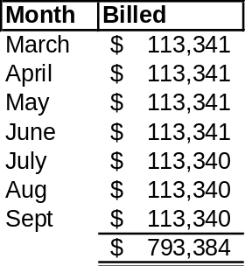

Supplier Profile

Ajilon Consulting

Supplier Corporate Overview
A. Corporate Headquarters Location

Suite 650
210 West Pennsylvania Ave.
Towson, MD 21204

B. Number of employees and contractors – total

Ajilon Consulting has 12,000 consultants internationally

C. Web site address

www.ajilonconsulting.com

D. Statement of company purpose and business

To assist our clients in the achievement of their business objectives through the appropriate use and implementation of technology. The purpose of our mission is:
- To provide value to our clients.
- To provide our employees with an opportunity to fulfill their professional aspirations.
- To provide return to our shareholders.
- To implement and maintain an effective Quality System.

E. Provide a copy of your Company's latest annual report or, in the absence of an annual report, the audited financial statements for the most recent three-year period

Ajilon Consulting is a wholly owned subsidiary of Adecco SA, a $17 Billion, ISO 9002 certified, international professional services organization that provides business solutions for companies at the local, regional, and global levels and has specialty units in Accounting, Executive Search and Out Placement, Engineering, and Information Technology. As such, Ajilon Consulting does not have an annual report or audited financial statements. We did however, include the latest copy of Adecco SA’s complete annual report in Appendix A, Adecco Financial Statements. For more information regarding Adecco’s financial performance go to www.adecco.com under the Investor Relations web page.

F. Supplier shall provide CMM certification level, if certified

Verizon has certified Ajilon Consulting’s systems development capabilities according to the Software Engineering Institute’s (SEI) Capability Maturity Model at CMM Level 2.

Certification at a particular level requires that an organization meet 100% of the requirements of that level and all of those before it. Because Ajilon Consulting is certified at a level two we met 100% of Level 1 and Level 2 requirements. It is important to note that for levels 3 through 5, we met at least 75% of the requirements for each level. Verizon also evaluated Ajilon Consulting according to the same standards used by the Center For Systems Management. However, according to Verizon’s rating scale that does not require achievement of 100% of the requirements to be certified at a particular level, Ajilon Consulting scored a CMM Level 3.2 equivalent.

Future, Long Term Vision and Strategic Plans:

Supplier is requested to provide such information as it relates to the direction of the proposed solution. Provide a clear vision of how the Supplier plans to support emerging technologies and industry standards related to the products/services requested in the RFQ.

Ajilon Consulting has provided a solution that addresses the specific needs of this engagement.
See Section 3 -- Technical Approach for a detailed discussion of the follow:

- Extensibility: The application functionality will be able to keep up with the future growth of the Application Domain and technological changes.
- Security: The application will protect the confidential information from unauthorized access and guard the integrity, privacy, and access to information from unauthorized sources.
- Portability: The application code will be portable and be able to be moved from one environment to another without rewriting.
- Scalability: The application will be able to maintain the quality of service as the system load increases without changing the system. With the increasing load, the system will be able to respond within the specified response time.
- Modularity: The application will be broken down into application level modules (services) that interact through well-defined interfaces, to allow independent development and enhance maintainability and testability.
- Code Reuse: The application will have reusable components for code reuse.
- Compliance with international standards: The application will comply with J2EE coding conventions and standards facilitating ease of integration with third party systems.
- Minimize network traffic: The application will be designed so that a minimum amount of information is transferred between the database and the application, thus minimizing network traffic.
- Performance: The application will adhere to the performance goals required by Risk System Team.
- Usability and Accessibility Support: The application will be composed of technologies that make it more usable and user-friendly.

Supplier Experience Level and Customer References:

A. The Supplier must demonstrate a proven track record of successfully providing products/services similar to those defined in Sections 5 and 6 to customers of similar scope and complexity. The Supplier shall provide a representative customer list. Supplier must also provide a reference list with company, contact names/numbers, and service descriptions. The References must be from organizations where the Supplier is providing services that are similar to those identified in Sections 5 and 6.

Ajilon Consulting has provided three references of similar scope and complexity to this engagement which the core team assigned to this project has conducted in the past. It is important to note that Ajilon Consulting has conduct numerous projects for many companies in the Fortune 500 list; however, we felt it was important to give you references related to the actual team being assigned to your project. Simply giving you reference of projects our company has performed in the past would not be representative of the team’s ability in conducting your work.

Please notify Ajilon Consulting of the reference you would like to contact directly. Ajilon Consulting will notify the appropriate reference of your intent to contact them and facilitate a schedule suitable to both parties.

Reference 1

Client | Contact | Phone | Contract Amount | Technical Environment
Ontario Ministry of the Environment | Donna Cramp | Number will be provided | $500,000 | NT, Unix, JAVA, JSP, Oracle, EJB, HTML
Project Description: OnAIR Information System
In support of Ontario Government Legislation requiring dischargers of air emissions to report regularly on the substances they release into the atmosphere, Ajilon Consulting was engaged to develop an Information retrieval and reporting system.
The goal of the OnAIR Project is to build an air emissions data collection and reporting system to support the Regulation and to meet the needs of internal clients, external clients and the public. Overall the objectives can be summarized as follows:
- To provide information to assist in monitoring reduction in air contaminants over time
- To provide information to assist in assessing the environment over time
- To provide data for analysis to assist in assessing specific point-source emissions
- To provide inventory of data to support focused attention on specific problem areas
- To provide the public with access to the environmental data reported to OnAIR
- To provide information to assist with policy decisions and to offer a means of measuring the progress of remediation, amelioration and risk management programs
The initial duration of this assignment was scheduled to be 5 weeks. During this time a complete data capture and reporting system was to be built. Furthermore, integration of this phase with prior phased as well as external systems, was to be performed, rendering a seamless application.
Ajilon Consulting and its team, working in our offsite development facility, provided all levels of development support including:
- Verify and extend business requirements
- Development of a full application mock-up to validate requirements
- Logical and Physical Database design
- Design of Applications Architecture
- Application programming
- Unit, System and integration testing
- Documentation and knowledge transfer
Ajilon Consulting has met or exceeded the client’s requirements even within this narrow time frame.

Reference 2

Client | Contact | Phone | Contract Amount | Technical Environment
Nortel Networks | Sean Graglia | Number will be provided | $900,000 | NT, Unix, JAVA, JSP, Oracle, WebLogic
Project Description: KRS Feature Management System
Key Code generation for Nortel clients involves an integrated series of activities from Purchasing and A/P to engineering. Feature activation within an existing and deployed Nortel product is key to the ongoing ability to generate revenue in the field without the need to deploy engineering support to initiate activation. The shear speed of this activation as it is enabled through a WEB browser, creates a user-friendly means for remote Telco’s to provide the service features to their customers, helping the Telco to maintain a competitive position in their own markets.
Ajilon Consulting’s MSO division assigned a team of 14 people to provide the following functions:
- Detailed Architectural Assessment of an existing Nortel application that was providing similar functionality but lacked key foundation architecture to provide for business function extensibility and enterprise scalability. The assessment focused on Nortel business objectives and specific functionality for the initial users – Wireless Division.
- Requirements Definition and Functional Mockup of the new application representing the business domain of Wireless to provide for Key Code generation by their end clients for the provision of Feature Enablement on installed switches in the field. The functional mock-up provided an end-to-end view of the application as a proof –of-concept for the design.
- Application Development began immediately following approval of the requirements document and acceptance of the system mock-up. This was an intensely collaborative effort involving numerous teams from Nortel as well as the Ajilon Consulting Solutions team. Nortel team members were geographically dispersed from Calgary, Santa Clara, Richardson, Ottawa and Brampton. By itself this was a significant Management challenge as all interrelated activities were scheduled, monitored and reported by the Ajilon Consulting PM.
Our Solutions Team included:
- Senior Project Manager
- WEB Applications Architect
- WEB Database Architect
- Portal Specialist
- WEB Developers
- Presentation Layer (GUI) specialist
- QA/Testing specialist
- WEB Product specialist
- WEB Technical Writer
Application delivery and deployment occurred on schedule for this fixed price engagement.
KRS Phase II included the addition of a new product line within the existing application framework. Our WEB service architecture established in Phase I was put to the test. The Nortel Line of Business (LOB) was located in Australia. All normal activities were undertaken to:
- Determine user requirements
- Provide a design document to confirm requirements
- Establish a team to provide for this enhancement
- Develop new Objects to encapsulate the LOB requirements and integrate with the SERVICE ARCHITECTURE framework from Phase I
- Deploy a total solution in 8 weeks
Ajilon Consulting successfully met this challenge in all areas.

Reference 3

Client | Contact | Phone | Contract Amount | Technical Environment
MCCR (Ministry of Consumer and Commercial Relations Ontario) | Harry Hergash | Number will be provided | $625,000 | NT, JAVA, JSP, EJB, J2EE, IBM Host Publisher, XML MVS, IMS, ASTRA Load Tester
Project Description: Personal Property Security Registration – PPSR
For the purpose of registration of a Lien on personal property that has been used as a collateral device to establish credit, the Ontario Government tendered a series of RFP’s for the purpose of:
- Business Requirements Collection and definition
- Establishing an Application Architecture Framework
- Construction of the PPSR site and application to support backend data sources
Ajilon Consulting was awarded contracts for each of these phases.
This is a complex environment of Mainframe technology supporting existing data that requires the creation of a middle-tier to interface to the WEB browser for both business and consumer access. Ajilon Consulting has defined a Service Architecture that supports all of the Ministry’s requirements and renders a fully scalable and extensible application while reducing downstream maintenance costs. This is further supported by a stringent authentication front-end to ensure confidentiality of access to this sensitive information.
The Ajilon Consulting E-business Solutions team was comprised of specialists and business domain experts to define and develop a WEB based solution for the Ministry. These included:
- Executive Project Manager
- Enterprise WEB Architect
- Portal Specialist
- Enterprise Database Architect
- WEB Developers
- WEB product specialist
- QA and Testing specialist
- WEB Technical Writer
- Mainframe Designer
- WEB Development Manager
- Security and Authentication specialist
- Enterprise Integration Designer
20 people worked on this assignment. The key element of this application lay in the fact that it provides to individuals and corporations, a service for which an on-line payment is made to the government Ministry. Reducing turnaround time in transaction processing and eliminating costly service centers previously serving walk-in clients, provides for an immediate ROI from this solution.
Phases 1 & 2 represent an equivalent task to that of the LMI project and were successfully completed on time and within budget to the client’s full satisfaction.

B. Provide a brief “success story” of proven customer results due to Supplier’s commitment to quality and increased operating efficiency. This is requested to demonstrate the added value that can be offered by the Supplier.

Nortel Networks | Karen Sprinkle | 919-905-4252 |  | NT, Unix, JAVA, JSP, Oracle, EJB
Project Description: Intranet based Visualization Engine (SAGE)
Nortel, like many other large organizations, sustains a large infrastructure of people and systems to support both internal and external clients. In times of rapid corporate growth, these systems are challenged and strained to meet user needs.

A typical approach to meet these demands is to acquire additional systems when response is slow or local nodes become taxed. A few critical things are revealed through this practice:

- A true evaluation of systems is not performed in the rush to add more of the same
- Network and communications services are ignored as a potential source of bottlenecks
- Capital expenditures rise beyond established budgets
- Standards may not be followed when purchases are made rendering internal support teams in a difficult situation to manage the myriad of products in the field

During a business downturn, Infrastructure requirements continue. Spending is tight and the previous approach to satisfying user needs becomes more disciplined. Planning/forecasting is critical and user expectations are formalized in Service Level Agreements (SLA) to measure service delivery success.

Each of the above points form the high level requirements for our Visualization Engine project. The goal was to provide a mechanism for evaluating system and network performance against an SLA, contrast this to actual performance metrics and determine (plan) a course of action that may or may not require a capital cost solution.

Ajilon engaged the following team to address this requirement:

- Project Manager
- WEB Integration Specialist
- Business Analyst
- WEB Developers
- Quality Assurance and Testing specialist
- Enterprise WEB Applications Architect
- Technical Writer

The application provided a visual representation of the system and network topology. Using a point and click approach, the user could localize activity reporting to a network, or a single node. Performance could then be assessed, evaluation of capacity determined and steps taken to either re-direct traffic, applications or data sources to improve the service.

This solution was delivered within a 12-week time frame. This timeframe is very typical of WEB solutions that are developed, deployed, and return positive results quickly. Each of these objectives was achieved, all within a fixed price budget.

Testimonial:

•‘…The Sage Command Center tool has been in production for the last month now and things are running smoothly. It has been presented to our IS Infrastructure VP who sees great potential in the value of the tool. Our focus now is to use the tool and increase the data contained within the tool. We've already used reports from the tool to assess decisions on the need to order more hardware (we're saving Nortel $$$ already), to hone in on the trouble area during service outages, as well as to verify performance improvements.
•I want to thank your team and company for producing the Sage Command Center user interface. Although we were a great distance apart, our teams worked well together. The dialogue between the teams was open, to the point, and effective. The tool meets the requirements that our team identified. We appreciate the dedication your team made in delivering the tool in such a tight timeframe and on budget.
•We hope that we can work together in the future. This has been a productive relationship. You were able to deliver what the last 2 vendors couldn't even comprehend. Great job!’

C. List former or present written Agreements with BATO, Bank of America, its predecessors, and/or Affiliates.

We are a current preferred vendor. Our agreement is effective 10/1/02 and is managed by Rob Robinson of Bank of America.

Performance Standards Methodology:

A. Describe the methodology used to develop Supplier’s internal performance standards, the processes and tools used to monitor and measure performance against the standards, and the management reporting systems that capture this data. Provide samples in the proposal Appendix.

Ajilon Consulting’s Professional Services (APS) organization through its Project Office (PO) and assigned Project Director PD) is responsible for defining and maintaining a Performance Standards Methodology, the associated detailed processes, and templates for managing and monitoring project-based engagements. Ajilon Consulting’s approach is based on the Project Management Body of Knowledge (PMBOK) and adherence to the International Standard’s Organization 9001:2000 but is flexible to accommodate client methodologies and SOW requirements. The Ajilon Consulting PO is responsible for authoring and maintaining the Delivery Guide that provides the detailed process steps to be followed throughout project initiation, project execution and control, and project closure. The Ajilon Consulting PD assigned to the engagement ensures that the Project Manager (PM) and the delivery team follow Ajilon Consulting’s standard methodology as tailored for a specific project.

During project initiation, the PO and the PD provides the following activities:

- Sets up an Ajilon Consulting project number for the engagement relating relate the project to a particular service and service code
- Establishes an entry for each project in a backlog and scorecard report that is updated and circulated weekly to senior Ajilon Consulting stakeholders
- Ensures that project folders are established on the Ajilon Consulting Professional Services (APS) server in accordance with the standard format defined by the PO for all key project artifacts – signed Statement of Work (SOW), Cost Model, planning documentation, status reports, deliverables, financial tracking, change requests, and quality control

During project execution and control, Ajilon Consulting provides training, project templates, and oversight to the Ajilon Consulting team in executing the following activities:

- Project planning
- Scope management
- Risk management
- Time and schedule management
- Cost and budget management
- PM project tracking and project quantitative measurements (metrics)
- Quality management
- Communication planning
- Defect and Issue tracking
- Resource tracking

Each week the Ajilon Consulting PO and PD updates and circulates the backlog and scorecard status report to senior Ajilon Consulting stakeholders who will take action as necessary when the status indicates that action is necessary. At quarterly intervals the PO and PD conduct an internal, written project audit to ensure that the client’s goals and objectives are being met on each engagement and define an action plan when required.

As the project ends, the PO and PD ensure that Ajilon Consulting-defined project closure processes are followed and the results deposited in the project files. These processes include:
- A Post project review
- Completed closeout checklist
- Customer satisfaction survey
A final audit of project artifacts against the SOW requirements

B. Indicate the customer satisfaction rating of the Supplier along with the criteria and methodology used. Include any relevant publication ratings or articles. Provide samples in the proposal Appendix.

Customer satisfaction indicators:
Ajilon Consulting possesses the following client awards, recognition, and satisfaction levels, which are indicators of our superior delivery of IT services:

- Client Survey Conducted by Specifics, Inc. – In 2001, Ajilon Consulting contracted with Specifics, Inc., an independent market research and consulting firm, to interview approximately 440 randomly selected clients from various locations around the country. The goal of the study was to better understand our position in the marketplace, and to identify ways in which we can better serve our clients' needs. The results of the study were very positive, and the following examples illustrate the general tone of the study’s findings:

- In each of five areas of overall satisfaction, the clients interviewed rated Ajilon Consulting “very good” to “excellent.”

- The respondents ranked Ajilon Consulting’s strengths as: 1) primary contact, 2) recruiting and screening ability, 3) quality of consulting staff, 4) technical skills of consultants, 5) overall capability, and 6) understanding of industry/business requirements.

- Nearly all respondents have worked with other consulting firms. Among these clients, at least 90% rated Ajilon Consulting “as good as” or “better than” similar firms in quality of work, consulting staff attributes, value for money spent, and responsiveness to requirements and concerns.

- The clients interviewed rated Ajilon Consulting’s consultants “very good” to “excellent” for their performance based on eleven different attributes such as technical expertise, problem-solving ability, professionalism and quality of work.

- The top three reasons for selecting Ajilon Consulting were technical skills of consultants, primary contact relationship, and Ajilon Consulting’s reputation and referrals.

  - Microsoft 2002 Infrastructure Solution of the Year Finalist for North America – Ajilon Consulting was recognized by Microsoft Corporation as the North American finalist for Infrastructure Solution of the Year in the fifth annual Microsoft Certified Partner Awards. The company’s entry was for a Web-based tracking and planning solution developed for a major telecommunications company primarily using Microsoft’s .NET technology. Nearly 900 entries were considered for awards in nine different categories.
  - Ford Motor Company Q1 Status – Ajilon Consulting was awarded the Q1 Flag, Ford Motor Company’s highest quality standard. To evaluate Ajilon Consulting, Ford examined our quality policies and procedures, examined statistical analysis to demonstrate quality process improvement and interviewed quality process participants.
  - DaimlerChrysler Quality Excellence Award – DaimlerChrysler recognized Ajilon Consulting’s commitment to quality and excellence for the commodities and services supplied. This distinction was earned by achieving superior levels of measurable performance in the areas of: quality and client satisfaction, project delivery and completion, technology and engineering service, and price.
  - Eastman Kodak Q1 Silver Award – In 1997, Ajilon Consulting was one of two approved vendors that received the silver award which measured vendors against five key result areas: product and technology leadership, service and support, quality, delivery and cycle time, and cost performance. As a participant in the Q1 program, Ajilon Consulting is required to conduct quarterly reviews with Kodak’s purchasing and contract labor organizations at which times Ajilon Consulting presents its performance data.
  - 1998 & 1999 Verizon Supplier of Excellence Award – Ajilon Consulting has been recognized among Verizon consultant suppliers as part of Verizon’s Partners in Quality program. Suppliers are evaluated on their ability to deliver on time, provide competitive prices and superior value, offer high quality customer service and provide top quality products and services.

Relevant publication ratings/articles:

  - Ajilon Consulting was the recipient of New Work Media’s Purple Squirrel 100 Award in 2001 and 2002. The Purple Squirrel 100 recognizes IT staffing/services firms that have demonstrated outstanding growth based on percentage increase in net sales. Please visit The Talent Economy magazine Web site (a publication of New Work Media) for more information and to view the Purple Squirrel 100: http://www.talenteconomymag.com/include/article2.php?articleID=84
  - Information Technology Services Business Report (ITSBR) – In June 2001 ITSBR ranked Ajilon Consulting as the number one IT services firm, ranked by revenue, out of 50 project and staffing firms.
  - Baltimore Business Journal Excellence in Technology Award – Each year, the Baltimore Business Journal’s editorial staff recognizes a Baltimore-based company for their superior use of technology. In 1998, Ajilon Consulting was recognized for their creation and support of OSMO. The Journal recognized the Ajilon Consulting system for allowing the company to track over 12,000 employees, as well as employee resumes and activities associated with the recruitment and sales process. The proprietary system also provided usage and reporting information to clients.

  - Since 2000, Ajilon Consulting has ranked among the Top 5 in the IT Services Business Report’s (ITSBR’s) annual ranking of the Top 50 U.S. IT Services Firms. Ajilon Consulting was #1 in the June 2001 ITSBR ranking; please visit Ajilon Consulting’s Web site at http://ajilonconsulting.ajilon.com/pdf/AjilonITSB.pdf
to view that ranking.

  - ISO 9001 Certification – ISO 9001 is an internationally recognized quality standard, and Ajilon Consulting was one of the first information technology services firms to receive it in 1995. ISO 9001 is the model for quality assurance in design, development, production, installation and servicing.

  - Largest IT Consulting Firms lists published by American City Business Journals, Inc. and Business Journal Publications, Inc. – In 2003, Ajilon Consulting will participate in and anticipates to be ranked in the Top 25 Largest IT Consulting Firms (or similarly named) lists published in approximately 20 national markets. Ajilon Consulting was ranked the fifth largest IT consulting firm in the Baltimore area in the January 24-30, 2003 issue of the Baltimore Business Journal; please visit that publication’s Web site at: http://baltimore.bizjournals.com/baltimore/stories/2003/01/27/list.html to view a portion of the list.

Supplier’s Organization Description:

A. Describe in detail the Supplier organization, the staffing model, and how future resource requirements are determined. Provide an organization chart in the Appendix section of the proposal.

Ajilon Consulting is organized according to the following tiered structure:

Corporate Operations - Ajilon Consulting’s corporate operations support district offices in contextual functions so that they may devote their time, talent, and management attention to core activities designed to enhance positive client relationships. Corporate operations consist of the following:
- Accounting – Performs activities related to accounts receivables and payable, general ledger, billing, and payroll.
- Human Resources – Develops, maintains, and communicates employee policies, procedures, and benefits packages.
- Management Information Systems – Develops and maintains internally developed and third party application portfolios that support Ajilon Consulting’s business processes.
- Quality – Develops, maintains, and communicates Ajilon Consulting’s ISO 9001 certified quality system. Additionally, this department ensures the consistent application of our quality system through the completion of internal audits.
- Training – Responsible for developing and administering training to all Ajilon Consulting employees. Training courses have been developed for new employees, account and district management, consultants, and recruiting professionals.
- National Accounts – Responsible for supporting the efforts of individual local offices that support those clients whose operations span multiple borders.
District Office Operations – Responsible for satisfying client IT requirements. Each district office consists of District Managers/Vice Presidents, Senior Account Managers, Account Managers, Senior Technical Recruiting Managers, Technical Recruiting Managers, District Administrators, and Consulting Personnel.

The following graphically depicts the organizational structure of Ajilon Consulting’s United State’s Operations.

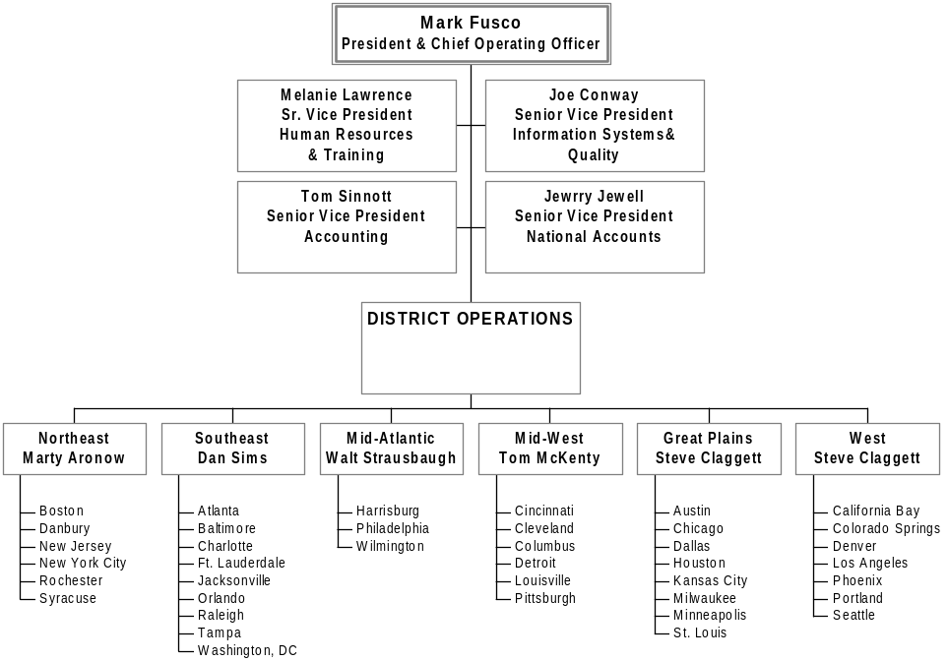

The specific structure for this project effort can be found in Section 6 – Project Team Organizational Structure.

B. Describe how the Supplier achieves internal training and certification requirements. Include a description of training types and schedules. Specifically demonstrate that an appropriate on-going training program is in place for all personnel assigned to the BATO account.

Ajilon Consulting recognizes that our most important asset is our consultants and the skills that they possess. Our ability to offer highly qualified and exemplary consultants to our clients is key to our continued success. Consequently, Ajilon Consulting is committed to the concept of continued training and development for all of its employees.

The objectives of Ajilon Consulting’s training program are two-fold. First, we seek to enhance our consultants’ skill sets. This may mean that new skills are provided or older ones are refreshed. Second, we attempt to ensure that as a whole, our resource pool has the appropriate representation of existing and anticipated client requirements. To accomplish these goals, Ajilon Consulting’s managers work with each consultant to develop an individualized training program. Specifically, as part of every employee’s annual review process, career goals and development objectives are jointly established for each individual.

In support of our commitment to training, the budgets of our district offices include $3,500 for each consultant to spend on continued education and functional training each year. This amount actually proves to be more than adequate, particularly in light of the fact that our consultants can choose from internally developed programs, third party programs, and courses for credit at area colleges. Specifically, in developing their training programs, our consultants can pick and choose from among the following:
- In House Training Seminars – Taught by Ajilon Consulting employees, these seminars concentrate on various technical and personal development subjects.
- Ajilon Consulting Virtual University – An Internet-based learning tool (www.vucampus.com) that allows Ajilon Consulting’s employees to have access to over 340 courses individually or as part of 28 curricula tailored to prepare technicians for certification, to upgrade skills, or to transition existing skills into new areas of technical focus. All courseware is certified by product manufacturers and maps to their classroom training directives. Project Management courseware, endorsed by the Project Management Institute, is one of the most popular offerings. Management training is available for all levels of management. The highest enrollments currently are in the Project Management, IBM DB2 Universal Database, UNIX, C++, and MCSD curricula.
- Client/Ajilon Consulting Co-sponsored Technical Training – Occurs on or off the client site and is a joint effort between Ajilon Consulting and our clients to improve Ajilon Consulting and client staff.
- Vendor Training – Ajilon Consulting sends its professionals to vendor training to obtain expertise with a particular vendor product.
- Internal Roundtables – Ajilon Consulting sponsors meetings in which our consultants discuss advances within their particular discipline. At these meetings the exchange of information is facilitated through a “case method analysis” in which our consultants learn of technological advancements by studying actual applications of technology.
- College/Continuing Education – Ajilon Consulting employees are allowed to take advantage of educational opportunities offered by colleges including obtaining undergraduate and graduate degrees or simply engage continuing education.

Supplier Disaster Recovery Plan

- Provide a brief description of Supplier’s Disaster Recovery Plan in the event of:
- Fire
- Strike
- Lockout
- Work stoppage or other labor dispute
- Flood
- Computer Malfunction
- Earthquake.
The following briefly define Ajilon Consulting’s internal disaster recovery procedures as well as the one that we implement when conducting projects at one of our off-site facilities.
- Internal Disaster Recovery procedures – Ajilon Consulting’s internal disaster recovery procedures address two levels of our organizational infrastructure:
- Districts:
  - Full DRA server with all associated networking components available for immediate shipment to a down district
  - Images and readied workstation / laptop hardware available for immediate shipment to impacted district customer
  - Redundant frame-relay PVC’s per district to recovery from logical network switching outage
  - Nightly full server backup with weekly shipment to offsite facility
- Corporate:
  - Redundant core network switches for data center and all enterprise connections
  - Redundant frame-relay PVC’s per district to recovery from logical network switching outage
  - Redundant, multi-carrier, Internet connections with supporting hardware
  - Nightly full and incremental server backups with weekly shipment to offsite facility
  - Redundant ERP servers capable of supporting both HR and Financial environments
  - Vendor agreements with 4 hour delivery of identified core hardware
  - 3-Phase UPS system to provide graceful shutdown of data center environment
  - Power and A/C remote monitoring systems in the event of failure
  - Replacement group network switches in the event of failure
  - Redundant T/1 WIC’s on all core routers in the event of failure
  - Redundant firewalls with immediate shutdown and manual fail over in the event of failure
- Off-site facilities disaster Recovery - Our processes allow us to provide a level of disaster recovery/contingency planning capability commensurate with the level of rigor a client perceives to have value and is willing to pay for. Specifically, we combine the following modular processes to develop a solution matching client requirements:
- Data Back-Up – With respect to all data defined by a client as critical, we maintain a server based copy in addition to the source file. Tape back-ups are made of the server and stored in a remote location. Note: The back-up frequency, method, and recovery window are determined on a per project basis.
- Fault-Tolerant Design – Where required, the technical infrastructure underlying an engagement performed in an Ajilon Consulting off-site facility can be defined to include back-up power supplies on servers, redundant routing, and mechanisms to keep partial failures from bringing down the whole network (e.g., hot swap/RAID)
- Fail-over Processing – Related to fault-tolerant design are solutions we can provide where one off-site facility can act as a alternative processing site for the prime location.
- Computer And Parts Inventory – As part of normal operating procedures we maintain an excess supply of computers, servers, peripherals, and associated parts which can be staged and/or drop-shipped for next day delivery.
- Cold/Hot Site – Lastly, in cases where a client’s risk tolerance is extremely low, we can engage the services of a cold/hot site and build the associated fees into our solution at cost.

We can also include activities designed to reduce a client’s exposure to risk, (i.e., risk mitigation) protect the confidentiality of information (e.g., user authentication and data storage encryption), and promote integrity (e.g., firewalls, intrusion detection, and antivirus).

B. What is the frequency of testing of Supplier’s Disaster Recovery Plan? Include a copy of the most recent Disaster Recovery Plan test results in the Proposal Appendix.

Ajilon Consulting has not conducted formal tests of our disaster recovery plan; however, we have had to execute section of it.

C. Describe any work stoppages experienced by the Supplier along with how restoration was implemented.

Ajilon Consulting has not experienced any work stoppages.

Litigation:

A. Has your company at any time been named as a defendant in a lawsuit initiated by a present, former, or prospective customer? If yes, explain the circumstances of each suit and the outcome(s) to the extent legally permissible.

To the best of our knowledge, Ajilon Consulting has not been named as a defendant in a significant lawsuit initiated by a present, former, or prospective customer.

B. Has your company at any time been involved in an arbitration or mediation proceeding with a present, former, or prospective customer? If yes, explain the circumstances of each proceeding and the outcome(s) to the extent legally permissible.

To the best of our knowledge, Ajilon Consulting has not been involved in any significant arbitration or mediation proceeding with a present, former, or prospective customer.

C. Has your company otherwise been named as a defendant in a lawsuit that may significantly impact your financial condition in the event your company does not prevail? If yes, explain the circumstances of each suit to the extent legally permissible.

To the best of our knowledge, Ajilon Consulting is not involved in any litigation that may significantly impact our financial condition.

D. Has your company otherwise been named as a party to an arbitration or mediation proceeding that may significantly impact your financial condition in the event your company does not prevail? If yes, explain the circumstances of each proceeding to the extent legally permissible.
To the best of our knowledge, Ajilon Consulting is not involved in an arbitration or mediation proceeding that may significantly impact our financial condition.

Detailed Description of Proposed Solution(s)

Project Approach

This section of Ajilon Consulting’s proposal contains a detailed overview of our proposed project approach to the EAGLS WebSphere Migration project. Furthermore, the deliverables associated with this project have been delineated. A project schedule has been prepared and included in Section 7 - Schedule. Note that Ajilon Consulting intends to deliver tier 1 and 2 deliverables a head of the requested schedule.

Overview
The EAGLS WebSphere Migration will rely heavily on Ajilon Consulting’s IDEA requirements and visualization process. This process facilitates tracking and documentation of data elements, functionality, workflow, and system behavior. Because Ajilon Consulting must make modifications to a system that does not yet exist, the use of this process will allow Ajilon Consulting to work with forecasted system behavior. IDEA metadata can be adjusted on the fly to address any differences between what is planned and what is actually created.

Important benefits
Ajilon Consulting’s IDEA Proof of Concept (POC) methodology provides numerous key benefits to BATO. The following is a brief discussion of the advantages BATO will realize:

- The POC will allow BATO to see, interacted with, and make rapid changes to the system requirements prior to any detailed requirements development, design or construction. This will allow BATO to adjust the functionality and behavior of the intended system during the cheapest part of the project – requirements.
- BATO can perform “What If” scenarios. BATO has the option to have POCs constructed with differing sets of behavior and functionality. BATO can then compare the various systems to see if any of these new and different features are desirable. The result is that BATO can change direction if what was planned on paper doesn’t work in reality.
- By utilizing the POC approach, BATO knows with certainty what the final system will do and what it will look like. This also allows Ajilon Consulting to know precisely what it will take to construct the planned system very early in the project lifecycle.
- A working POC will allow BATO to review the intended system with a broader audience to facility feedback or to demonstrate to key end users. This is an important concept because it eliminates the surprise factor for end users. It goes a long way in mitigating issues for key stakeholders.

Project Structure
Ajilon Consulting has built an iterative project development cycle. As opposed to a waterfall approach, Ajilon Consulting will cycle repeatedly through the same tasks a number of times in each activity including improvements based on activities from previous iterations and BATO feedback.
Another important note is that Ajilon Consulting will address all of the requirements for each tier (1,2, and 3) during the requirements and POC phase. This was determined as the most efficient use of resources and will allow BATO to know what the predicted finished state of the application will be very early in the project lifecycle. BATO will have plenty of time to adjust plans and fine tune its message to end users; as well as, solicit feedback that may require project changes due to end user issues. It is far cheaper to make these types of changes during requirements than during Testing!
Ajilon Consulting also intended to complete Tier 1 & 2 requirements at the same time. During analysis, it was determined that a new architecture needed to be constructed to facilitate migration to WebSphere. The project approach addresses Tier 1 & 2 as one entity.

Tools and Automation
Ajilon Consulting will utilize the following tools and automation components during the execution of this engagement:
- Rational Rose
- IDEA Visualization and Proof of Concept Tool
- Quckplace project documentation repository and Collaboration Tool
- JTest – Unit Testing
- Astra Load Test – Load Testing
- Rational Robot – Functional and Regression Testing
- Rational ClearCase - Defect and Issue Management System
- IBM’s Visual Studio (Java) – Integrated Development Environment

Milestones
The milestones table below shows the major activities to be conducted:

Task | Duration | Start | Completion
BATO WebSphere migration | 147 Days | Mon 3/13/03 | Fri 10/3/03
Phase 1: Project Start-Up | 4 days | Thu 3/13/03 | Tue 03/18/03
Phase 2: Requirements and Design | 33 days | Wed 03/19/03 | Fri 05/02/03
Phase 3: Tier 1 & 2 Framework | 40 days | Mon 05/05/03 | Fri 06/27/03
Phase 4: Tier 1 & 2 Layer Construction | 35 days | Mon 06/30/03 | Fri 08/15/03
Tiers 1 & 2 UAT Ready ! |  | Fri 08/15/03
Phase 5: Tier 3 Enhancements | 35 days | Mon 08/18/03 | Fri 10/03/03

EAGLS WebSphere Migration

Project Activities Summary
The EAGLS WebSphere Migration project will consist of five (5) phases which are:
- Phase 1: Project Start-Up
- Phase 2: Requirements and Design
- Phase 3: Tier 1 & 2 Framework
- Phase 4: Tier 1 & 2 Layer Construction
- Phase 5: Tier 3 Enhancements

Phase 1 -- Project Startup

Kick-off
Regardless of the size of any project, general start-up tasks, both administrative and technical must be performed before any work can be directed at the primary goal of the system under discussion. Ajilon Consulting plans to perform the following task in conjunction with BATO project staff:

- Project kickoff and orientation. A joint meeting will be held with BATO and the Ajilon Consulting project team to introduce both teams; acquire needed user-id’s and security clearances to access the systems; and discuss the project goals and set expectations for the project. An additional meeting will be held with designated BATO personnel and the Ajilon Consulting project team to train Ajilon Consulting staff on the overall hardware and software environments at BATO and to map the functions and gather data that will be included in project efforts.
- Establish Acceptance Criteria for the acceptance of each deliverable
- Make adjustments to the project plan showing interim and final deliverables; a new timeline if necessary, including a Project Calendar; and the resource utilization for the remaining phases of the project based on the outcome of the kick-off and Discovery activities if necessary.
Additionally Ajilon Consulting Project Management will build and implement a Communication Plan that keeps all stakeholders informed during each phase of the engagement. Typical elements of an Ajilon Consulting Communication Plan include the following:
- Status Reports - Ajilon Consulting Project Management will prepare status reports to communicate project status to all team members and stakeholders according to a mutually defined schedule.
- Status Meetings - Status meetings will be held according to a mutually defined schedule and are attended by all identified stakeholders.
- If BATO requires additional components to the proposed Communication Plan, Ajilon Consulting will incorporate those elements to comply with BATO requirements.

Discovery
Ajilon Consulting will collect all system related documentation related to the EAGLS system. Additionally, Ajilon Consulting will conduct meetings with project stakeholders to establish expectations and conduct initial interviews with Subject Matter Experts (SMEs) to help facilitate a better understanding of the issues related to the EAGLS application.

Phase 1 -- Deliverables
The major deliverables of Phase 1 include:

- An updated project plan (if necessary) and Work Breakdown Structure: The Ajilon Consulting project team will work collaboratively with the BATO team to develop an updated and detailed WBS, project plan and schedule, milestones, acceptance criteria, and finalized project deliverables list for all remaining Phases.

Phase 1 -- Schedule
The following is the intended schedule for phase 1 activities:

Phase 2 -- Requirements and Design

Requirements
Ajilon Consulting will execute at least three Joint Application and Development (JAD) session with BATO SMEs to determine key system requirements. The requirements for all three tiers will be addressed during this period. Based on the outcome of the JAD session, Ajilon Consulting will create the system model, technology model, and will create the QA strategy and plan.

Develop Planner View
BATO will conduct a detail demonstration of EAGLS application for Ajilon Consulting staff. The intent is to transfer knowledge to the project team. The following activities will occur:
- BATO Demo of EAGLS System
- JAD Session with BOTA SME to address the current state of the EAGLS application

Develop Enterprise Model for Tier 1 & 2
Ajilon Consulting will conduct a JAD session with BATO SMEs and key staff to identify the features, look and feel, and behavior of the intended application. Ajilon Consulting will then create the Enterprise Model for the application. It is recommended that Tier 1 and 2 be done together with emphasis placed on building the right look and feel into the rebuilt application from the very start. If Ajilon Consulting were to build AS IS system and later give it a face lift and optimize the workflow, there will be approximately 20-30% rework. This approach eliminates that additional cost and schedule impact.

The following activities will occur:
- Requirements JAD Session for Tier 1 & 2
- Development of the Enterprise Model. This is the first look at the tier 1 & 2 new system.

Develop Enterprise Model for Tier 3
Requirements for tier 3 enhancements will be identified during JAD and analysis activities during this time. It is important to identify what the enhanced functionality for the new system will be at this stage as this additional functionality could significantly affect system foundation and framework efforts. These issues can be mitigated and incorporated into the overall system model prior to any design or development work.

The following activities will occur:
- Requirements JAD Session for Tier 1 & 2
- Development of the Enterprise Model. This is the first look at the tier 1 & 2 new system.

System Model
An architectural overview and the detailed design of the application framework of the intended application will be created during this time.

Technology Model
Ajilon Consulting will construct the detailed design for Tier 1, 2 & 3 during this section.

Develop QA Strategy and SQA Plan
The overall approach to Quality Assurance and the Software Quality Assurance plan will be created during this period. BATO will then know what will be tested and how that will be done based on the output of this sections activity. Please refer to Appendix C for details on typical QA Strategies.

Business Rules and POC

A number of activities will be executed in parallel with the requirements generation. Ajilon Consulting will decompose the existing application and break out the current workflow, business rules, data model, and – most importantly – create three or more Proof of Concept (POC) functional prototypes. The final activity will be to develop the foundation application framework.

Whereas the foundation application framework is a development activity, it is found in the phase because it is actually the output of the POC work efforts. Ajilon Consulting propriety IDEA visualization tool constructs J2EE compliant code based on the requirements input into the metadata repository. As opposed to other system generating tools, the output from IDEA if fully functional and J2EE compliant. In other words, the code generated are not ‘stubs’ to be filled in later during development, the code is very extensive. Later system building activities in the following phase will extend this foundation code base.

Reverse Engineering Models and Rules
Ajilon Consulting’s project team will work in conjunction with BATO SMEs to decompose the current EAGLS application into its constituent parts. To do this, the following activities will occur:
- BOTA SMEs will discuss the current architecture with the Ajilon Consulting team.
- Ajilon Consulting will review the data model
- Ajilon Consulting will review the key workflows
- Ajilon Consulting will construct system deposition diagrams
- The business rules for the application will be document and reviewed
- Ajilon Consulting will analyze and construct or document the database design
- Ajilon Consulting will analyze and construct workflow documentation

Requirements Visualization
This is perhaps the most important component and process for this engagement. Ajilon Consulting will utilize it propriety process and tools to construct approximately three fully functional POC prototypes. Because of the power and ease of this POC process Ajilon Consulting estimates that only three POCs will be needed to demonstrate the behavior and functionality of all three tiers of the future EAGLS system based on our experience with other clients. If required, Ajilon Consulting can create more POCs as necessary within the 30 day windows established to address BATO ‘s system vision.
Because of the speed by which Ajilon Consulting’s IDEA process can generate POC’s, BATO has the option to create any number of prototypes within the specified timeframe to address any number of system scenarios. Ajilon Consulting clients utilizing this process have enjoyed a 30% reduction in project schedule and related cost.
These POCs are interactive, functional prototypes suitable for usability testing, stakeholder buying, and end user feedback. A first draft POC has already been constructed for BATO’s review as part of this proposal submission.

Foundation Framework Development
Once the final POC has been reviewed and accepted, Ajilon Consulting will utilize its output to create the EAGLS foundation classes and base framework.

Requirements and Design Deliverables
Quite a few deliverables will be created during this phase of the project. The anticipated deliverables are:

- Business Glossary: The Business Glossary is a vocabulary or a dictionary of business terminology.

- Business Use Cases: The model of the business intended functions.

- Object Model: is an object model describing the realization of business use cases. It serves as an abstraction of how business workers and business entities need to be related and how they need to collaborate in order to perform the business.

      - Technical Use cases: The functionality of a system is defined by different use cases, each of which represents a specific flow of events.

      - Key Sequence Diagrams: Following UML the key sequence diagrams will describe the pattern of interaction among objects, arranged in a chronological order; it will show the objects participating in the interaction by their "lifelines" and the messages that they send to each other.

- Class Diagrams: The Class Diagrams will show the collection of declarative (static) model elements, such as packages, classes, interfaces, types, and their contents (attributes and operations) and relationships (generalization, realization etc).
- Deployment Diagram: Deployment Diagram is a diagram that shows the configuration of run-time processing nodes and the components, processes, and objects that live on them. Components represent run-time manifestations of code units. Deployment Diagram also shows the topology of deployment environment such network.

- Security Design: Security Design will show the security strategy and policy.

- QA Strategy: This discusses how Q/A will be conducted for the project as a whole. It will address process as well as software.
- SQA Plan: This plan will focus on the testing activities to be conducted for the intended application.
- 3 or more POC’s: Interactive, functional prototypes suitable for usability testing, stakeholder buying, and end user feedback. More POCs can be created up to the limitation of the established timeframe for POC activities. If additional POC are desirable to address other BATO system, these POCs additional POC will required a Change Order.
- Business Rules: Documentation of the specific business rules the new EAGLS system must execute and comply too.
- Detailed Workflow: The sequence of activities performed in the business that produces a result of observable value to an individual actor of the business. Further the Detailed Workflow presents a grouping of activities that are performed in close collaboration to accomplish some result.
- Data Model: Detailed documentation of the new or enhanced data model which addresses ERD, data dictionary, physical structure, logical structure, and application dependencies.
- Architecture: Documented integration with Application Framework Detail design
- Foundation Framework: This is J2EE compliant system foundation classes and application code.

Phase 2 Schedule
The following details the schedule for phase 2 activities:

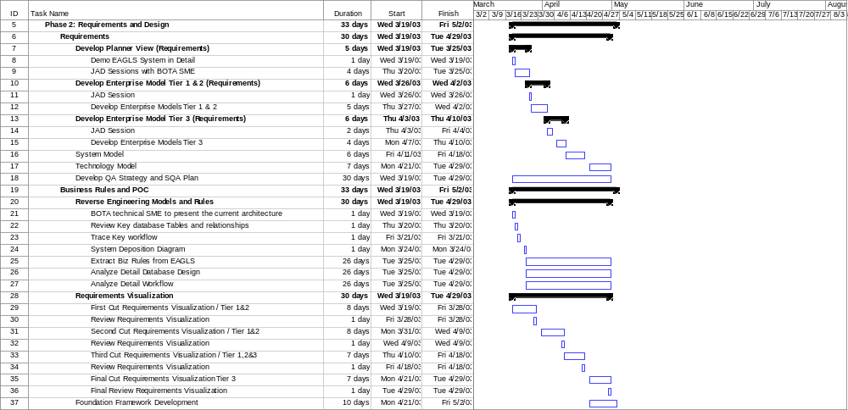

Phase 3 – Tier 1 & 2 Framework
Activities during the phase build upon the base classes and foundation work generated from the POC process and extends those base function activities in advance of integration into the BATO environment

Framework Construction
The development team will construct the system framework based on the output of the POC and design activities. Unit testing is performed during this phase.

Framework Q/A
Ajilon Consulting will execute component level testing to validate the behavior of the objects in preparation for integration into the BATO environment. (See the Q/A Strategy in the appendix for further details)

Phase 3 Deliverables
The major deliverables of Phase 3 as described earlier in this section include:
- Tier 1 & 2 Framework source code: The J2EE compliant framework code and objects constructed during this phase
- Framework Q/A Test Results Report: A report detailing the status, activities, and outcome of Q/A efforts during this phase.

Phase 3 Schedule
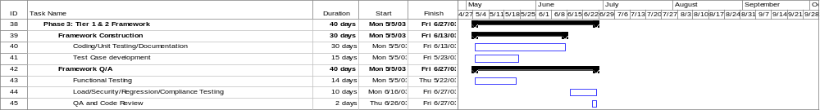

Phase 4 – Tier 1 & 2 Layer Construction
The Ajilon Consulting team will construct the enhancements and final level of functionality as layers to the application during this phase.

Data Migration
Based on the analysis work done in conjunction with BATO, the database will be adjusted to address the new data model and migration activities will be conducted to populate this new model.

Layer Construction
The Ajilon Consulting team will construct the final Presentation and Business Logic layers for the application following the baseline established during the POC effort. Unit testing is performed during this phase.

Layer Q/A
Testing will be conducted for the Layer following the test plan established during phase 2. Typical elements of the Layer testing can be found in the Q/A Strategy discussion found in the appendix.

Phase 4 Deliverables
The major deliverables of Phase 4 as described earlier in this section include:

- Final Code Base: This is the finished application for tier 1 & 2 requirements suitable for UAT activities.
- Layer Test Results Report: This report describes the activities performed for testing and their outcome.
- System Ready Report: This report discusses the status of the application and certifies the application for UAT testing.

Phase 4 Schedule
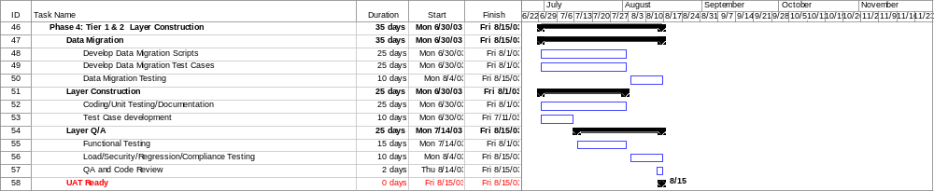

Phase 5 – Tier 3 Enhancements
During Phase 2, the requirements and design for EAGLS enhancements were identified and document. This phase focuses on constructing those elements.

Enhancements Construction
Based on the outcome of the Enhancements POC and design efforts from phase 2, the application is built to those specifications. Unit testing is performed during this phase.

Enhancements Q/A
The system is tested in accordance with the Q/A Test Strategy and Q/A Test plan constructed during phase 2 of this engagement.

Design Documentation
All design documentation is created and updated to reflect the current state of the system. The system may have changed due to construction and Q/A activities; the documentation will be synced at this point.

Deployment and Maintenance Guide
The Ajilon Consulting team will construct guide suitable for use by production personnel to use in their deployment and system maintenance activities in accord with the acceptance criteria and level of effort identified during phase 2 of the engagement.

Phase 5 Deliverables
The major deliverables of Phase 5 as described earlier in this section include:

- Final Code Base: This final code base deliverable incorporates enhancements to the EAGLS application in accordance with Tier 3 requirements. This code base is suitable for UAT activities.
- Test Results Report: This report describes the activities performed for testing and their outcome.
- System Ready Report: This report discusses the status of the application and certifies the application for UAT testing.
- Updated Design Documentation: Incorporates adjustments made during construction and testing phases.
- Deployment and Maintenance Guide: A guide that facilitates deployment and maintenance issues and procedures necessary for production staff to conduct their work.

Phase 5 Schedule
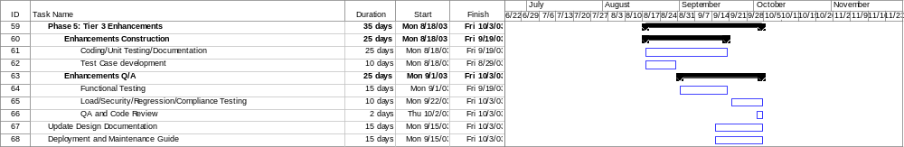

Assumptions

Assumptions
The success of any project is dependent on the establishment of a common understanding between all parties. Therefore, the following assumptions have been made in defining the boundaries, scope, and approach of the proposed effort and provide a common understanding for all readers of this document:
- Pricing for this engagement is valid for 45 days from the date of submission to BATO.
- A working Proof-of-Concept for the EAGLS system has been provided as part of this proposal submission. BATO staff needs contact Ajilon Consulting to arrange for a walkthrough of this important submission.
- Ajilon Consulting has constructed this fixed bid RFP response based on the information provided by BATO. If the level of effort required to execute this project is less or greater than forecasted based on activities conducted during Discovery and Requirements, a change order may be required to adjust scope to current conditions.
- Data migration activates are considered an estimate as they are depended on the final system design. Since the final system design does not yet exist, it is not possible to specifically forecast the work effort needed to migrate system data to the new application. Ajilon Consulting has provided its best effort estimate for this level of effort. Note that a change order may be required if the actual level of effort exceeds the amount estimated.
- Additional project skill sets that are not described in the proposal that are necessary for the project to complete will be determined during the first phase of the project.
- Ajilon Consulting will assist BATO in the determination of the type, size, software, and hardware required to develop, test, and run in production the system under discussion. Ajilon Consulting does not have sufficient information nor is Ajilon Consulting privy to current contracts and relationships BATO has or may have with existing software vendors to provide cost information.
- BATO will provide environment and infrastructure support to the Ajilon Consulting team.
- The Ajilon Consulting Project Director, BATO Project Sponsor and BATO Project Manager will define the project acceptance criteria relative to deliverables and project success.
- Relevant BATO Subject Matter Experts (SMEs) who are familiar with the project, the business functions supported; the environment and tools; and internal procedures and organizational structure, shall be made available to support the engagement as needed. This involvement of SME’s should be considered critical to the success of the project and lack of access will affect the project plan and associated costs.
- All organizational and environmental changes which may affect the project schedule and/or deliverables will be communicated by the BATO Project Manager to the Ajilon Consulting Project Director, in writing, as soon as possible.
- The BATO Project Manager and the Ajilon Consulting Project Director will have sufficient authority to make day-to-day project decisions, organize and command resources, and approve changes to project scope, schedule, or deliverables.
- BATO Project Management will respond to all issues that have a priority of Critical or High within 24 hours of notification by Ajilon Consulting.
- BATO Project Management will respond to all issues that have a priority of Medium or Low within 2 working days of notification by Ajilon Consulting.
- Schedule is central to our pricing. Changes in the schedule or delays due to the inability of BATO to make resources, reports, technical information, complete dependant tasks, and SME’s available to the Ajilon Consulting team in a timely manner may impact project scope, duration and price.
- The engagement will be performed primarily at Ajilon Consulting’s Toronto based Development and Rapid Prototyping Center.
- Ajilon Consulting will bill BATO in seven equal increments based on the project schedule provide for the labor portion of the project. Expenses will be billed as incurred. Terms are net 30. The billing for labor will be as follows:
- BATO will be required to sign a Project Change Order if adjustments are required for project scope, project resource staffing, or any issue that impacts project cost prior to any work towards those efforts.

Project Team Organizational Structure
This section identifies the key personnel that will be assigned to the project. As depicted in the exhibit below, Ajilon Consulting has defined the staffing requirements necessary to successfully complete EAGLS WebSphere Migration project. All members of this project team are experienced in conducting engagements of this exact nature.

The following briefly describes of the Ajilon Consulting portion of the Project Team:

Role | Skill
Project Director | - The Project Director serves as the liaison between the project team and the BATO Executive Sponsor. The Project Director’s responsibilities include resolving issues and concerns between the Wells Team and the Wells personnel and performing a Quality Assurance role.  - Extensive knowledge of Ajilon Consulting’s Project Management Methodology.  - Extensive knowledge of Ajilon Consulting’s Delivery Service Methodology.
Project Manager | - Ability to manage and coordinate the project activities.  - Experienced with Java/JSP development projects  - Experienced with Oracle projects  - Ability to gain the confidence of the Executive Sponsor and the respect of subordinate personnel.  - Overall knowledge of tasks to be done and techniques to be used.  - Ability to understand and interpret any current or future modeling efforts of the business
System Architect | - Extensive knowledge of Ajilon Consulting’s Delivery Service Methodology.  - A sound understanding of the Ajilon Consulting’s Project Management Methodology.  - Understanding of the business objectives.  - Excellent knowledge of business modeling and design techniques.  - Excellent facilitation skills.  - Excellent communication and presentation skills.  - Extensive experience with JSP/JAVA/DB2/WebLogic projects.  - Experienced with Ajilon Consulting’s IDEA Requirements and Visualization Tool.  - Knowledge of XML  - Experience with DB2 tools and the ability to design data models
Sr. Business Analyst (2) | - Extensive knowledge of Ajilon Consulting’s Delivery Service Methodology.  - A sound understanding of the Ajilon Consulting’s Project Management Methodology.  - Understanding of the business objectives.  - Excellent communication and presentation skills.  - Excellent knowledge of business modeling and design techniques in JSP/Java/Oracle/WebLogic.  - Functional knowledge of RUP and Rational Rose.  - Ability to adjust role from BA to Q/A lead during the project Lifecycle.
Senior Developer JSP/JAVA/DB2 (14) | - Extensive knowledge of Ajilon Consulting’s Delivery Service Methodology.  - A sound understanding of the Ajilon Consulting’s Project Management Methodology.  - Understanding of the business objectives.  - Excellent knowledge of design techniques.  - Extensive experience in JSP/JAVA/DB2/WebLogic development projects.  - Optional: Familiar with XML.
Test Leads (4) | - Understanding of the business objectives.  - Ability to generate test plans, test cases, and test scripts.

Note: Key staff resumes can be found in the appendix.

Project Management Rigor

Ajilon Consulting’s Project Management Methodology Overview
Ajilon Consulting’s Project Management Methodology (PMM) was modeled after the PMI's Guide to the Project Management Body of Knowledge (PMBOK). First published in 1987, the PMBOK is a general representation of "proven, traditional practices which are widely applied," for managing most projects. Ajilon Consulting used the sections of the PMBOK to develop a management process (and supporting procedures) that encompasses the PMBOK knowledge areas, in a language and context that is understandable by experienced Project Managers (but not necessarily by team leaders who may have only technical expertise).

PMI does not certify any methodology – there is no project management process or methodology certification available. There is, however, an SEI certification available for software development methodology (Ajilon Consulting has been certified at an SEI Level 2). The equivalent Project Management Maturity Model, a draft of which was published in 1997, has not been adopted by PMI.

Ajilon Consulting implements project management using a defined methodology, compatible with the PMBOK, in a company that has earned its ISO 9001 Certification. The following graphic depicts the Ajilon Consulting’s project management methodology.

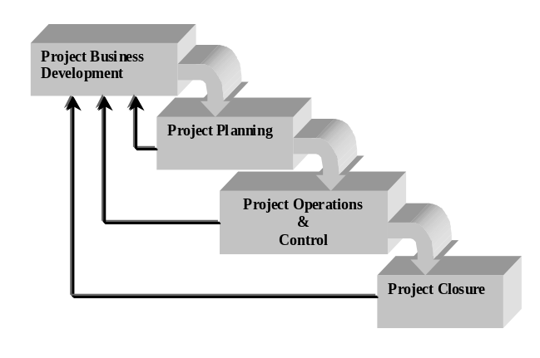

Of particular importance is the fact that Ajilon Consulting’s PMM is applied across all projects for which we maintain responsibility. Ajilon Consulting has defined Service Delivery Methodologies (SDM) for each of the services that Ajilon Consulting offers. By integrating Ajilon Consulting’s PMM, with a specific SDM, and its ISO 9001 certified policies and procedures, Ajilon Consulting can develop a complete project plan that ensures achievement of project objectives, within budget and on-time.

All Project Directors are trained in the methodology and provided with on-going support to ensure successful project completion. Should a project run into difficulty, Ajilon Consulting has additional trained professionals that can assess the project and recommend the actions to bring the project back into acceptable performance.

Management Approach
Ajilon Consulting’s approach to conducting a project is tailored to the unique requirements of our clients, while incorporating fundamental characteristics included in all of our engagements. Specifically, Ajilon Consulting:
- Works with the client to set objectives.
- Represents client interests.
- Ensures quality throughout the process.
- Offers the client a single interface.
- Coordinates personnel, manages and assigns resources, controls costs, and reviews progress.

Ajilon Consulting’s management approach includes solid project management principles as embodied in the following processes.

Change Management
Change Management is an essential activity of project management. The primary purpose of Change Management is to provide a controlled means to allow a project to expand or contract in terms of what will be delivered and the time/cost necessary to complete it. Without Change Management, there is no way to determine what is to be delivered, at what cost, and according to what schedule.

Change to a project is inevitable and must be managed pro-actively to ensure compliance with contractual requirements. The resources required to investigate the project impact of a proposed change are beyond the time estimates associated with the scope of this project. This budget is not part of the project budget, but should be available to the client Project Manager to transfer from client financial resources into the project in the event of the identification, definition and acceptance of a project change.

Requested changes will be described on a Change Request Form. Either the client or Ajilon Consulting Project Director may initiate a change request. All requests to investigate a change will be authorized by the client Project Manager or a designated representative. A request to investigate a change will be assigned a time/dollar value and will be added to the baseline project time budget.

The impact of a change, both upward or downward, to both project cost and schedule will be assessed and included on the Change Request Form. Upon acceptance or rejection of a change by the client and Ajilon Consulting Project Directors, the Project Team will proceed with, or table the change request. The dollar impact of the change will then be transferred to the project budget, project documentation will be changed accordingly and the Project Schedules will be modified to reflect the change impact.

A Change Request Form, to determine any impact to the project schedule and any associated costs, will be created if any of the following occurs:
- If there is any deviation from the original project scope, including identified assumptions, as defined in the Scope of Service Agreement or Systems Definition Report, or when a modification is requested to a deliverable that has been previously approved by the client.
- If the project schedule is impacted when the level of effort of client personnel associated to this project falls below the level of effort defined in the Participation Section of the Project Plan or Systems Definition Report.
- If the project schedule is impacted by any change in provisioning, operating, and maintaining the work environment, office supplies, or access to the network environment.
- If the project schedule is impacted by any client assigned task or deliverable not being delivered on time, including any sub-project, as defined in the Project Plan or Systems Definition Report.

The Project Director will prepare the Change Request Form and submit it to the client Project Manager for approval. The Change Request Form will include information on the costs associated with the changes and the impact they might have on the schedule.
- The Change Request Form will be returned to the originating Project Director within five business days with approval and/or comments.
- Joint signatures of both the client and Ajilon Consulting Project Director are required to approve requested Design Changes for implementation.

The Ajilon Consulting Project Team will not perform work that is outside the scope of the baseline project as defined in this document until a change request is approved in writing by the both the client and Ajilon Consulting Project Director.

Issues Management
Issue Management is the process of identifying, recording, discussing, and resolving issues related to a project. An issue is “a point, matter, or question to be disputed or decided“ whether raised by a project team member, the client, or some other stakeholder in the project. Issues may be questions, observations, changes, or problems that require further investigation and potentially some action to be taken. Issues fall into one of the following three categories:
- Defect
- Scope Change
- Enhancement.

Issues might remain on the issues list, be moved to a risk management list, have change requests or defect log entries opened for them, or be closed with no action taken. In short, an issue is a point of contention about the project that is documented and addressed.

Anyone opening an Issue must submit it in writing to the Project Director who tracks it throughout the project’s duration. The process is as follows:
- Anyone opening an issue enters the issue in the Issues Log and is designated as the issue owner.
- The Project Sponsor and Ajilon Consulting Project Director shall report project progress and review the Issues Log provided by the system on a weekly basis.
- The Project Sponsor or Ajilon Consulting Project Director may only close an issue.

The Issues Log tracks all issues according to the following process:
- The Project Sponsor and Ajilon Consulting Project Director determine the category into which an issue is placed.
- Issues in the Defect category are to be fixed by Ajilon Consulting and delivered to the SME for review and sign off as quickly as possible.
- Issues in the Scope Change category are discussed regarding their impact on the project and schedule. Scope Change issues may be incorporated into the existing scope and implemented as part of the initial project if budget and schedule permit. The Project Sponsor and Ajilon Consulting Project Director make those decisions.
- Issues in the Enhancement category are considered separate projects to be evaluated after the core project is delivered and accepted by the customer.

Risk Management and Mitigation
Risk Management is the discipline of identifying, assessing, mitigating and managing any events that could affect an endeavor. Risk is defined as “the chance of injury, damage, or loss” to project success, as well as “anything contributing to an improvement in condition” which will help ensures project success.

Risk management includes minimizing negative risk events and emphasizing positive risk events. Project risk events may occur at any time and last for any duration during the life of the project. They may be internal to the project, and thus under the control of the Project Director, or may be external to the project and beyond the control of the Project Director. Ajilon Consulting will perform a Risk Assessment as part of the project that will manage identified risks, define a plan to mitigate the risks, and provide a tracking tool for the risks.

An assessment is conducted to identify several risk factors as having a potential impact on the estimated project completion date. This structured assessment serves to identify potential risk factors and define associated mitigation plans. Critical milestone dates are established within the risk management profile to provide a basis to proactively manage date sensitive mitigation factors. Ajilon Consulting provides the risk management documentation to the Project Sponsor/Project Manager to foster participative risk management. Shared management of the risk factors and mitigation plans by both the Ajilon Consulting and the client helps to ensure minimal negative impact due to outside influences on the project and provides an increased project success factor at the senior management level.

Acceptance Procedures
All of Ajilon Consulting’s projects are deliverable based. As such, each major activity has specific deliverables associated with it. Each deliverable requires formal approval by the Project Sponsor. Each approval is treated with equal importance. This provides pro-active project review throughout a project by providing both the Project Sponsor and Ajilon Consulting with an on-going status of the project.

Approval Process

Deliverable Approval

All formal and interim deliverables will be approved using a Project Deliverable Acceptance Form and will be submitted to the client Project Manager by the Ajilon Consulting Project Director for approval.

The Ajilon Consulting Project Director will coordinate all approval documentation with the client Project Manager. It is essential that deliverables be thoroughly reviewed the first time they are submitted. If a deliverable is not accepted, the reason(s) should be stated and corrective action steps specified. The Implementation team(s) will take corrective action and resubmit the deliverable for approval.

A response to the Project Deliverable Acceptance Form is typically requested within three business days.

Final Project Approval
Upon completion of the final deliverables for the project, Ajilon Consulting will prepare and submit to the client a completed Final Project Approval Form. The purpose of this form is to obtain client’s acceptance of the project as a complete engagement thereby authorizing Ajilon Consulting to receive any and all outstanding invoice payments. The client should note that the submittal of the Final Project Approval is made dependent upon client’s prior formal acceptance of all Deliverables submitted for approval under a Project Deliverable Acceptance Form.

Project Schedule
The following exhibit shows the project schedule:

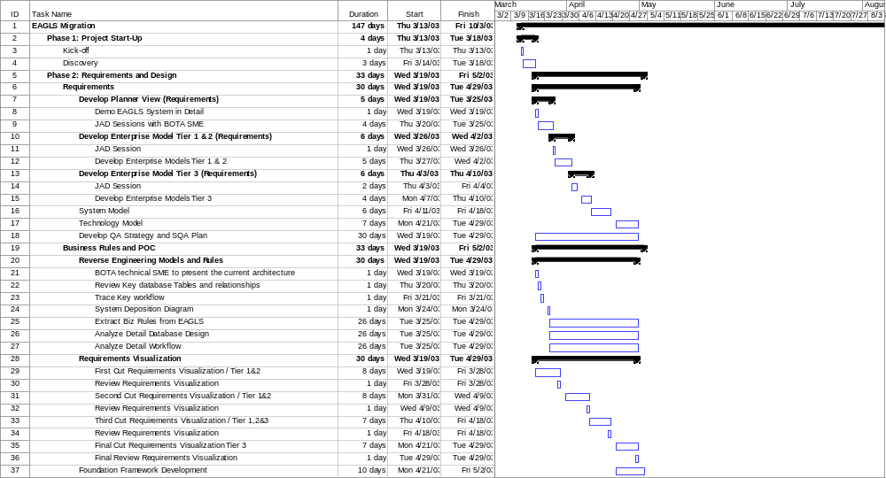

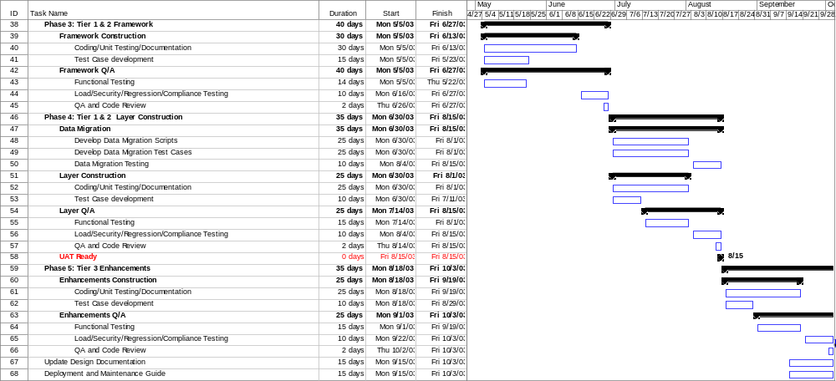

Technical Approach

Overview
The proposed architecture for EAGLS application is optimized for the WebSphere web and application server environments. The primary goals for architecture are modularization and flexibility. The environment initially is scaled for capacity needs forecasted through December 2004. The architecture is flexible enough to allow addition of low cost components to the presentation and application tiers with minimal system impacts.

Architecture Design Considerations
The major system J2EE compliant attributes addressed when designing the EAGLS WebSphere Migration Application architecture are listed below (Based on industry standards).
- Extensibility: The application functionality will be able to keep up with the future growth of the Application Domain and technological changes. It is expected for the customer base to grow, requiring new features to be added to the application. The migrated code will be flexible enough to allow simple integration of new features with minimal system impact.
- Security: The new EAGLS application will protect the confidential information from unauthorized access and guard the integrity, privacy, and access to information from unauthorized sources. The new EAGLS application will be consistent with Bank of America corporate information security guidelines. The application uses 128-bit encryption and is expected to comply with any future industry standard encryption improvement. User access is maintained through database-defined roles. The application will be accessible to both Bank of America associates and external customers via the Internet. All user sessions expire after a configurable period.

- Portability: The application code will be portable and be able to be moved from one environment to another without rewriting.
- Scalability: The application will be able to maintain the quality of service as the system load increases without changing the system. With the increasing load, the system will be able to respond within the specified response time.
- Modularity: The application will be broken down into application level modules (services) that interact through well-defined interfaces, to allow independent development and enhance maintainability and testability.
- Code Reuse: The application will have reusable components for code reuse.
- Reliability: The new system will achieve:
- 99% system availability
- No single point of failure in any application tier
- Single geographic location with disaster recovery plan

- Maintainability: The migration code will reduce code complexity and improve code modularization and re-usability.
- Minimize network traffic: The application will be designed so that a minimum amount of information is transferred between the database and the application, thus minimizing network traffic.
- Performance: The application will adhere to the performance goals required by Risk System Team.
- Usability and Accessibility Support: The application will be composed of technologies that make it more usable and user-friendly.

Development Methods and Environment

Coding IDE
The coding will be done in the IBM WebSphere Studio Application Developer 5.0 environment.

Unit Testing
JTest will be used to check for runtime exceptions and coding conventions. However, to check the business logic the developers will be required to write test components, one for each testable class. The testable classes will include the services and the data access objects. All test components will be in a separate package hierarchy.

The test components will be maintained throughout the project and will be run whenever the files are integrated or changed in a way that could create bugs.

If the test code is expected to be small the developers may create main() methods to test the class. However if the test code exceeds more than 100 lines, it must be moved to a separate class.

Code Reviews
Frequent internal code reviews will be done to ensure that the code conforms to this related coding standards and conventions. Peer developers and/or team leaders will do the review.

Integration
The integration will be continuous and will be done at least as frequently as the end of each day. For integration, first all the source code will be checked in. Then it will be checked out (read-only) to a separate machine and rebuilt. At this time all test cases will be run to 100%. If any test cases fail, the code will either be rolled back or the error fixed.

Configuration Management
For configuration management Microsoft Visual Source Safe (VSS) will be used. All artifacts like source code files and documentation will be added to the VSS repository. The directory structure in the VSS for the source code and JSP will follow the package hierarchy and Java web application hierarchy.
The files will be checked into Source Safe at the end of each day. However, they can be checked in at any time as well as long as it does not break the build. The frequency of check-in will vary but will be performed at least once for every 4 hours of programming to ensure that work is not lost due to power failures, disk crashes or other unforeseen circumstances. Before every check-in, all tests will be run to 100% to ensure that the version is reliable.

Documentation
All developers will be required to provide JavaDoc comments for all the properties and methods of a class. Note that this may not apply to simple accessor and mutator methods. After the project is built, the documentation will be generated and checked for completeness and accuracy at least once every three days.

System Architecture Model
This document presents the architecture of the application as a series of views: logical view, implementation view and deployment view.

Logical View
The Logical view of the system outlines the logical layers of the application

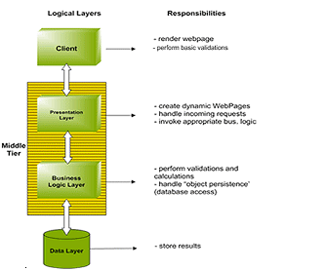

Figure 1 – Logical Layers of Application

Implementation View

Architecture Tiers

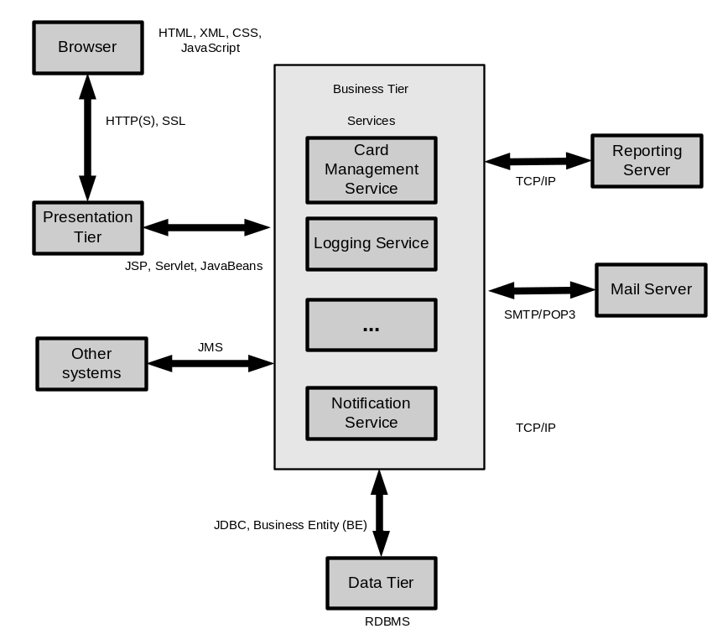

Figure 2 – Architecture Tiers
The application, as depicted in the Logical View section, will be three-tier. It comprises of the Application Client tier, the Middle tier (Presentation and Business logic tier) and the Enterprise information tier (backend).

The Application Client Tier
The Application Client tier will be a browser-based thin client. The Client tier will present its user interface through a web browser in the form of HTML.

The Application Middle Tier
The middle tier comprises of two tiers: the Presentation tier and the Business logic tier.

Presentation Tier

The presentation tier components are hosted on the Web server and provide users with information-rich content. The Presentation tier hosts the JSP and Servlet. It presents dynamic contents to the users accessing the application using a web browser. Using JSP technology to create dynamic contents will provide a higher level of reusable, maintainable, and dynamically generated web pages.

JavaScript (.js) and Cascading Style Sheets (.css) files will be used to standardize and enhance the maintainability and interactivity of the presentation tier. A presentation tier created using the combination of JSP, JavaScript and CSS is easily maintainable and manageable.

Custom Tag libraries will be used to provide a maintainable rendering solution.

Business Logic Tier
The Business logic tier will host business-specific logic and system services such as the User Management Service, Business Rule Management Service, Document Archive Service, Logging Service, Audit Service, Reporting Service, and Data Access Service, etc.

Business logic will be encapsulated into different services. Components hosted at the Business Logic tier will interact with the Enterprise Information System tier and other services to execute various requests.

The Enterprise Information System Tier
The Enterprise Information System (EIS) tier is comprised of an RDBMS server and other enterprise information servers. The EIS tier will provide an information infrastructure for the application.

Application Client Tier Model
The Application Client tier consists of an HTML-based user interface. A client connects to the application using a web browser.

Tools and Technologies

HTML
HTML is used to create the user interface of the application.

HTTP(S)
HTTP(S) is used for communication between web browser and web server to protect critical information.

XML
XML is used in Macro Level System/JMS interface.

JavaScript
JavaScript is used to perform data validation and to enhance the user experience where needed. For clients who do not have JavaScript enabled (including users with disabilities), an alternate server-side validation will always be performed for security purposes.

Cascading Style Sheet
CSS is used to render user interface and control the layout of user interface.

SSL
SSL provides secure communication between web server and web browser.

Presentation Tier Model

Tools and Technologies

JSP
JSPs are used to create the front-end of the application. Custom tag libraries will be developed to minimize the amount of Java that needs to be coded into complex JSP pages.

Servlet
The application will use a FrontController servlet to handle all incoming user requests.

Presentation Tier Components

FrontController (Servlet)
FrontController is an HttpServlet object.

The FrontController’s responsibility is to translate the request made by the application client into an invocation of a Command. The FrontController is implemented as the Controller in a MVC pattern. All client requests are directed to the FrontController.

The FrontController Servlet is implemented as the class FrontController. The FrontController receives an HttpRequest and responds using HttpResponse. The FrontController extracts the “command” variable from the request to determine which Command needs to be invoked. FrontController provides Command name to Servlet Command Factory (Command Selector). CommandSelector consults a Resource (defined as part of an XML file) in order to map named Commands to their actual class names. Command Selector is also responsible for command chaining.

The Command is invoked, and is given the user-defined input parameters that contain methods for operating on the HttpRequest and HttpResponse. The Command is required to return output parameters, as well as the name of a next Command. The Response of the currently executing command will be forwarded to the next-in-queue command.

Command
Command is a standard Java class.

An HTTP request from a web browser may span more than one Command invocation. Each Command uses the property getNextCommand() to determine if chaining is required.

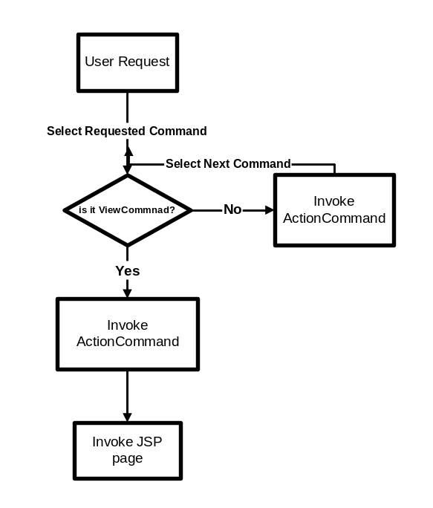
Figure 3 – Command Processing

An ActionCommand (AC) is defined as “an encapsulation of the user’s request, independent of the application client”. The AC will handle the submission of data. This Command is tightly coupled with the user’s action. If there is a button or link on the HTML page, there will be a corresponding ActionCommand. The ServletCommandFactory (Command Selector) instantiates an AC which is named in the HttpRequest parameters as “command”, then calls its execute() method. ActionCommand performs the transaction and interacts with other services to carry out the requested task. Typical actions performed in Command Invocation may include

- Populating BusinessEntity (from HttpRequest or Session data)
- Interaction with Data Access service
- Interaction with Notification service
- Interaction with Logging and Audit services
- Populating BusinessEntity (to be displayed)

AC will determine which command is next-in-queue (using getNextCommand() property). ServletCommandFactory (Command Selector) will use this property to perform Command Chaining.

The ViewCommand (VC) is responsible for

- Populating the appropriate BusinessEntity (to be displayed by JSP) with the data
- Placing the BusinessEntity in the HttpRequest (or HttpSession) and
- Forwarding control to JSP pages to render the information.

The design of the application allows the VC to be invoked in different ways.

- Using Browser redirect to force the browser to request a VC
- Directly calling a VC from AC.

The purpose of VC is to only present information to the user (essentially a read-only operation). A VC command can safely be invoked repeatedly. In normal circumstances, it is best practice to use browser redirect from AC to VC, as the user cannot re-invoke the AC by pressing the Refresh button on the browser. This prevents actions/transactions from unintentionally being executed multiple times. Using this method, when the user forces a browser refresh, only the VC will be called again (the AC will not be called), resulting in a single update transaction.

The AC and VC are each inherited from a common ancestor called Command.

Display of data entry screens
We posit two scenarios for use of AC and VC as they have been defined. In the first scenario, a user requests a new screen, in which case View Command will be invoked. VC will invoke the appropriate business tier object to obtain the data to be displayed on the screen. Data will be packaged in the form of a Business Entity. After gathering the data into the Business Entity control is forwarded to the appropriate JSP page.

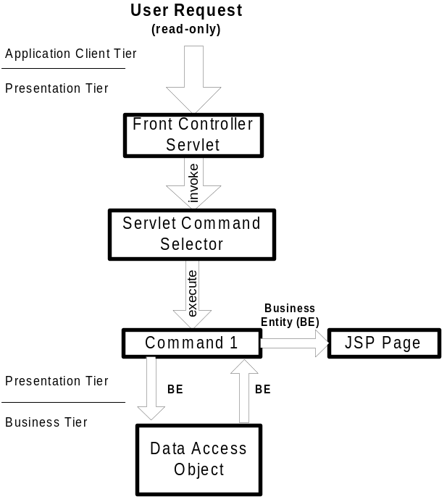
Figure 4 - Presentation Tier Objects (request for new screen)

Submission of information
In the second scenario, the application client request is a submission of data to the system. An ActionCommand (AC) handles this submission. A submission of data may be performed in order to
- Validate the data
- Store the data in the user’s session (HttpSession) or
- Change the model – this could be an update, delete, or change operation on the database.

This second scenario is shown below.

The ActionCommand takes the data submitted, packages the data and calls a business tier object to perform the action (e.g. validation, model update, etc.). Depending on the success or failure of the business request, the AC determines the next logical page to display (typically the same page) or an error would be re-displayed if the user supplied invalid data. If the data were correct then the next logical page would be displayed.

The actual display of the “next” screen will be handled by a ViewCommand (or VC). In preparation for the next screen, the AC places the data that it requires into the HttpSession object and then control is forwarded to that VC.

The VC makes an optional call to the business tier to get additional data that it might require for display. Once that data is obtained and packaged into a BusinessEntity Javabean, control forwards to a JSP page so that the returning page can be built.

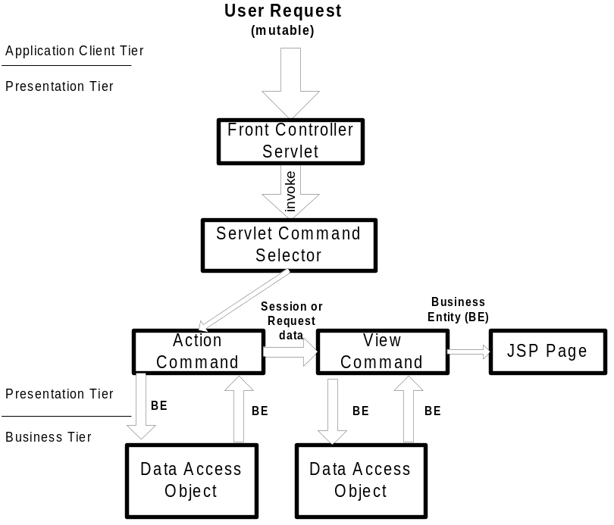
Figure 5 - Presentation Tier Objects (submission from existing screen)

Servlet Command Factory (Command Selector)
Command Selector is a factory for creating command objects based on the name of the action, which is supplied as a parameter. It reads the information from a resource (an XML file) and creates the appropriate command objects. Each command has a nextCommand() property. ServletCommand Selector continues to execute Command (i.e. perform Command chaining ) until a “null” value is provided for the nextCommand() property by the currently executing Command.

Command chaining typically ends with a ViewCommand or DisplayErrorJSPCommand (also implemented as a VC).

Command chaining
A user request may be handled by more than one Command object. ServletCommandFactory is responsible for performing Command Chaining based on the information provided by each command. Command chaining is performed unless the current executing command specifies a “null” value for getNextCommand() property.

Java Server Page (JSP)
JSP pages provide users with an information-rich user interface. A JSP does not perform any business transaction. It needs to display business entities that will be preloaded (by a VC) and stored in the HttpRequest. JSPs will use accessor methods to retrieve the data from the BusinessEntity objects.

If a JSP is used to implement Wizard screens, the multiple then Business Entities that are created will collectively be stored in HttpSession by the VC.

JSP pages will make use of Custom Tag Libraries (CTL) to display complex Business Entities. Use of CTL will eliminate the presence of conditional logic (if- and while-loops) on a JSP page. It will also facilitate the creation, maintenance and reusability of user screens.

It is critical that the JSP only perform operations on Business Entity objects using their accessor methods. All objects should be retrieved from the HttpRequest or from the HttpSession, using <jsp:useBean>. The VC, whose responsibility is to provide the information to the JSP, should have performed any business operations – anything that might generate an exception – in advance. The VC retrieves whatever data is needed in order to display the JSP, and implements accessor methods so that the JSP can retrieve the data. It is the VC’s responsibility to place the BusinessEntity in the HttpRequest so that the JSP can find it.

The accessors on the BusinessEntity may return primitives, objects, or arrays. It is recommended that the BusinessEntity not return Collections, as this requires the JSP to perform casting operations, which might lead to unexpected exceptions.

Wizard screen
The VC may also be used in the context of a Wizard, which is defined as “the collection of data from multiple client interactions prior to a single business transaction”.

The following process defines the creation of a Wizard in the architecture.

A ViewCommand contains all the data required for its corresponding screen. A ViewCommand that is part of a Wizard will place the BusinessEntity in the HttpSession as well as in the HttpRequest. When it invokes an ActionCommand, that ActionCommand will retrieve the BusinessEntity(s) from the HttpSession and call its populate() method with the ActionCommand’s input data. When that ViewCommand is re-invoked, the JSP will be automatically repopulated with the previously input data.

The ActionCommand will perform its task, and then invoke the appropriate (next-in-sequence) ViewCommand. This process will continue, including back and forth operations, until the final ActionCommand, whose task will be to retrieve all the BusinessEntities from the HttpSession, invoke the business logic tier object, and then remove all the BusinessEntities from the HttpSession.

If the user clicks Refresh, the last command will be re-invoked. If browser redirection is used between ActionCommand and ViewCommand, this will have no ill effects, as the ViewCommands can be invoked repeatedly with the same result.

If the user clicks the browser’s Back button, and modifies and then resubmits the last screen, the ActionCommand will be repeated. If the AC invokes a Data Access Object whose function is to change the model, then the operation will be repeated. This sequence of events can happen whether or not we use a Wizard.

In many cases, if the user clicks explicitly clicks on the Cancel button or completes the transaction, the intermediate BusinessEntitites created within HttpSession will need to be destroyed. This ensures that the user, should they re-invoke the Wizard screen, will not be presented with information from a previous invocation.

There are at least three types of Wizards that must eventually be considered. One is a direct sequence, where only linear movement is allowed (Back and Forward). A variation of this is a sequence with branches, where an ActionCommand must choose between two ViewCommands in order to display the next screen. One more is a freeform Wizard that allows the user to update several different screens in any sequence before committing them to the model (imagine a tabbed interface).

The first and the third appear relatively trivial, but the second may be more complicated. An important consideration in the creation of a Wizard is the flexibility offered to the user. It is trivial to implement a Wizard that bans any unexpected actions by the user, but this may not be user-friendly.

Security considerations
The application will have the following security features:

- Both client side and server side validations will be used for error checking.
- Only valid requests will be forwarded to the Business tier.
- Front Controller servlet will be used to provide a common entry point to the application.
- The Front Controller will verify the referrer URL, which indicates the Web page the user previously visited (and, therefore, referred the user to this application).
- Session will be verified at the Front Controller.
- Only authenticated users will be allowed access to the Business tier using the Servlet Command Selector.
- A user session expiration policy will be implemented.

Error handling

- Validation errors will be reported to the user on the user interface.

Business Tier Model

Tools/Technologies

JavaBeans
Business Entities are JavaBean objects. In addition to accessor and mutator methods each contains a validate() method.

JavaMail
Sun JavaMail APIs are used for notification (sending e-mails using SMTP protocol) and receiving bounced e-mails (using POP3 protocol).

Bounced email is handled using a POP3 server. All e-mail sent by the system will have the same specific configurable “return address”. All e-mails coming back to the “return address” box will be inspected by a scheduled task. When e-mail is bounced back, and the recipient can be identified, that user’s e-mail address will be marked “unverified”. The application shall then notify the user’s sponsor of the error, suggesting that the e-mail address in the users profile be corrected and/or re-verified.

J2SE
The application will be developed using the 1.3x version of J2SE.

XML
XML will be used to implement the Macro Level System Interface/JMS interface subset of the Application. EAGLS application also uses XML-based configuration files.

Business Logic Tier Components
This section describes the implementation of the Business Tier. The Business tier consists of the objects, DAOs, and Business Entities. An overview of the Business Logic Tier is shown below

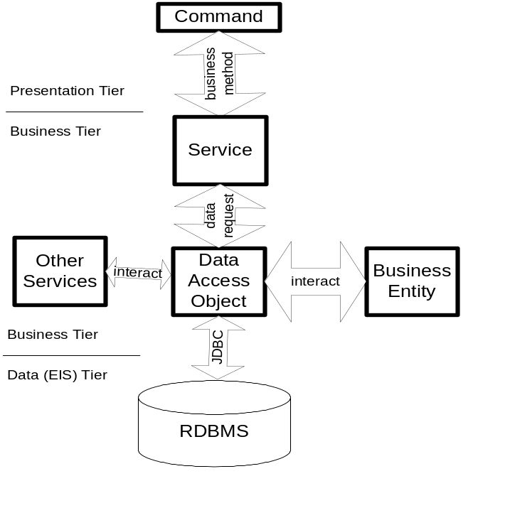
Figure 6 - Business Tier (Data Access Object-only)

Abstract DAO
The functionality of Abstract DAO is to provide a database connection handling mechanism. Abstract DAO provides methods (getConnection(), freeConnection(), etc.) for retrieving and returning Connection objects.

Data Access Object (DAO)
Each Data Access Object extends AbstractDAO.

The Data Access Object encapsulates the business logic implementation for a business request. Its responsibilities include:

- Obtain and maintain (open and close) connection from the connection pool
- Implement JDBC transaction management
- Perform validations
- Implement business logic computations
- Interact with Data Access Service

The Data Access Object contains static methods that are invoked by ActionCommand or ViewCommand.

The primary task of the DAO is to encapsulate business logic and provide persistence mechanism for the Business Entities. To perform these tasks DAO will have to communicate with other services (Notification, Connectivity, Logging, Data Access). Before performing a transaction DAO will ensure the validity of the BEs. As BEs are self-validation classes so DAO will invoke a BE’s validate() method before persisting the BE.

Business Entity (BE)
Business Entities are JavaBean objects.

Business Entities are used to transfer data between application tiers as follows:

- Data access tier to Business logic tier (and vice versa)
- Business logic tier to Presentation tier (and vice versa)

The BusinessEntity is intended to abstract the complexity of the database into a composite object that more closely approximates the business’s understanding of the data. The BE provides an intuitive composite interface to the useful data in all of these tables and data sources, while maintaining database integrity and enforcing all of the complex rules of the data model.

BusinessEnitites are self-validating objects. Each BE has a validate() method that is invoked by the DAO before persistence of the object. Validation includes simple criteria validation and protection against input of harmful data (e.g. allowing users to enter HTML tables or SQL elements in the input may adversely alter Presentation or Data access logic).

A typical BE may contain the following methods:

- Public no-argument constructor
- Accessor methods
- validate() method to provide self-validation mechanism.
- populate() method to populate class members with data provided by the user (the data may be present in HttpRequest or HttpSession )

If a BE is complex and spans sub-entities (or tables) recursive calls to validate() and populate() will be made.

It is recommended that BE does not return Collection objects as it will require Casting which may lead to unnecessary Exceptions. Using Arrays will provide a better alternative and ease with which to iterate the elements.

Processing User Requests
Each button or link will correspond to a Command (Action or View).

There are two scenarios for processing user requests. User requests are handled by a common entry point (FrontController) and forwarded to appropriate Commands based on the nature of request. There are two kinds of user requests:

- Read-write requests
- Read-only requests

Read-write Request
Read-write requests primarily involve ActionCommand. Read-Write requests generally result in persistence of the data (posted by the user from the user screen)

The typical sequence of events for ActionCommand type of communication will be as follows:

- FrontController
  - Performs session verification.
  - Authenticates user.
  - Parses the value of HttpRequest variable “command”.

- ServletCommandFactory (Command Selector)
  - Looks up a Resource (property file) and invokes the Command class based on the “command” HttpRequest variable.
  - Performs Command chaining (based on the property nextCommand() or currently executing Command)

- Command:
  - Instantiates the Data Access Object that handles the request.
  - Instantiates Business Entity (BE).
  - Calls BE’s populate method.
  - Invokes the public method of the Data Access Object using the BE as a parameter.
  - After the Data Access Object operation is complete, it checks for success/failure by checking the data type returned from the Data Access Object.
  - In case of error, Command prepares an Exception object and calls the appropriate ViewCommand to display the error.

- The Data Access Object (DAO):
  - Invokes BE-level validation.
  - Obtains database connection and starts transaction.
  - Passes the connection to sub entities (if needed) to avoid creation of an unnecessary connection object.
  - Commits or rolls back transaction (based on success of DAO operations).
  - If transaction was a failure then throws suitable exception.

- Business Entity (BE):
  - Provides data access to DAO by using accessor functions.
  - Performs BE-level validation.

Read-only requests
Read-only requests are only concerned with ViewCommand. ViewCommand accesses data access tier objects and prepares BEs to be displayed on the user’s screen.

The typical sequence of events for ViewCommand type of communication will be as follows:

- FrontController:
  - Performs session verification.
  - Authenticates user.
  - Parses the value of HttpRequest variable “command”.

- ServletCommandFactory:
  - Looks up a Resource (loaded from property file at startup) and invokes the Command class based on the “command” HttpRequest variable.
  - Performs Command chaining (based on the property nextCommand() or currently executing Command )

- Command:
  - Instantiates the Data Access Object that handles the request.
  - Instantiates Business Entity (BE).
  - Calls BE’s populate method.
  - Invokes the public method of the Data Access Object using the BE as a parameter.
  - After the Data Access Object operation is complete, it checks for success/failure by checking the data type returned from the Data Access Object.
  - In case of error, Command prepares an Exception object and calls the appropriate ViewCommand to display the error.

- The Data Access Object (DAO):
  - Performs criteria validation
  - Obtains database connection and starts transaction
  - Obtains the data and populates BE object(s)
  - Passes the connection to sub entities (if needed) to avoid creation of unnecessary connection objects.
  - Commits transaction.
  - If transaction was a failure then throws suitable exception.

- Business Entity (BE):
  - Provides data access to JSP using accessor functions.

EAGLS Application Exception Handling (parameterized errors)
All exceptions can be categorized as follows:

- Application exceptions (user correctable)
- System exceptions (unexpected)

The general rules for exception handling are as follows:

System exceptions will flow up to the FrontController, which will:

- Log the error to the application error log and console
- Display a generic apology page to the user explaining that an error was caused by the system (with a reference number which ties the apology page to the information logged in the error log)
- Send an e-mail notification about the error to the administrator of the Application (e-mail addresses for one or more administrators can be configured in a property file).

Application exceptions will include a message name (sometimes with message parameters). The message (stored in a database table or property file) should describe the error in a way that will allow the user to correct the problem. Generally, application exceptions will flow up to the Command (AC/VC) level that will catch the exception and forward (with exception details) to the appropriate JSP page (typically the same JSP page where the user made the mistake).

Security considerations
- Only the presentation layer and Macro Level System Interface (JMS) will be allowed access to the business layer. The business layer will be protected from all other types of access.
- The application will ensure that proper validation is performed before executing a command.

Validation and Error handling
In case of an error:

- The application will log the error.
- Provide a user-friendly message on the user interface.
- Provide instruction on how to continue using the system.

Performance and Scalability
The system will be designed to allow easy horizontal and vertical scaling.

Transactional Workflow
The EAGLS Application needs to interact with Logging service and Notification service to carry out a business transaction. The application shall perform each task in the following order:

- Data access object(s) will perform the necessary data access operation(s)
- Interact with Logging service (Synchronous call)
  - If the logging fails then rolls back the transaction and throws an Exception.
- Interact with Notification service (Asynchronous call)
  - If notification fails then rolls back the transaction and throws an exception.
- Commit transaction.

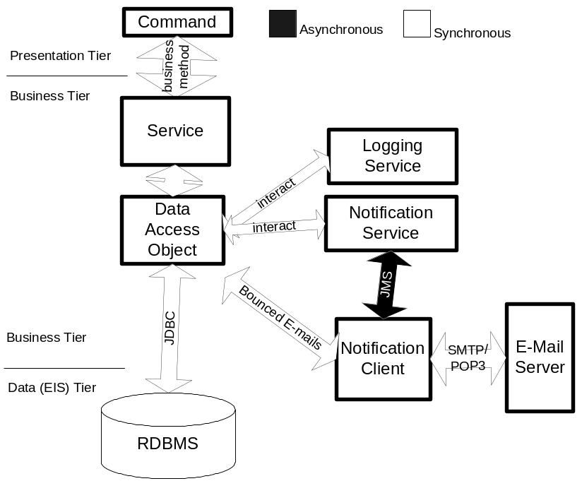
Figure 7 - Transactional Workflow

Data Persistence and EIS Tier Model
The Data Persistence tier consists of the RDBMS server and other data stores. The RDBMS server will be accessed using the JDBC APIs. EAGLS will communicate real-time with other system through Macro Level System Interface. JMS/MQ Series will be used for now. SOAP could be also supported in the future.

Technologies

SMTP/POP3
Simple Mail Transfer Protocol (SMTP) and Post Office Protocol 3 (POP3) are industry standards for sending and receiving e-mails on the Internet. Specific server addresses and accounts to be used will be configurable via a property file.

Java Messaging System (JMS)
JMS is used for Macro Level System Interface.

Also a persistent JMS Publish-Subscribe model provides the Notification handling mechanism in the EAGLS Application.

JDBC
JDBC APIs are used to access the RDBMS persistence mechanism for the application.

Data Access mechanism
Mechanism | Method
Data access mechanism | JDBC
Connection pooling | Vendor specific
Connection acquisition | JNDI Data Source (in conjunction with Connection pooling)
SQL execution | PreparedStatement object and stored procedure

Security considerations
- Ensure user credentials for the database are not saved in a format that will compromise security of the database. Sensitive information should be stored using one-way encryption.
- Ensure that all text in the generated SQL is properly quoted to prevent any possible malformed queries.
- Ensure that database access roles are implemented.
- Ensure user read-only access to the database where applicable.
- Ensure database integrity constraints will be implemented for consistency and integrity of the data.
- Ensure scheduled backups of the application data.

Validation and Error handling
A logging mechanism will be implemented to log all the database access errors for audit purpose. As soon as an error occurs the application will display a user-friendly message and notify the system administrator by e-mail.

Components

Client side components
Component | Description
JavaScript | Simple criteria validation
CSS | Used to render user interface
HTML | Generates user interface

Server side components
Component | Description
Web Server | Accepts users’ requests
Java Server Page | Dynamically generates HTML user interface
Front Controller Servlet | Common entry point of the application; session verification
Servlet Command Selector | Invokes requested command; command chaining
Data Access Object | Processes database related requests
Business Entity | Transfers data between layers

Exception Handling
Location | Type | Responsible | Mechanism
HMTL forms | Simple criteria | JavaScript | JavaScript
HMTL forms | Complex criteria | Web tier
Web tier | Web application error | Web tier | Takes user to an error screen showing message (cause of error and how to resolve it) and provide a mechanism to continue the current operation.
Database | Critical database error | DAO | Provides a user-friendly error message and uses the web tier to handle the exception.

Deployment View

Deployment Diagram
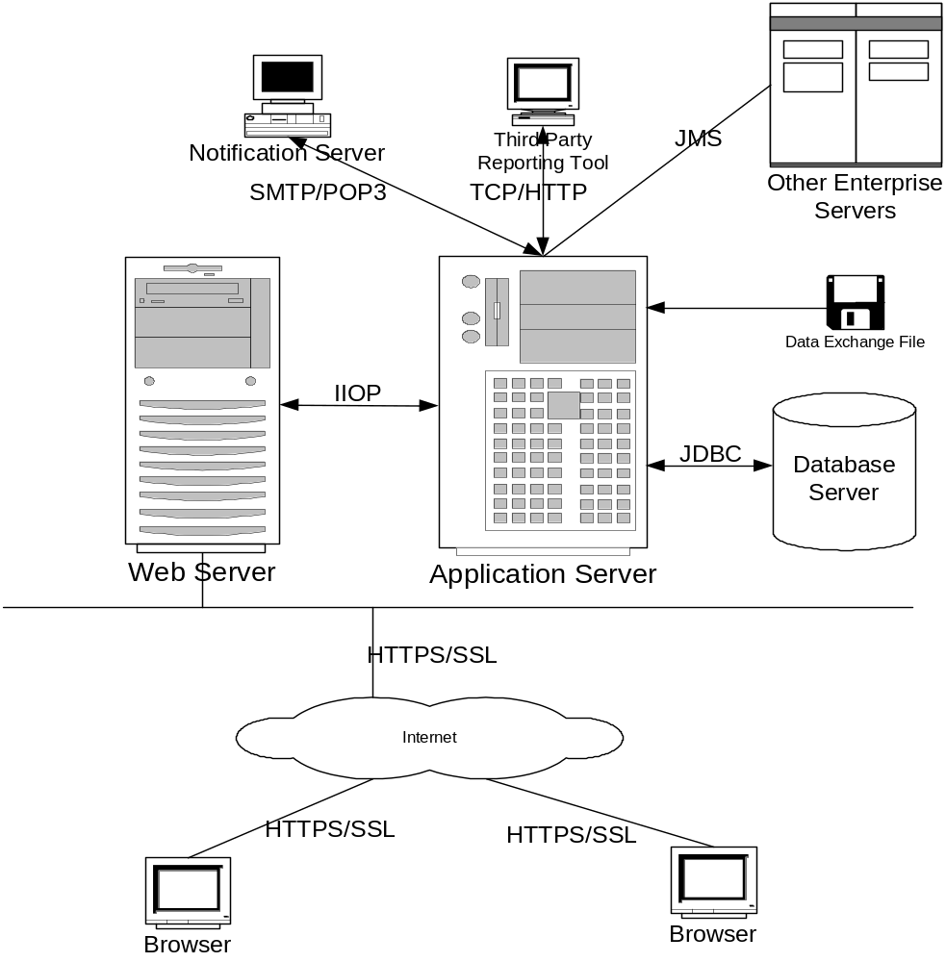
Figure 8 – Deployment View of the Application

The above diagram illustrates the high-level deployment architecture of EAGLS.

Software Architecture
This architecture defines an application model of a service-oriented system, which encapsulates business logic into service components. As a server-side infrastructure, this system provides a framework to define, implement, and deploy service components or applications. Services can be properly used as a group or as independent pieces of executable software.

Essence of the Service Architecture
- A service is a component or an application process, providing certain services, which encapsulate specific business logic and utilized functions.
- A service can also utilize the services of other services.
- A service is accessible only through the specific service interfaces, which inter-exchange ‘requests’ and ‘responses’.
- Additional services can be added and configured into this system.

Service Diagram
The Service Diagram is depicted below.
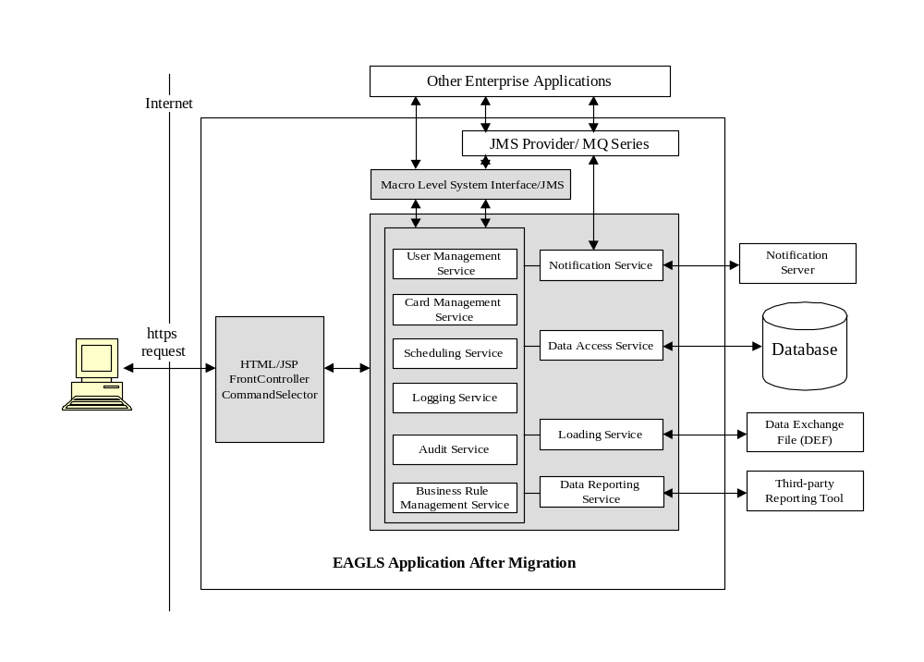
Figure 9 – Application Services

Service Description

User Management Service
The User Management Service will control user’s privileges to access certain resources.

The User Management Service will be used to create profiles for Non-Authenticated Users, modify profiles and assign user rights to the existing users, etc.

User management will include:
- Management of user profiles
- Management of user rights
- Government Agencies Management

Scheduling Service
The Scheduling Service will be used to manage and launch scheduled tasks. Tasks can be set to run once or every hour, day, week, month or year.

The Scheduling Service will be also responsible for invoking automated e-mail notification.

To support scheduling the open-source Quartz scheduler will be used. However details of the low-level scheduling APIs will be properly encapsulated and the application will provide its own abstractions for jobs and schedulers. This will ensure that the scheduling library (Quartz) can be changed without changing the implementation.

Loading Service
The Scheduler Service will be responsible for loading data from a Data Exchange File (DEF).

Notification Service
The Notification Service will be used to send e-mail notification to application users.

There are 2 types of e-mail notification:

- Instant e-mail notification. E-mail is sent immediately after a process is complete
- Automated e-mail notification. E-mail is sent at scheduled intervals.

Notification Service will use a SMTP server to send email. This service can be invoked by any service within the EAGLS that needs to send out E-mail.

Java Message Service (JMS) will be used to implement the asynchronous processes in this service. The purpose of JMS is to decrease the response time and provide a fail-over mechanism. The SMTP server information will be saved in the configuration file.

For the most part, the notification service and the scheduling service will be used in unison. However there are exceptions. In many circumstances the notifications will be user-triggered rather than scheduled.

Logging Service
The Logging Service will be used to log all the activities in the EAGLS application. It will provide services for other components. The Logging Service will log data to log files as well as to database.

There will be five types of logging during development to allow the developers to track and debug system problems. During production, the system will only log messages that the administrator specified in configuration file.

- Error
- Warning
- Usage
- Security
- Information

Audit Service
The application will have the ability to monitor and log all the key activities the user performs. The Audit Service will be used to update the audit trail for key processes in the EAGLS application.

The Audit Service will update audit trail to database.

Managing Business Rules
The application will have to check for some business rules each time an operation is invoked or a service is performed. These business rules may also be dynamically configurable, requiring the use of a simple rules engine.

There are three types of business rules.

  - Access rights-related business rules:
These rules are the most ubiquitous in the functional requirements. A user should not be able to invoke an operation or see data that he/she is not authorized for in accordance with his/her place in the delegated authority model.

  - Validation rules:
Validation rules are rules that apply to the data the user enters or changes.

  - Time-based business rules:
Time-based business rules are automated events that determine whether an action or data is valid based on the current time.

Reporting Service
The Reporting Service is used to generate various reports. Access to reports will be restricted to authenticate.

The application will optionally allow the users to define ad-hoc reports based on their interests.
Report formats will be customizable.

The application shall provide for the use of a report tool e.g. Crystal Reports and will have a separate reporting (highly optimized read-only) database.

Data Access Service
The Data Access Service is used to communicate with the database. All database requests from other services need to use this service to get data from and save data to the database. Other services will use the Data Access Service to interface with the database.

JDBC will be used for the backend connectivity with the database.

Connection pooling will be used to manage to the database connections and improve the performance of the application.

Macro Level System Interface
This Macro Level System Interface will be used to provide a uniform interface between EAGLS Application and other applications. Other applications can communicate with EAGLS services through JMS interface, and therefore manipulate EAGLS data.

Architecture Patterns
Architectural patterns are used to solve recurring architecture problems. An architectural framework or infrastructure is a set of components on which we can build a certain kind of architecture.

Command
Execute distinct client requests within the business tier.

Singleton
It ensures common object for all in process requests.

Data Access Objects
Data Access Objects provide access to the particular data resource without coupling the resource’s API to the business logic. DAO objects are best suited to hide the complexity of the data store dependent APIs where more than one type of data-store is used (e.g. RDBMS server).

Model-View-Controller
The classic Model, View, Controller (MVC) design pattern is selected as the architecture pattern. The Model holds the data displayed by the View and is managed by the Controller. The View is responsible for delivering output to the user, and the Controller reacts to user actions and updates the Model appropriately. Separating user display (View) from actions (Controller) promotes code reuse. Separating the data (Model) from the actions performed on it (Controller) allows the design of a system to be independent of its backend data storage. If designed correctly, a system based on the MVC design pattern does not know whether the data provided to the Model component is stored in a DB2, Oracle database or a set of XML files.

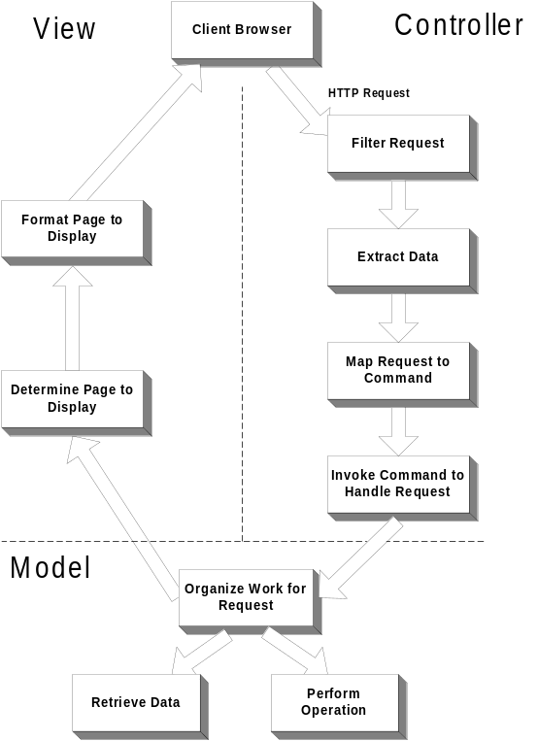

Figure 10 - Model-View-Controller

System Design Model

Component Design
This section provides a detailed overview of all the major components in the system.

The intent of the system is not to define components but to define frameworks in which any number of components can be plugged in easily. Each package has one super class that all the classes in the package extend. All the classes are instantiated with the help of a factory class. The system will be built to ensure that new classes can be added to the system at runtime. The system provides various configuration files for the deployment of these classes at runtime.

Component Layers and Partitioning
The components are partitioned according to the tier on which they operate. All package names are prefixed with ‘com.bankofamerica.eagls’, which is in conformance with the Java package naming conventions (see http://java.sun.com/docs/codeconv/html/CodeConventions.doc8.html for details).
The following diagram shows the top-level package hierarchy.
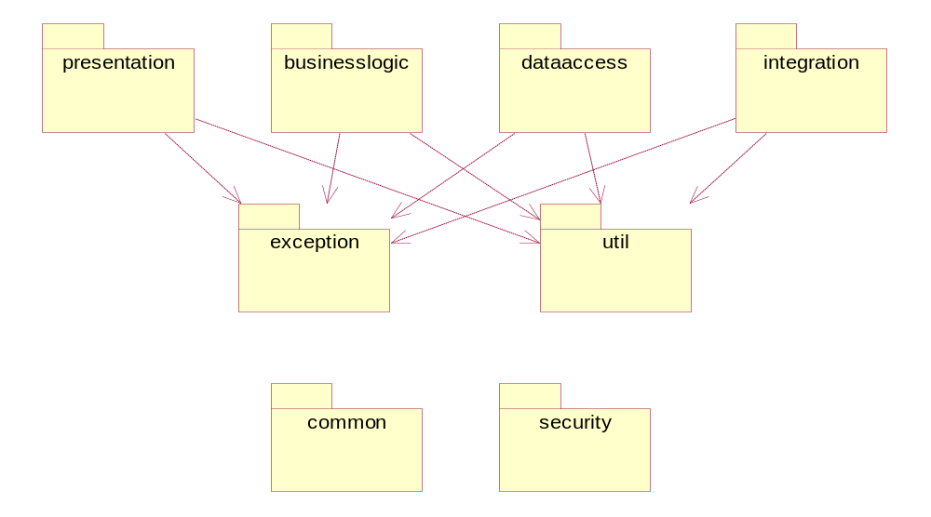
Figure 11 - Top Level Package Hierarchy
The business tier components are further classified into services, notifications and scheduled tasks packages. The dependencies between these packages are outlined below.
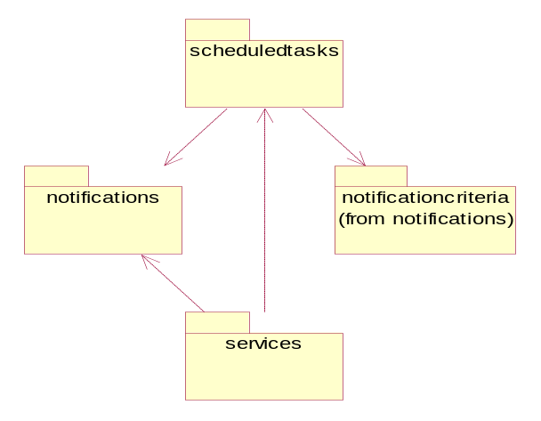

Figure 12 - Business Tier Package Diagram

The presentation tier components comprise Servlets, Commands and JavaBeans.

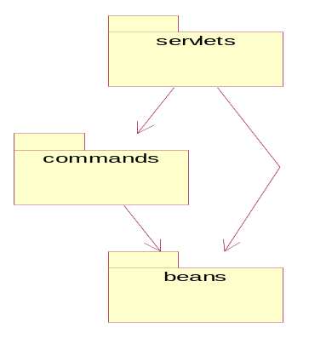

Figure 12 - Presentation Tier Package Diagram

Finally the data access tier components comprise Data Access Objects, Entities, Report Objects and Value Objects.
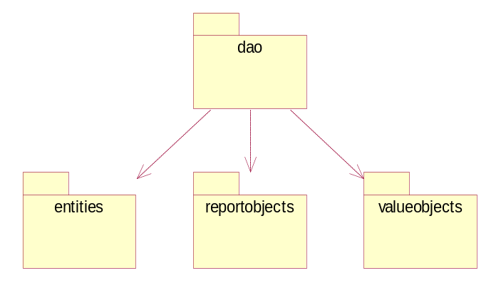
Figure13 - Data Access tier Package Diagram

Generic Components and Utility Classes
Utility classes are degenerate classes that contain some utility methods used by all components in all layers. These classes usually contain public static methods that can be invoked in a stateless manner. They should not modify any resources or state.

Other components in this section are exceptions, which define the exception-handling framework of the system. However all layers should define their own exception classes which should extend from the abstract classes listed here.

StringUtils
The StringUtils class provides basic utility methods for string manipulation and formatting.

DateUtils
This is a utility class for manipulating dates and times. It provides static utility methods which can be used without instantiating any class or setting any properties.

IOUtils
This is a utility class for manipulating files, sockets and I/O streams. It provides static utility methods which can be used without instantiating any class or setting any properties.

XMLUtils
This is a utility class for manipulating XML nodes.

DBUtils
The DBUtils class provides utility methods for database access code.

Presentation Tier Components: Servlets
Servlets are the main controllers in the presentation layer.

FrontController
The FrontController Servlet is the main entry point to the application. It is mapped to all the URLs in the web configuration file so that all accesses to the web site pass through this Servlet first.

Presentation Tier Components: Commands
The commands are simple Java objects that encapsulate execution logic. This follows the famous Command design pattern. A variation is the introduction of a macro command that encapsulates one or more commands that execute in sequence.

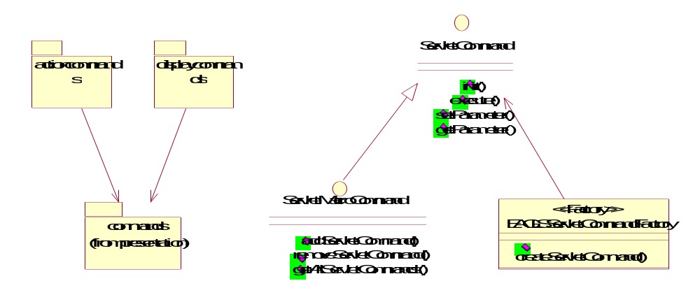

Figure14 – Command Design Pattern

Presentation Tier Components: Page Beans
Page beans are JavaBeans that encapsulate a form data. Their typical use is in the JSPs where they are used to provide an object-oriented model of the HTML forms that are submitted by the user. They typically have one property corresponding to each of the form field.

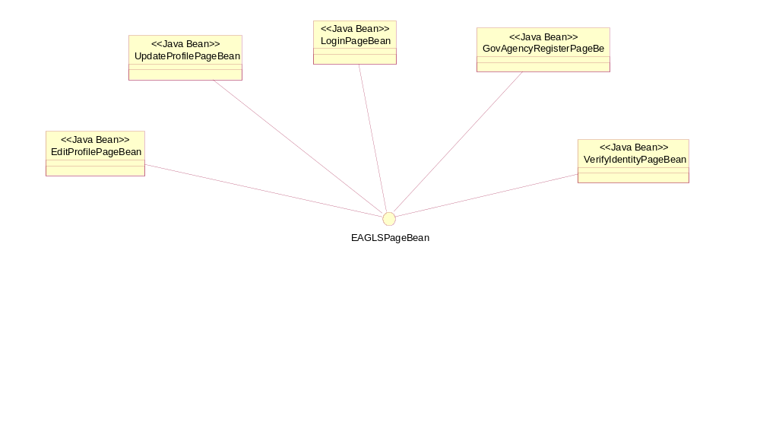
Figure15 – Page Bean

Business Logic Tier Components: Services
Services are plain Java classes that encapsulate the services provided by the system. Typically each service method represents a use case and all related use cases are packaged into a service class. All services are stateless.

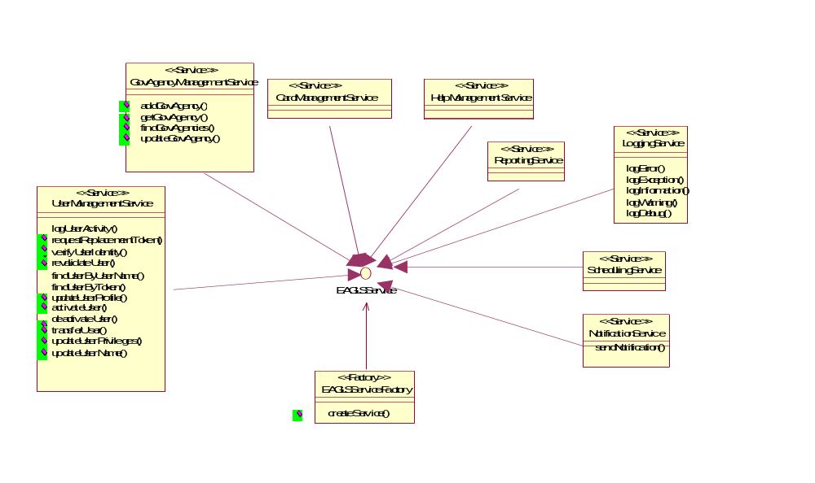
Figure16 – Services

Business Logic Tier Components: Scheduled Tasks
Scheduled tasks are tasks that are scheduled for future execution by the system master scheduler. They are similar to the command objects in that they encapsulate execution logic but the similarities end here. These classes are called from the business layer and do not hold any state information.

For scheduling purposes the open source Quartz scheduler will be used. This means that the EAGLSScheduledTask will implement the org.quartz.Job interface. Also the EAGLSTaskScheduler will implement the org.quartz.Scheduler interface and will act as a wrapper for the low-level scheduling APIs.
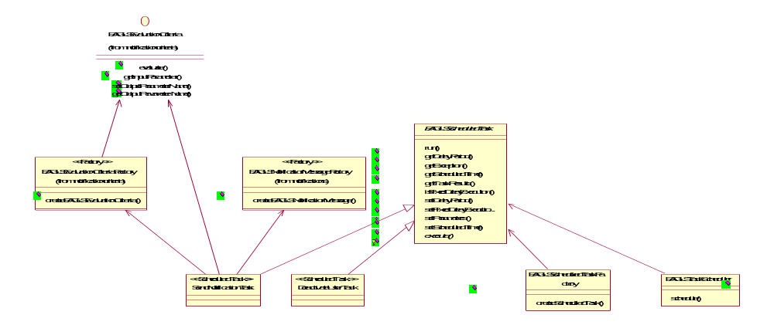
Figure17 – Scheduled Tasks

Security Components: Users and Roles
The security components consist of a user session bean that will hold information about the user’s session. Other components are role objects that represent the roles a user can have. These objects will hold role-specific information about a user.

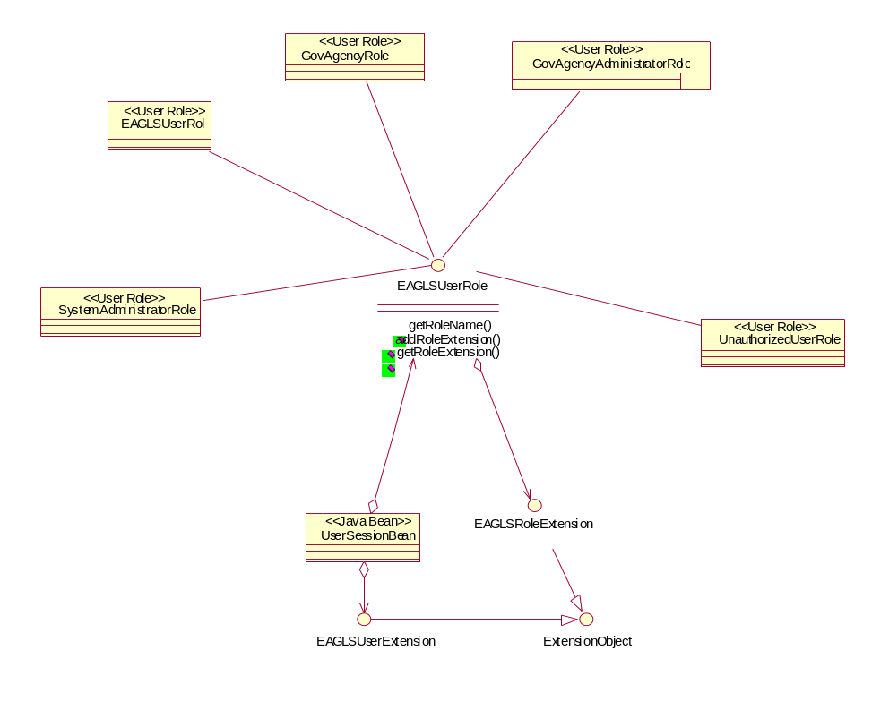
Figure18 – Users and Roles

Data Tier Components: Entities
Entities are persistent objects that are saved in the database and have an identity associated with them. Typically they form the object-relational (OR) layer that encapsulates the database and provides an object-oriented view of all the data.

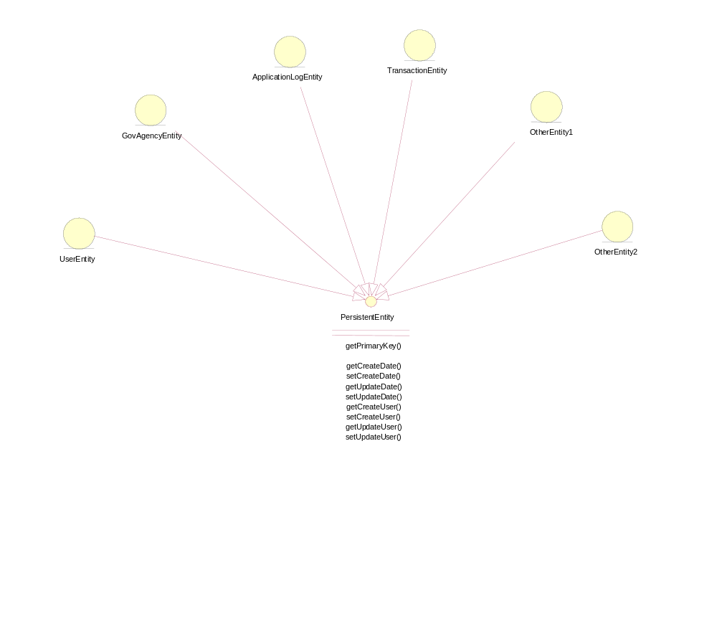Figure19 – Entities

Data Tier Components: Data Access Objects
Data access objects are objects that encapsulate SQL queries and data access mechanisms. For more information about data access objects see http://java.sun.com/blueprints/patterns/DAO.html.

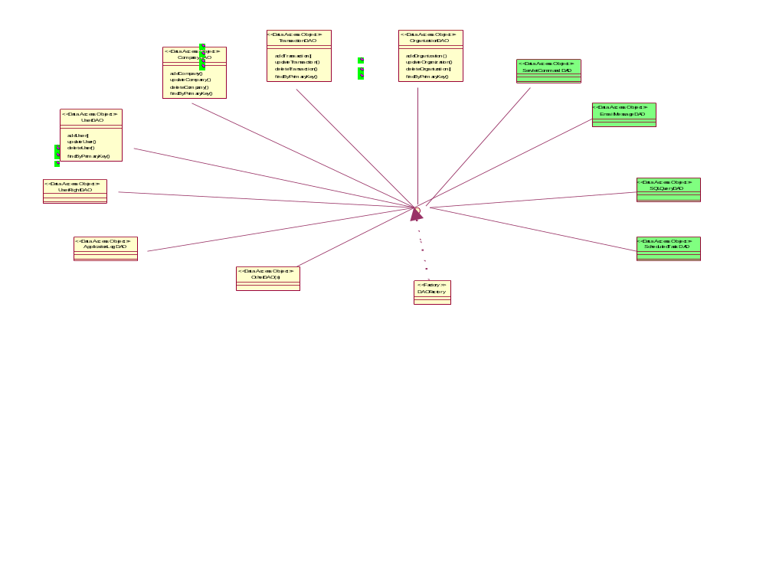
Figure20 – Data Access Objects

Security Design
This section will discuss the security design of the EAGLS Application. This includes not only the security and authentication schemes involved but will also address various security threats for a web application.

Authentication
The authentication will mainly take place in the presentation layer except for B2B clients, which will interact with the application through Macro Level System Interface/JMS.

The users will be authenticated from a login screen by entering their username and passcode. The credentials will first be checked at the client tier for basic format errors (e.g. empty usernames) and then will be passed to the web/application server via a SSL connection. The services will first see that the user is a valid user by searching for the user profile in the database.

In case the user is not a valid user or active, the application will not try to authenticate and will immediately display an error message to the user.

If a user attempts to log in while he/she is already logged in, his previous session will be invalidated before continuing with the login process.

Authorization

Presentation Tier Authorization

In the Presentation Tier, it is necessary to determine these things:
- which top level menu items should be displayed for a user
- which side-level menu items should be displayed for a given top-level menu
- which help topics should be displayed for a user, given their rights
- which buttons (or links) should be displayed for a given screen
- what content should be displayed on the start pages.
- which pages/resources should be accessible to a user

All this information will be predetermined and will be stored in the user’s session. Though all the requests will pass through the FrontController servlet, which will check for basic security, it will also be necessary for all pages and resources to be aware of their security constraints and be able to deny access to unauthorized users.
All the information that is not available to a user will not be shown to him/her. The user will never get an access denied message unless he tries to disrupt the normal flow and access the application in an abnormal manner.
It will be necessary that cookies be enabled. Otherwise the session tracking mechanism will not work. The user will be shown a warning message whenever cookies are disabled.

Business Tier Authorization
In the Business Tier it will be necessary to determine which methods of a business service are accessible to a particular type of user. Since this type of restriction is dynamic, it will not be hard-coded into the services. Instead it will be the responsibility of the particular servlet commands to determine whether the user can invoke a service method or not. The servlet command will check the user role and decide the appropriate workflow for each type of role. Under no circumstance should the business tier classes interact with the user’s session classes because that would create an unnecessary coupling.

Database Tier Authorization
In the Database Tier it will be necessary to determine who has created/updated or deleted the records in a table. Although not all tables need this check, the system maintains an audit of these updates for all the tables. This is largely for the sake of consistency.

All database tables have these 6 columns that track changes. However, if a record is modified multiple times, only the most recent history will be saved.
- CREATE_DATE_TIME: The date/time the record was first created.
- CREATE_USER: The user who created the record.
- UPDATE_DATE_TIME: The date/time the record was last updated.
- UPDATE_USER: The user who last updated the record.
- END_DATETIME: The date/time the record was logically deleted.
- END_REASON_DESC: The reason for the logical delete.

Besides providing an audit trail for the changes to the database, these attributes will also be used to prevent concurrent modification of data by two users, which may compromise the integrity of the data if a use case spans multiple transactions. The UPDATE_DATETIME will be modified in all updates. So when updating a record, if the UPDATE_DATE_TIME field has been modified since it was last read, the change will be discarded.

Physically deleting data will not be permitted to users, except as a result of an archiving process.
Price Information
Ajilon Consulting is providing BATO a fixed bid for the EAGLS WebSphere Migration effort to include all items listed in the RFP for tier 1, 2, and 3 with exceptions noted in the assumptions section of the proposal.

The effort is fixed bid to as a 147 day project with a cost of $793,384, not including estimated expenses. Expenses have been estimated and included for budgetary purposes only. Expenses will be billed as incurred and are not part of the fixed price.

Ajilon Consulting will provide a team of 23 to manage, design, build, and to assist BATO with deployment of the EAGLS WebSphere Migration application. The following table summarizes the pricing details:

The above table includes estimated expenses for budgetary purposes only. Actual expenses will be billed as incurred.

Pricing is exclusive of BATO software, hardware, and licensing cost. Ajilon Consulting can assist BATO in the sizing and estimating of those costs. It is assumed that BATO has current relationships with software and hardware vendors.

Ajilon Consulting will bill BATO in seven equal increments based on the project schedule provide for the labor portion of the project. Expenses will be billed as incurred. Terms are net 30. The billing for labor will be as follows:

Appendices

Appendix A – Additional Financial Services Clients
COMPANY NAME | RELATIONSHIP | APPLICATION
ABN AMRO Bank | Preferred Vendor | Test Process Improvement
A.G. Edwards | Preferred Vendor | Sales & Investment Banking Apps, eBusiness Apps, Technology Services, Operations Apps, Real Time Processing Apps, Trades System Redesign Testing, IRA Database System Testing
American Express | Preferred Vendor | Fraud to Risk Management, Credit Authorization Systems, Interactive Customer Service (ICS) application
Bank One/ First USA | Regional Preferred Vendor (Delaware) | Testing and development on Customer Care Systems such as– Billing, Customer Information, Customer Service, etc. Level 1 Help Desk.
Capital One Auto Finance | Preferred Vendor | Project Management, Business Analysis, Test Plans/Scripts.
Certegy | Preferred Vendor | Card Services-Testing, Business Analysis, Client Server Development i.e. VB, SQL etc.
Citibank | Preferred Vendor | Student Loan Division, Client server development, testing and Database administration
Citigroup | Preferred Vendor | IT Consulting, 2 SQP Projects (Test Automation, Acceptance Testing and Process)
Commerce Bank | Approved Vendor | Project Office
CSFB Credit Suisse First Boston | Preferred Vendor | Global Network Services  Fixed Income  Equities
Deustche Bank | Preferred Vendor | Recently added as preferred vendor
Evergreen Funds/ First Union | National Vendor | IT Consulting (BSA's, DBA's, Java Developers, QA Role, etc)
Federal Reserve Bank | Approved Vendor | ACH Support
Fidelity Investments | Approved Vendor | Various 401K,trading, and research systems
Fifth Third Bank | Approved Vendor | Product offering to redesign/web enable their customers investment statements
First Data Merchant Services (a division of First Data Corp.) | Preferred Vendor | Provided legacy mainframe programming services and support for the past 10 years. Technologies included IBM MVS environment, COBOL, CICS, DB2, VSAM, JCL, Oracle, CLIST, Assembler and other mainframe-based tools and utilities.
First USA | Preferred Vendor | Regression Testing, System/Integration Testing, UAT and Performance/Stress Testing, Customer Care
Firstar Bank | Preferred Vendor | Peoplesoft, Mortgage Apps, Database Administration, Project Management
Fortis, Inc. | Preferred Vendor | Provided developers, Project Managers, and Desktop support personnel
Franklin Templeton | Preferred Vendor | Production Support-Global TAC
Inter American Development Bank | Approved Vendor | Ajilon Consulting works in the Finance Department with Treasury operations, Information Technology Services in Loan Management and System Operations
JPMorgan Chase | Regional Preferred Vendor (Delaware, Florida, Texas) | Provided developers, testers, infrastructure design & support, help desk. Ajilon Consulting has had approx. 70 consultants working throughout JPMC. In '98 Ajilon Consulting did a worldwide operating system rollout.
Harris Bank | None | Working through Alltell
Key Bank | Preferred Vendor | 1) Project Administration  2) Main Frame development  3) Document Imaging conversion support of Computer Associate’s View/Deliver to Mobius
MBNA | Preferred Vendor | Credit applications  (MBNA.com), credit  processing, loss prevention
Manulife Financial | No vendor list. | IT Consulting (developers, DBA's, BA's/BSA's, Network folks, etc. Discovery, Recommendation, and Assessment Project, Wood Logan Network Security Project
MasterCard International | Preferred Vendor | Member Parameter System, Global File Transfer System, Credit Card Fraud System, MasterCom System, Global Payment System, Clearing and Authorization System, Settlement System
The MONY Group | Preferred Vendor | Technical Help Desk Services and Mainframe Application Maintenance Support (Staff Aug)
Nationwide Financial Services | Preferred Vendor | Multiple Systems Serviced, SQP engagements, PALLM, etc.
New York Mercantile Exchange | Approved Vendor | Automated Testing Trading Applications
Nuveen Investments | Primary Vendor | AMS Outsourcing
PFPC | Approved Vendor | Investment Accounting System, Shareholder Retirement Plan Accounting System Testing
Pioneer Group | No vendor list | Various
Piper Jaffray | Preferred Vendor | Call Center, Broker Support, Beta, Digitrade
Putnam Investments | Preferred Vendor | Various
SEI Investments | Approved Vendor
SIAC Securities Industry Automation Corporation | Preferred Vendor | Trading Services, Development Market Data Systems, Operations 24/7 Server Support, Automated Testing for NYSE and AMEX
SunTrust | Preferred Vendor | Various
The 401K Company | Approved Vendor | Informix 4GL Maintenance - We have a contractor on site supporting the maintenance, enhancement  and development programming while the client transitions in-house personnel to Java based  applications with an Oracle database.
Texas Guaranteed Student Loan Corporation | Preferred Vendor | AdvanTG Web
Thomson Investments | Approved Vendor | Trading and Research systems
TIAA CREF (Teacher's Insurance and Annuity College Retirement Equities Fund) | Preferred Vendor | Web Development
Transamerica |  | MM Base Line Assessment
US Bank | Preferred Vendor | ATM, Commercial Loans, E-Commerce, Testing, Leasing, Brokerage, ACAPS, Call Centers, Network Services, Security, ACH, Merchant/Splitter, Credit Cards, Imaging
Vanguard Group | Preferred Vendor | #1 Vendor for IT Consulting
Wachovia | Preferred Vendor | Various
Washington Mutual Bank | Preferred Vendor | Mainframe Development, Enhancements, Maintenance (numerous applications). Software and hardware deployments across the enterprise (many platforms including Win 2000 and XP)
Wellington Management | Preferred Vendor | BA, Developers, Desktop, DBA, Database Developers
BATO | Preferred Vendor | Home Equity Direct (Services Division), BATO Service Company  Help Desk

Appendix B -- Adecco Financial Statements
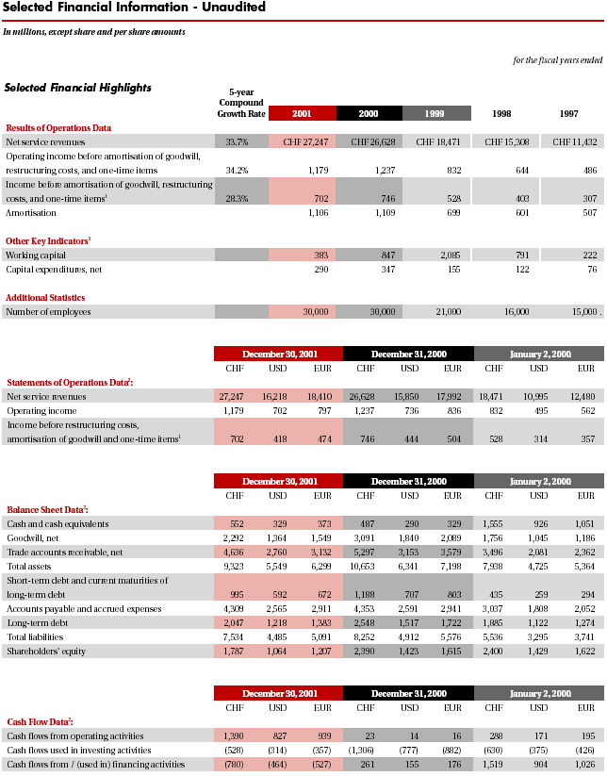
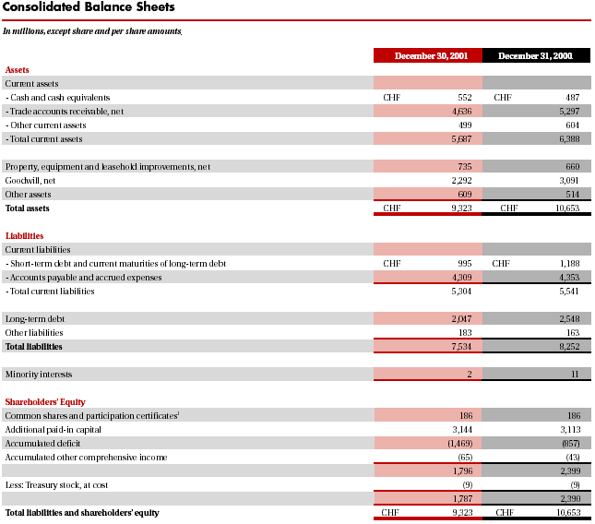
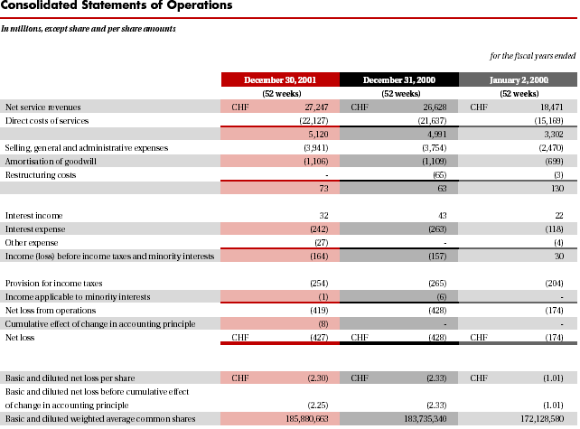
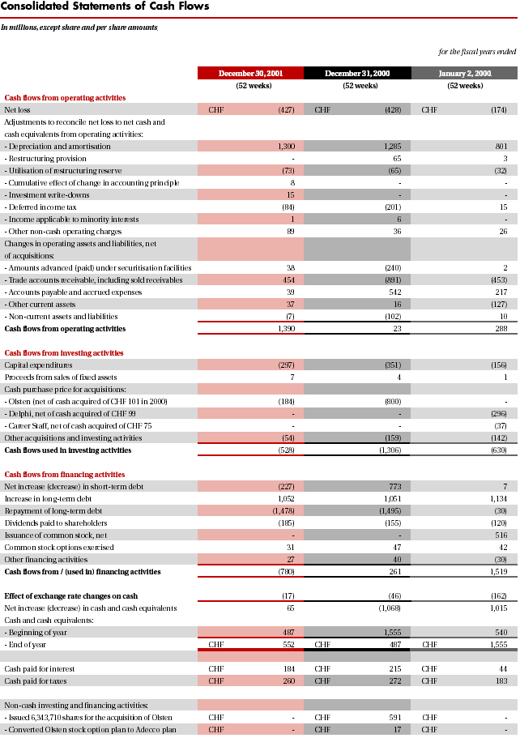
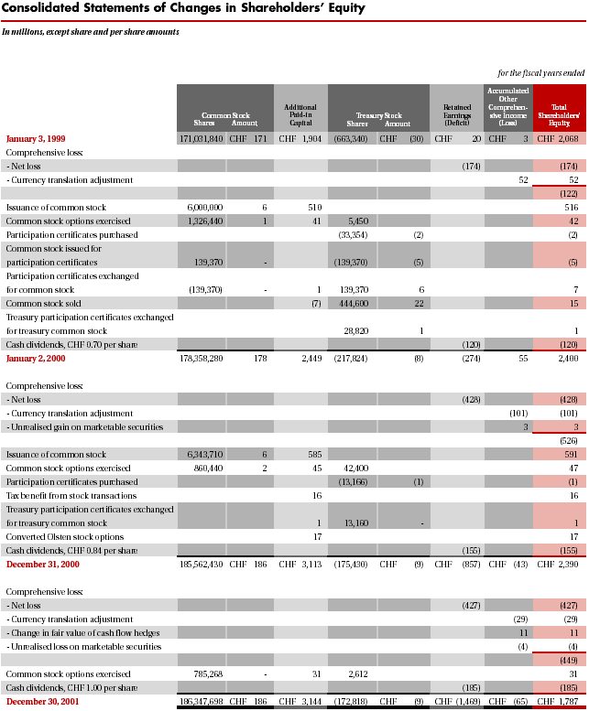

Appendix C – Q/A Strategy

Introduction
This document provides Ajilon Consulting’s QA strategy for the Government EAGLS WebSphere Migration project.

Ajilon Consulting’s QA strategy outlines the standards and techniques used to meet quality expectations of the project. It is also the foundation for the test plan document and subsequent QA activities.

Ajilon Consulting’s QA process provides a comprehensive system of auditing, reviews, testing, accessibility conformance validation, error tracking and reporting. Both automated and manual methods will be used in the process.

Testing will be done in iterative cycles throughout the lifecycle of the project. However, for some modules, testing may run in parallel with development. Each development effort will result in implementation of a particular use case/module or function; this implementation is referred to as Implementation under Test (IUT). For each IUT there will be a testing cycle in which those testing activities relevant to the implementation will be undertaken. For example, for the first iteration, performance testing may not be relevant, however, activities like unit testing (white box) and use case testing (black box) will take place.

Specific details of timings of reviews, audits and testing will be detailed in the Project and Quality Assurance Plan.

Related Documents

- High Level Architecture Document
- Design Document
- Software Quality Assurance (SQA) Plan
- Project Plan

Project Overview
The Government EAGLS WebSphere Migration Project involves the creation of a web-based application.

The system will be designed around an n-tier architecture using the Java language and be J2EE compliant. The application will be deployed on a WebSphere application server with an Oracle backend.

The maximum time to download a page (including images) should not exceed 15 seconds over a 28.8 kbps network connection. Average page downloads over the same connection should not exceed 8 seconds.

The average response time of the application, as measured from the time a message is received by the web server to the time the results are output by the web server, under nominal load should not exceed 3 seconds for simple operations. A nominal load is considered a given number of concurrent users executing similar, simple operations.

The above information is only a general guide for web applications and is subject to change based on requirements and load.

Scope
The Quality Assurance strategy will be based on the requirements and functional specification documents provided by the client.

General Approach
The overall approach is to ensure quality throughout the life cycle of the project with planned QA and testing activities during the Software Development Life Cycle (SDLC). These activities serve as markers for gauging the factors that affect the quality of the deliverables and suggest preemptive corrective measures to increase the quality of the final product.

The Software Quality Assurance (SQA) plan is tightly integrated with the development plan. It is coordinated and implemented by the QA Manager and Team Lead. They are also responsible for communicating the plan and activities to members of their respective teams.

The activities belong to the following levels of monitoring and correction.

- Project monitoring in terms of resource utilization, progress on deliverables and deadlines.
- Conformance to standards.
- Overall quality of deliverables.

The system will be divided into modules and developed iteratively. The QA team will perform a test run of the implemented features and report bugs for the iteration. Subsequent iterations will be tested for integration with the previous implementation. There will be several different levels of testing as defined later in the document.

The Project Plan will detail the frequency of releases to QA.

In addition, Audits and reviews will be performed at defined checkpoints within the project and QA plan. Audits and reviews are part of preemptive approach towards correcting defects and developing quality software.

The diagram in Figure 1 illustrates the testing process for the Government EAGLS WebSphere Migration Project:
Unit Test
Test each component of the application and internal and external interfaces for correctness according to designed functionality
Use Automated Test Tool
For automated dynamic load test
GUI
Win Standards, Design, Internal, and External Links, Broken code, Images, GUI Check-lists
Functional
Test all integrated components developed to ensure that every deliverable meets the functional specifications
Use Test-scripts for Integrated Functional Testing
Functions
Expected results
Pass/Fail criteria
Observations
Verify Source Code
Structure
Documentation
Ease of debugging
Coding convention
Conduct System Testing
Functionality
Throughput / capacity/performance
Robustness
Review Test Results
Functionality
Throughput / capacity/performance
Robustness
Figure: 1 – Proposed Government EAGLS Websphere Migration testing process

QA Activities
The QA activities to be performed for this project are:

- Audits (Progress and conformance).
- Reviews (Technical and Non Technical).
- Testing
  - Unit Testing (Done by the developer)
  - Build Verification testing
  - Functional Testing
  - Interface and usability testing (GUI, etc.)
  - Integration / System testing
  - Security testing
  - Performance Testing
  - Load testing
  - Volume testing
  - Migration testing
  - Regression Testing

The SQA plan will document these activities. The QA Manager is responsible for resource allocation for these activities. Audits and reviews will be conducted on pre-defined checkpoints in the project life cycle. All of the testing will be done in cycles in conformance with iterative development. Figure 2 illustrates activities in the different phases of the SDLC.

QA Activities

Inception
Elaboration
Construction
Transition
Reviews
Reviews
Audits
Reviews
Audits
Testing
Testing

Figure 2: QA Activities in different phases of SDLC

Audits
Audits will monitor project progress against baseline plans to ensure milestones are achieved with planned resources and within budget, and suggest corrective measures for the issues found. They will also ensure that project standards are being followed. Ajilon Consulting’s QA Manager will review audit reports to ensure Quality Control.

The following deliverables are subject to audit during the life cycle of the project.

- System architecture
- Application architecture
- Software Design
- User experience designs
- Entity Relationship Diagram (ERD)
- DB Schema
- User Manual
- Administrator/Operator Manual
- Project Plan (for monitoring progress)
- Test Plan
- Test Phase reports

The following factors will be considered in an audit:

- Progress in relation to planned activities and baseline.
- Conformance to guidelines.
- Addressing of the threats identified in the Risk Analysis.
- Resource utilization.
- Conformance to relevant standards i.e., coding, design and documentation standards.
- Change Management.

Reviews
Peer and QA reviews will be performed to uncover errors in deliverables, ensure organizational expertise sharing, and provide a platform for dialog to ensure the best possible solution.

Reviews will be performed for the following deliverables:

- Requirements and Requirement Documentation.
- Design and Design Documentation.
- Code.
- Help system.
- User and Operation Manual.

The QA Manager is responsible for conducting reviews and setting up the review environment. All of the review and audits discussed in this document are internal reviews. The Project Plan will cover client reviews.

Review: Requirements and Requirement Documentation

The requirements review will only focus on the requirements passed on by the client, this include reviewing documents for completeness, clarity, testability, etc. The review will also include gap analysis. A requirement report is the output of the review process. This report identifies the gaps and present questions from the development and QA teams. The review teams consist of representative from development, QA and an analyst.

Review: Design and Design Documentation

The design review consists of a formal technical review and walkthrough. The design review ensures the design deliverables meet the Bank of America application architectural and design requirements. The design review team consists of the project team members responsible for the design and technical experts outside the project team. The review results in a report detailing issues and recommendations.

Review: Code

Code reviews are to be performed by peers and the development team-lead. Code reviews will be done using both manual and automated methods. Each class and piece of code is to be reviewed for the following:

- Common errors.
- Adherence to guidelines and Java coding standards.
- Programming Logic.
- Security.
- Accessibility.
- Adherence to design and architecture.

Automated analysis tools will be used to test against common security loopholes. The SQA Plan will define the selection of tools. The QA team will prepare checklists of common code errors that can result in security bugs. A guideline for best practices has also been prepared. Following are some of the resources used in preparing those guidelines.

- IBM WebSphere Handbooks.
- www.cert.org
- SANS Top 20 security vulnerabilities and Exposures.

Testing for Government EAGLS WebSphere Migration 2.0
Government EAGLS WebSphere Migration Project testing will be done in multiple phases at various levels. Subsequent sections detail the categories and levels of testing which will be performed during the various SDLC phases.

Testing Types

Following types of testing will be performed in this project:
- Functional Testing
  - According MS Windows Standards using four main levels
  - Low Level (test cases, GUI Check Lists)
  - Functional (test existing functions, sub-functions and their objects)
  - Non-functional (boundary conditions- “Login” and “Password” windows, security issues)
- Integration Testing (Links, connections, security transactions between functions and Main Modules)
- System (end-to-end testing)
- Security testing
- Build Verification tests
- Performance, Stress, Load testing, volume testing
- Testing for DB integrity under abnormal conditions (incl. Failover, locking, etc)
- Usability and Capacity testing
- Performance Database Testing
- Field validation testing
- Regression Testing

Some of the major testing techniques and types are detailed in later sections.

Test Case Design

Test cases will be designed to validate business requirements including non-functional, security and performance requirements. Both automated and manual testing will be performed. The tools used are listed in subsequent sections of this document.

The web pages will be tested to ensure conformance to user interface guidelines provided by the client.

Test cases will be designed to test the following:
- Verification and testing of all the features.
- Verification and testing of all the workflows.
- Verification and testing of all user experiences.
- Security loopholes.
- Performance, volume and load testing.
- Uncovering the unpredictable behavior.
- Boundary conditions.

The basic test design method should consist of following six steps:
- List test requirements based on the specifications (written or unwritten).
- Add test requirements for a range of inputs.
- List a test type for each test requirement.
- Review test types and fill in the gaps.
- Write a test case for each test requirement.
- Group test cases into test suites.

Test cases should be arranged into suites so that at the end of each test suite a specific testing objective is achieved. Script algorithms will be prepared for test cases, which run on automated tools.

Coverage matrices will be prepared and each test suite should clearly identify the coverage it has achieved, this will be done against test requirements identified earlier. A proper requirements mapping will also be done. Use of matrices and tables will be used for breaking tests and for finding new ones. While designing the test cases, reviewing requirements against the test types suggested in Section 5 will help the designer to look at the features from a variety of perspective, and a variety of perspective leads to a variety of test cases.

All of the test cases should be properly identified according to Ajilon Consulting’s naming conventions. The mapping will follow the function identifiers used in Functional Specification document provided by the client.

Test Environment

The test environment needed for Government EAGLS WebSphere Migration will be very extensive, especially for system testing. The test environment should be as close to the final deployment environment as possible. A dedicated server, client machines and load generating machines will be allocated to the project. The software and hardware configuration of these machines will be detailed in the test plan.

The QA Manager is responsible to establish the test environment before the test plan is put in place. Following are the various testing environments that need to be setup for all the levels and phases of testing.

Unit Test Environment

For the Government EAGLS WebSphere Migration Project unit testing environment will be the development system and environment. Unit testing will be done on the development systems by the developer.

Build Verification Test Environment

This test environment is used to test the application produced from a controlled build. A controlled build will have source control (VSS in this case), build scripts, and packaging scripts for the application. The Build Verification Team will run a subset of regression tests to verify basic functionality of the system that is representative of a wider scale of testing.

System Test Environment

This test environment will be used for Functional test, System test, System Integration test (SIT) and all other types of tests to verify the functionality of the application and integrate it with other components. The client will provide the required hardware, network and software for final testing.

Test case execution and recording results

Experience has shown that sometimes the easiest way to know what broke the functionality of a component within the application is to know when the test case last worked. Recording the successes and failures of test cases for a designated application build is essential to having an accountable test organization and a quality application.

Each test cycle for the application should produce Test reports detailing the number of planned cases (Test Plan), number of pass and fail cases, etc. These reports can be generated anytime from the Defect Management tool.

Problem Reporting and Tracking Procedure
All of the defects found during a test run of Implementation under Test (IUT) will be reported in a centrally maintained repository. The repository is a web-based application. Project team members will be provided with a Login ID, Password, and appropriate access rights to the application. The access rights will be based on the roles a member is playing in the project.

The following are some of the fields that will be recorded for each bug: Description, Severity, Priority, Status, Assigned to, Status, Reproducible, R&D Comments, Module, Version, Build No, Test data, Fix Build, Bug Root, Browser, etc.

Bugs will be tracked throughout their life cycle. Figure 3 shows the bug reporting, fixing and retesting cycle. The circles in the diagram represent bug states and status. The team and QA Lead will review all the bugs reported, including those whose status has been changed. All the bugs Re-Opened or Rejected will be investigated by QA / Team Lead. Both Leads will maintain proper communication to resolve issues. Only a QA team member can close a bug, nobody from the project team has bug deletion rights.

Following is the suggested list of values to be used for prioritizing bugs for this project:

Priority | Severity | Description
4 | Low | Spelling and Language errors, minor GUI problems, Graphical errors.
3 | Medium | GUI, Usability, Flow, Minor functionality.
2 | High | Usability, Flow, Missing screens, Missing functionality, Bugs in critical functionality.
1 | Urgent | Bugs, which make other areas of application un-testable. Failure of suite. (Show stoppers.)

If there are several high priority bugs, the client will provide Ajilon Consulting with a list of bugs and the sequence in which they should be fixed. The list can be transmitted either electronically or on paper.

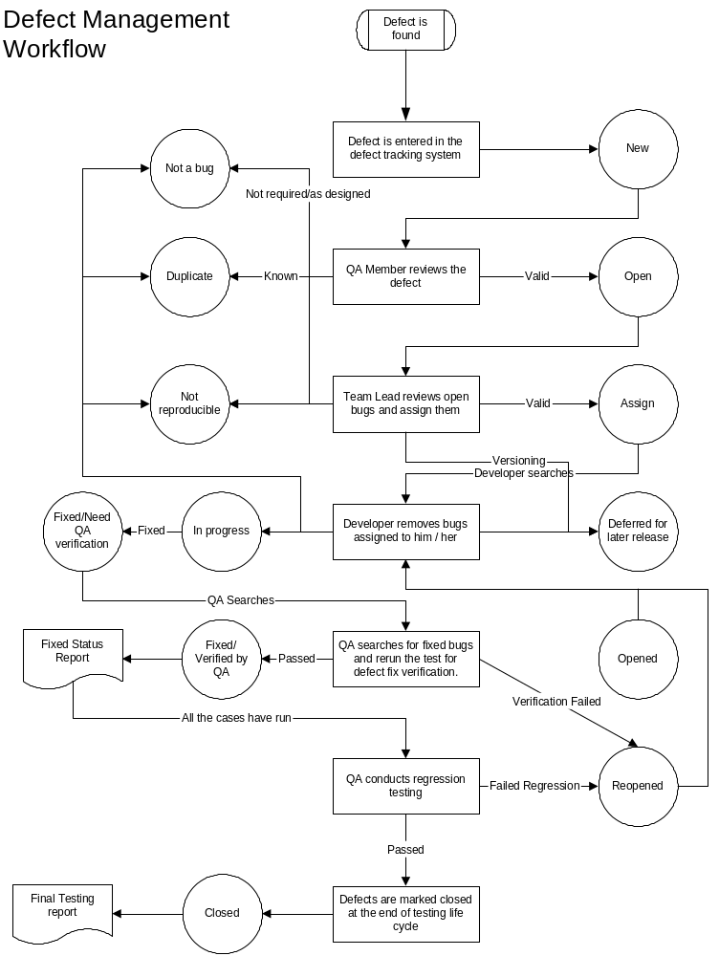

Figure: 3 – Complete Bug Reporting, Fixing, Re-testing cycle.

Functional Testing
Functionality testing consists of checking that all the functional requirements have been committed. To achieve this, a list of test cases will be created to verify the application does what it is expected to do, and the application does not do what it is not expected to do.

Functional testing tools

Automated tools will be used for Build verification and Regression testing. It may be feasible to exercise some of the tests manually. All of those functional tests that have to be exercised through automated tools will be identified before the test run. The test plan should also allocate resources for scripting and configuring these tests in the tool.

Following are the suggested tools for automated functional testing:

- Rational Team Test
- Rational Robot
- Astra Load Test

Only one tool will be used out of the first two. The tool will be specified in the test plan and will be selected once design and other details have been finalized.

Application Security
Security testing ensures that there is no loophole in the system, which can be exploited by, willful internal or external attacks.
There can never be a system which is 100% secure and there can never be any testing that uncovers all the loopholes in the system. However, we can always reduce and manage the risk.
Our security strategy is geared towards managing and reducing risks that can compromise the application. Identification of risk and mitigation is the cornerstone of our approach to implementing security. There are various levels and components in a system where security can be compromised:

- Application
- Web and Application Servers
- Operating System
- Network Resources (Routers, firewalls, proxies, etc)
- DBMS

This document only discusses the application level security.

Ajilon Consulting is committed to build security right from the start of development of application. We have defined a simple Security development life cycle, which runs within SDLC. At each relevant phase, it is ensured that solution developed follows security guidelines. Security testing is embedded in all the testing techniques.

Security Development Life Cycle

Our Security Development Life Cycle has two phases:
- Risk Analysis.
- Test.

Each phase has its own set of tasks that contributes towards designing and building a more secure product.

Risk Analysis

In the Risk Analysis phase, the security specialists, QA and development teams work together to ensure that security is a major consideration in the design of the system. There are three major security activities in this phase.

Risk Assessment
Once the design begins to take shape, the security specialist from QA and the development team will perform risk analysis of the system design, ensuring that designs that would violate security standards are rejected, or modified. The risk assessment process documents risks and threats to the application, and determines counter measures that mitigate each threat. As the Risk Assessment is the most important security document relating to an application, the next section of this document looks at risk assessments in more detail.
The counter measures suggested in the Risk Assessment are tracked during audits and any non-conformance is reported.
One of the suggested techniques to use during this phase is Attack Trees.
Technical Specifications
Finally, counter measures determined by the risk assessment need to be included in the technical specifications for the application.
Test
The Test phase is the next phase of the Security Development Life Cycle. In this phase, the security specialist works with the developers and the test team to ensure that counter measures suggested in the Risk Analysis are correctly implemented and that code is developed following security best practices. There are three security activities in this phase.
- Unit Testing
Tests for security related issues should be designed to be run during unit testing. The security behavior of each module should be tested. For example, all buffers for a module should be checked to determine if they are susceptible to overflows. Code reviews will complement unit testing. Only selected code will be reviewed for security.
- Integration Testing
During integration testing the QA should ensure that security testing is embedded in the overall integration test plan for the product at this stage. Specific tests should be in place to check authentication, authorizations and entitlements, and to test all counter measures that are put in place because of the risk analysis.

A limited number of penetration and DoS (Denial of Service) tests will be run to ensure that application itself is not prone to such attacks.

Deployment
This stage is out of scope of the document, however, the client should ensure conducting a full penetration, or ethical hacking test before the site is entered into the DNS servers. This final level of security testing should involve professional ‘hackers’ attempting to penetrate the system. The testing should be done from the perspective of an outsider with no approved system access and a malicious insider who has access to the system. It is recommended that a third party with no involvement in the development or design of the system should do this testing. Once the penetration testing is complete, any remaining vulnerabilities can be corrected before the system is in production. The reason for doing penetration testing at this stage, and not during integration testing, is to ensure that the system is tested in its production state, and not in a QA or development environment, which may not completely mirror production. Following are the suggested types of testing during this phase:
  - Penetration testing
  - DoS (Denial of Service) attack Testing

Integration Testing
On completion of all iterations, the complete application is subjected to integration testing. Integration testing ensures that a set of modules that work individually work correctly together and that security has not been compromised during the integration. Following are some of the common occurrences that could be identified during integration testing:
- Differences in understanding of the Business Requirements by various developers resulting in different events taking place for the same test case.
- Ensuring that fields are defined consistently throughout the application. For example – date format in DDMMMYY rather than some in DDMMYY.
- Identifying differences in field content. For example – phone numbers with country codes and those without.
- Modules with errors, which were not uncovered in unit testing. Integration testing may add new test cases, some of which may have been difficult to generate during unit testing, that result in additional errors being uncovered.
- Verifying links between modules.
For details of how security will be handled during integration testing, please refer to the Section: Application Security.

Load/Performance/Stress Testing
Performance Testing measures response times, transaction rates, and other time sensitive requirements. The goal of Performance testing is to verify and validate that the performance requirements have been achieved. Performance testing is usually executed several times, each using a different background load on the system. The initial test should be performed with a nominal load, similar to the normal load experienced (or anticipated) on the target system. A second performance test is run using a peak load. Additionally, Performance tests can be used to profile and tune a system’s performance as a function of conditions such as workload or hardware configurations.

Load testing subjects the system-under-test to varying workloads to evaluate the systems ability to continue to function properly under these different workloads. The goal of load testing is to determine and ensure that the system functions properly beyond the expected maximum workload. Additionally, load testing evaluates the performance characteristics (response times, transaction rates, and other time sensitive issues).

Stress testing is intended to find errors due to low resources or competition for resources. Low memory or disk space may reveal defects in the software that are not apparent under normal conditions. Other defects may results from competition for shared resource like database locks or network bandwidth. Stress testing identifies the peak load the system can handle.

Volume Testing subjects the software to large amounts of data to determine if limits are reached that cause the software to fail. Volume testing also identifies the continuous maximum load or volume the system can handle for a given period. For example, if the software were processing a set of database records to generate a report, a Volume Test would use a large test database and check that the software behaved normally and produced the correct report.

NOTE: Transactions above refer to logical business transactions. These transactions are defined as specific functions that an end user of the system is expected to perform using the application, such as add or modify a given record.

Regression Testing
Regression testing is the process of validating modified parts of the software and ensuring that no new errors are introduced into previously tested code. After the deployment of the application, it is quite usual that small changes are introduced frequently. Regression test processes are needed to assure the behavior of the whole application remains as expected.

Regression testing consists of running a selected subset of the test cases used in the functional test phase that are representative of other related functions. All of the test cases that will be re-exercised in regression should be clearly identified.

Regression test tools

Same as identified in functional testing and in Section: Functional Testing

Migration Testing
The basic aim of this test is to ensure that the database has not been corrupted during the migration process and that the source and new DB are same. This testing will be done by comparing database characteristics before and after migration. This will be achieved by generating control totals, number of records, etc from the source database and then again generating the same totals from the new (migrated) instance of the database. Both of the totals should be equal. In addition to this data will be checked randomly to ensure that no corruption has occurred.

Unit testing
Unit testing is one of the white box testing technique that will be performed for this project. It is the responsibility of the developer to perform unit testing. QA should make sure that this testing happens and relevant reports are generated. A class is defined as the testable unit. QA Team will ensure that no code is integrated or released without testing. The developer will maintain reports showing the resolution of the bugs found.

Unit testing and code review may be done in parallel. Please also refer to Sections: ‘Application Security’ and “Testing for Government EAGLS WebSphere Migration 2.0”.

Testing Debugging Cycle

Following figure depicts the testing debugging cycle to be followed in the project.

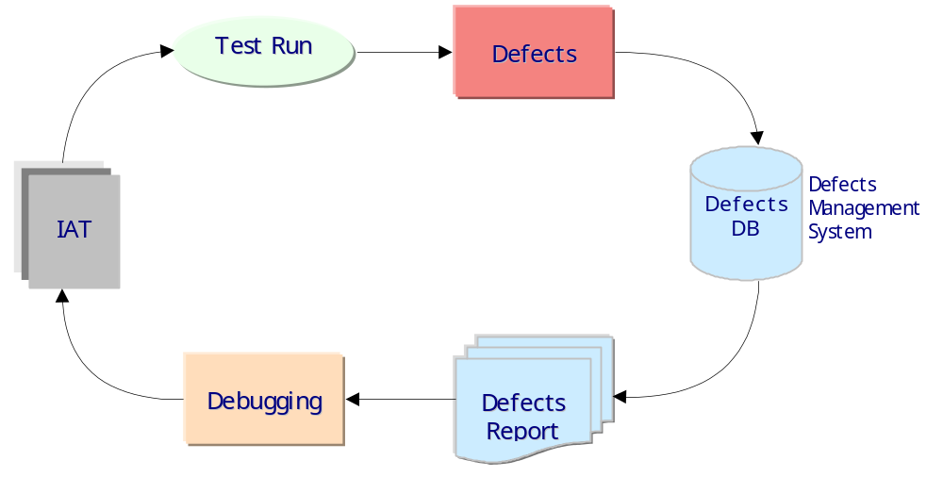

- Figure 4 : Testing Debugging Cycle

Test data generation
All of the test data should be organized and identified before commencing the test run. The data should be as close to the real data as possible. Each test and test suite should have an associated a data set where relevant. The client will be responsible for providing real world test data.

Use of Automated Tools
Automated tools will be used for Requirements Management, version controlling, testing, load testing, unit testing and accessibility conformance validation.

The following tools have been currently identified which may be used for conducting QA activities. These tools may change after the technical kickoff meeting is concluded.

Version controlling
VSS

Testing
Astra Load Test (Load/Stress)
Rational Robot/Team Test
Jtest (Unit Testing)

Security
Not yet decided

Business Risks

Risk Area | Level (H/M/L) |  | Risk Mitigation Strategy
- A QA team member can fall ill or can take sick leaves. |  | M | - Allocate sufficient backup resources that have an understanding of the system and have current information on the progress of the project.  - Knowledge sharing through reviews, meetings and central data repository.  - Proper documentation of all the activities.
- Change in requirements |  | H | - Proper planning for change and requirements management, and use of automated tools.  - Project specific estimation and change effect methods.
- Test System availability |  | H | - Proper planning and coordination with client.
- Late delivery of IUT for testing |  | H | - Proper planning, use of additional resources, use of automated testing, Pre release builds testing.

Roles and Responsibilities
The following RACI Chart is a list of roles and responsibilities for each of the team members. One or more members can be responsible for completing a given task. Each task has a participant who is accountable for the task. Some participants will be consulted before the task is completed and some will be informed after the task is completed.
R -- Responsible for doing the work
A -- Accountable for delivery of the task
C -- Consulted with during task execution
I -- Informed after the task is complete
Function | QA Manager | Team Leader | Developer/  Tester | Doc Specialist | QA Tester | Client

Planning Phase
Configuration Management | A | A | C | I | I | I
Change Control | A | C | C | I | I | I
Metrics capture | A | R | I | I | I | I
Traceability | A | R | I | I | I | I
Project Planning | C | A | I | I | I | I
Test Creation & Execution
Create Test Plan | A | I | R | C | C | I
Inspection of Test Plan | A | I | R | I | C | C
Create Test Cases, Scripts | A | I | R | C | I | I
Execute the Development Test(as defined in the Test Plan) | A | I | R | I | C | I
Produce Metrics | A | R | R | I | I | I
Inspection of Test Results | A | I | R | I | C | C
Approval of Test Results | A | I | R | I | I | R
Conduct Quality Review by Team | A | R | C | I | C | I
Performing Audits | A | I | I | I | R | I
Performing QA Reviews | A | I | I | I | R | I
Unit testing | I | A | R | I | C | I

Resources
The following dedicated resources and equipment have been allocated to the project.

To be assigned.

The detailed resource allocation will be provided in SQA Plan.

Deliverables and QA Activities
Following matrix shows the focus of activity on each deliverable. The focus has been defined as being High, Medium and Low or Not Required. This is only a guideline and is subject to change.

Deliverables | QA Activities
Deliverables | Auditing | Reviews | Testing
Guidelines for  - Java coding  - JSP (web-pages) coding  - Servlets (controller) coding  - Java Doc  - Documentation  - Unit testing  - Quality Assurance | L | H | Not Required
Program Deliverables  - Project Plan  - Risk Management  - Action and Issues Management  - Progress Reports | H | H | Not Required
Architecture  - System  - Application  - Integration | L | H | Not Required
Test Plan, Case, Result & Summary  - Integration  - Stress  - Guideline Conformance  - Design Conformance | L | H | Not Required
QA Audit Reports | H | Not Required | Not Required
Progress Metrics | H | H | Not Required
Source Code – Documented  Compilation and Configuration Guide | Not Required | L | H
Database conversion scripts | Not Required | Not Required | M
Code Review Feedback | L | H | Not Required
Support Documentation  - User Manual  - Admin Manual  - Installation & Configuration Guide  - Maintenance Guide | H | L | L
Detail Design  1. UML artifacts  - Component Diagram  - Deployment Diagram  - Class Diagram  - Sequence Diagram  - Activity Diagram  - Entity Relationship Model  - DB Schema  - Logical Design  - Physical Design  - Data Dictionary  - Transaction Model | L | M | L

Appendix D – Key Staff Resumes

Project Director -- Brian J. Coffey
PROJECT DIRECTOR – BRIAN J. COFFEY
Brian J. Coffey, Director Managed Services. Mr. Coffey is part of Ajilon Consulting’s Managed Service Team a solution based consulting service. His 30 years of experience spans both international and domestic markets in the area of system analysis, design, development, implementation, organizational review and analysis, market analysis and project management. He is currently a Director in Ajilon Consulting’s Managed Services practice for the Southeast Region, residing in the Atlanta office. Mr. Coffey has been part of the management team with a number of consulting companies, Nextera, Sigma, Cap Gemini and Price Waterhouse. He possesses an excellent record of accomplishments working with businesses in a variety of industries, including banking, manufacturing, transportation, insurance, healthcare, utilities, entertainment, and telecommunications.

Mr. Coffey has significant experience in:
- Strategic Planning |  | - Project Management & Change Control
- Requirements Analysis & Definition |  | - Business Continuity Planning
- Strategic Partner Relationship |  | - Policy & Procedure Development
- M&A Strategy |  | - Application Development
- Knowledge Management and Planning |  | - Product/Vendor Evaluation & Selection
Mr. Coffey started his career in finance working for a large manufacturing company (Litton Industries). He developed financial and implemented manufacturing applications for this company for years then went to work for Harris Corporation implementing package applications at their locations globally. He then went to work for Price Waterhouse as one of the original participants of their Applied Technology Center, managing several strategic relationships with key partners and building a practice in the package implementation marketplace. He then took the Applied Technology concept that was so successful in the US to the Price Waterhouse Southeast Asian/Australian markets working there for a number of years. Mr. Coffey then worked for a number of years for Cap Gemini, Sigma, and Nextera Consulting as a practice leader. Some highlights of specific engagements are:
- Directed IT merger strategy at Chase and JP Morgan; this included relocation of data centers, cost savings analysis, manpower reduction, and system strategy.
- Managed a major insurance company’s electronic commerce strategy (The Hartford). Implemented Netscape Directory services for 60,000 producers and 25,000 employees.
- Coordinated the implementation of a data warehouse and web strategy for start-up computer manufacturer. The manufacturing, distribution, and customer support were all completed outside of the organization and required coordination and interfacing with external businesses. The project was fully operational, including tracking of purchases via the WWW, within nine months as scheduled. Selected and implemented financial applications as part of the overall project.
- Led impact analysis project designed to study the alternatives of using web-based reservations systems for a major airline.
- Reengineered a company’s existing business processes for a four-division full suite PeopleSoft financial and manufacturing implementation.
- Advised major entertainment broadcaster during assessment, design, and implementation phases of the PeopleSoft accounts receivable application. Project included reengineering business processes at multiple locations, domestic and abroad.
- Managed project to select vendor to maintain and convert a major telecommunication company’s Continuing Property Records (CPR). Phase I, maintenance of the CPR, was a $50M, three-year project. Phase II, the ultimate mechanization and conversion of the records to digital format, was recognized as one of the Top 5 Successful Projects and was nominated for several internal awards.
- Assisted in the project management of a telecommunication company’s Program Management Office for five large development projects. Coordinated this activity with Trecom, EDS, and Ernst & Young to deliver seamless project direction, synergies within projects, and reporting from a single source.
- Developed a package implementation services group; created methodologies and standards for software package implementations. Acted as program/project manager during implementations.
- Created marketing plans and developed sales leads in generating new business.
- Developed a consulting practice dedicated to package implementation. Created a three-tier Consulting and SI Partner Strategy by gaining support across all levels of the organization, then implemented Global Alliance structure for Strategic and Major Partners by geography, line of business practice, and industry.
- Designed and managed a transition set of application from Mainframe to Client Server for a major software provider. Created single toolkit for multiple sets of existing financial applications that ensured successful migration for the user base from current software to new technology. The development and rollout included beta testing with ten multinational companies and was considered a huge success for the future viability of the company.
- Managed selection and implementation of PeopleSoft financial application for a major information provider. Due to recent acquisition, the new parent company had contractual obligations to be completely off old system within six months; project was completed on time and within budget.
- Led project to develop an expense accounting system for a European electronic manufacturing company, including the conversion of 11 currencies at daily spot rates into British Pounds.
Speeches &  Publications: | Mr. Coffey has given numerous presentations in relevant topics to industry and trade groups, business associations, and clients. He also has had a number of papers published in internal news publications.
Education: | University of Massachusetts  Bachelor of Business Administration, Business Management and Organization

Project Manager – M. A. Sriram, PMP
Project Manager / Senior Consultant – M.A. SRIRAM
PROFESSIONAL PROFILE:
Ram Sriram is a Senior Consultant with about 20 years of experience in the IT industry and has worked as a Management Consultant, Project Manager and Business/IT consultant in both private and public sectors. He is a mechanical engineer and also has a Master’s in Computer Applications. He is professionally associated with the Canadian Association of Management Consultants (CAMC) and also the Project management Institute (PMI) and is a Certified Management Consultant (CMC) and a Project management Professional (PMP). He recently completed an assignment with MBS as Manager – Business Analysis and with MCBS as Project Management Consultant.
TECHNOLOGIES and METHODOLOGIES:
ANALYTICAL: IT Planning & Strategy, Business Systems Modelling & Design,
Business Process Reengineering , Requirements Definition, Data Warehousing, Knowledge Management, Business Intelligence, Application Development, Project Management Office, Project Management Assessments/Evaluation (Tools/Practices)
MANAGEMENT: Management Consulting, Project Management & Team Leadership
BUSINESS: Exposure to a wide variety of Businesses and Industries
PERSONAL: Excellent Interpersonal, Communication, Facilitation & Training skills
INDUSTRIES METHODOLOGIES & CASE DATA DESKTPOP
STANDARDS TOOLS BASES TOOLS
Airlines Protocycling ADW M204 Lotus 123
Finance PROMPT ASYST DB2 Wordpro
Insurance IEM/JAD IEF DB400 Freelance
Mutual Funds ISO 9000 BACHMAN Oracle MSProject Petroleum COMPAS DR Planning CADRE MSAccess
Retail P-Plus (Productivity Plus) ERWIN Ami Pro
Telecommunications Method 1 Visio
Utilities (Oil & Gas) SDLC Word
Manufacturing Project Management Office E-Room
Investment Brokerage CMM
Credit Card PMMM
Provincial Govt Zachman Framework, RUP
Labour, Transportation
MBS, Consumer and Business Services
ENVIRONMENTS - Mainframe, Client-Server, E-Commerce, Mid-Range, PC based
CURRENT TRAINING – Rational Unified Process – Use Case Development & Methodology
PROFESSIONAL EXPERIENCE:
Management / Information Systems Consultant (Independent)
October 2002 – Sunlife Financial Canada - Project Manager/Project Leader
Present Technical Environment – Web based application (ASP)
Professional Services Automation (Time Tracking) – Phase 1
- Responsible for developing the project charter, developing and maintaining the project schedule for implementing an enterprise wide (Professional Services Automation) Changepoint Time-Tracking system for Sunlife Financial Canada.
- Provided Business Analysis insight into the overall implementation, performed Vendor Management and helped negotiate a licensing deal for acquiring the enterprise wide Changepoint Time-Tracking system
- Developed Business requirements, Communication Plans, Conversion Validation plans, and a Production Support Strategy for the successful implementation
- Developed enterprise wide communication messages supporting three levels of audiences – Senior management, line managers and user community at a whole to establish a sense of awareness and expectation of the new system that was implemented in a compressed timeframe
June 2002- Ontario Provincial Government – Ministry of Consumer and Business
Oct 2002 Services - Project Manager/Project Management Consultant
Technical Environment – Web based application
High Level Preliminary Analysis /Implementation Evaluation
- Conducted a high level preliminary analysis along with the Director of the PMO for the eRoom Evaluation project. Developed a project proposal and plan with cost estimates to help gain Senior Management approval.
- Involved in the Ministry’s Project Management Committee to set priorities around eRoom implementation, and prepared a ministry wide communication survey around this implementation.
- Conducted an evaluation of the pilot implementation of eRoom, a project management tool for the ministry and the PMO and developed and presented the findings through a management report.
Mar 2001 - Ontario Provincial Government – Management Board Secretariat
May 2002 Manager – Business Analysis
Technical Environment – Client-Server, Web based application
Management and Leadership
- Responsible for managing (directing, coaching, mentoring and empowering) a team of business analysts to successfully develop business requirements, conduct feasibility studies, and implement business intelligence applications for MBS clients.
Some of the successful initiatives of the Business Analysis team include:
  - Development of the Business Analysis Guide
  - Development of expertise within the team in Proposal & Project Plan development using standard templates
  - Continuous Knowledge transfer and lessons learned after a successful completion of a project
Business Analysis & Proposal Development
- Acted as the Lead liaison from the Business Analysis team to evaluate various client project opportunities and prospects identified by the Client account
representatives. Assigned business analysts to the assignments and developed project proposals for successful prospects.
Project Management
- Successfully combined analytical & project management skills to complete projects on time, on budget through proper planning and teamwork
Some of the projects managed include:
- PKI Security Implementation for a Business Intelligence application for the Shared Services Bureau (Cognos Powerplay & Impromptu)
- Re-engineering LIS from Foxpro to a new platform for Ontario Realty Corporation (SAP). Involved in developing new processes (Zachman Framework), and communication/change management strategies to different levels of audiences and inform them about changes to the business process
- Development of a pilot OPS Performance Measures – Business Intelligence application for the Shared Services Bureau (Cognos Powerplay, Impromptu, KPI, Webfocus)
- OCMS Cube Conversion & Development for Ministry of Consumer and Business Services (Cognos Powerplay, Oracle)
- Business Process Development from a Security perspective (Zachman Framework) for the OPS Mailroom
- LIS – Phase 2 consisting of Development of a RFP for an integrated Lease Administration, Space Management and Facility Management system
- Re-engineering Billing for Managed Hosting for iSERV (Zachman Framework, RUP)
- Energy Needs Analysis - FASER for the Shared Services Bureau
Management Planning & Reporting
- Participated in the following routine planning initiatives for iSOLUTIONS:
  - Resource Planning for Business Analysis projects
  - Planning for proper training for the Business Analysis team
  - Budgetary planning for the fiscal year for Business Analysis
  - Strategic Project planning for iSOLUTIONS
  - Identification of Change Management risks
  - Organizational Process Improvement using CMM for iSOLUTIONS
- Provided continuous updates and reported issues & progress on all prospects, projects and resources through weekly updates on the Project Management Tracking System and weekly management meetings
Billing & Recoveries
- Responsible for the confirmation of all billings and recoveries from clients for all Business Analysis managed projects, at the end of every quarter during the fiscal year.
Nov99 - AMERICAN EXPRESS – Project Management Consultant
Mar2001 Technical Environment – Client-Server
Project Coordination
- Responsible for Project Coordination for a portfolio of IT projects performing Planning, Scheduling, Progress Reporting, & Resource Allocation according to a planned schedule. Responsibilities included Liaison with Project teams and associated Management to communicate progress and resolve any issues.
Change Control/Management
- Responsible for Change Control impacts to plan for all projects to provide an early assessment of all change requests from a timing, budgetary and resource perspective. This was to aid the decision making process for Management to schedule revised implementation deadlines and allocate the requirement and resources to the right release.
MS Project - Evaluation
- Evaluated Reporting capabilities of MSProject 98 resource pool and suggested improvements to the Time Reporting System interface to allow for Budget and Resource allocation reporting for all projects.
- Evaluated the capabilities and features of MS Project 2000.
Training & Audit
- Conducted training sessions for Project Managers and Project Leaders on Project Management methodology.
- Involved in the development of an audit review document and conducting audit reviews for projects.
Aug 99 - CORPORATE COMMUNICATIONS INTERACTIVE - Project
Sept 99 Management Consultant
Project Management Office Study/Evaluation/Assessment
- Conducted an in-depth study of the current project environment in this
multimedia company and developed a project proposal for implementing a Project Management Office. The proposal included identifying the overall approach, the necessary deliverables and the phased implementation timeframe with project plans and resources.
Jun 98- IBM/NESBITT BURNS - Project Management Office/Project Leader
Jun 99 Project Management & Management Reporting
- Responsible for the Planning, Analysis, Design, Development & Maintenance, of the Year 2000 Project Management Office Database (the repository for all Y2K application inventory status & progress information) for Nesbitt Burns.
Managed a team of two developers and an analyst on this project while coordinating with senior management for ongoing planning & direction.
- Responsible for overall communication (management reporting) to three levels of audiences (Board, Sr.Mgmt, PMs), progress tracking of all different areas of the Y2K project, monitoring of compliance status of vendor companies and day-to-day coordination of new reporting requests.
Jan 98- CGI / MOLSON CANADA - Y2K PMO /Project Manager
Jun 98 Technical Environment – Web based application
Project Management & Methodology Development
- As part of the Year2000 practice at CGI Canada, provided regional support across Canada in the Inventory & Risk Assessment of systems for Molson Canada. Responsible for the design and development of a PMO database for Molsons and managed a team of two developers to implement the same on two platforms - Microsoft Access and Web.
- Developed a Project Management Office methodology for implementing Year2000 projects for CGI Canada and outlined the steps with procedures, diagrams and checklists.
Apr 97 - ZURICH INSURANCE - Y2K Consultant / Team Leader (Planning,
Dec 97 Analysis, Certification, Testing) Technical Environment - Mainframe
- Methodology Development
- Developed an Estimating methodology for providing time estimates for Y2K validation testing tasks.
- Developed a Y2K application Certification methodology for Zurich Internal Audit to certify application systems to be Y2K compliant.
- Project Planning
- Identified and prioritised over 50 applications from the Corporate Business Unit for Validation testing.
- Developed detailed project plans for Conversion and Validation for the above applications (time and resource estimates).
Resource Selection
- Involved in the selection and interview of Y2K resources for the above projects.Interviewed over a dozen personnel and selected six team members.
- Project Management
- Project Leader for three simultaneous projects with monitoring & reviewing project plans and guiding a staff of three validation analysts.
- Provided management feedback & progress of the projects.
Jan 97 - SEARS CANADA - Sr. IRM Consultant/Project Planner
Apr 97 Technical Environment – Mainframe, Client-Server
- Proposal Development
- Developed a Proposal for gathering Business Requirements for the Sales Tax Management System (GST/HST Harmonization). Participated in information gathering sessions to develop a conceptual Process and Data model for managing corporate financial transactions.
Sep 96 - FIDELITY INVESTMENTS - Sr. Systems Analyst/Project Planner
Dec 96 Technical Environment – Mainframe, Client-Server
- Disaster Recovery Project Planning
- Developed a Strategy White paper on Disaster Recovery Planning to aid the development of three major project plans for Retirement Savings systems.
Developed three project plans for developing and testing DR plans. This involved defining the project schedule tasks, timeframe and the responsibilities of key personnel for further implementation.

Jan 96 - Manulife Financial - Management Consultant
Sep 96
- Management Consulting
- Responsible for developing a Conversion workflow model to enable the merger of Processes, Procedures & Systems of two insurance companies. The model documented all major Pre-conversion, Conversion and Post-conversion processes through detailed business analysis of Group Life Insurance.
- Developed detailed Work Plans for solving Conversion Change Management Issues and managed the implementation of solutions for such issues.
Other Assignments: (1995 – 1980)
Ministry of Transportation – ADW Support Architecture & Strategy
Consumers Gas – Management Consulting, Business Process re-engineering, Change Management, Communication Plans
Rogers Cantel – Strategic Planning & Information Architecture
Rogers Cable – Information Systems Planning, Communication Plans
Air Canada – Business Requirements, Information Engineering Consulting
– Aeroplan
Imperial Oil – Business Requirements, Performance Management
Ministry of Labour – Feasibility Study
Zurich Insurance – Strategic Planning, Toronto
ERS Ltd – AS/400 Consulting - Move Management System, Toronto
State of New York - M204 assignments, Department of Housing & Insurance,
Albany, NY, USA
SHL Systemhouse - Consulting assignments, Toronto
Canadian Depository for Securities - M204 Systems Analysis, Toronto
Computer Task Group - M204 Consulting, Dunedin, Florida, USA
Ernst & Young - National Information Systems, Toronto, Canada
Ernst & Young - Management Consulting, Singapore
EDUCATION AND PROFESSIONAL DEVELOPMENT:
B.Eng. Mechanical Engineering, University of Mysore, India
M.Eng. Computer Applications, Asian Institute of Technology, Thailand
Certified Management Consultant CMC - Member (CAMC) 1994-2003
Project Management Professional PMP - Member (PMI) 1996-2003

Architect – Asif Sharif
SENIOR ARCHITECT – ASIF SHARIF
PROFESSIONAL PROFILE:
Asif Sharif has a Bachelor of Science in Computer Science and a Bachelor of Business Administration. He has designed multiple large scale Web based applications and has managed project teams in the design, development, testing. Implementation and deployment of Web based applications.
TECHNOLOGIES and METHODOLOGIES:
- Internet and Web Technologies: Java, HTML, ASP, IIS, JavaScript, Netscape Server, WebSphere, WebLogic, MQ Series, SML
- Visual C++ MFC, SDK: GUI, OOP/OOD (UML), OpenGL, CORBA, COM/DCOM/OLE, Design/Analysis, Graphics, Image processing, Database, Instrumentation
- C/C++: GUI, Database, Graphics, Design/Analysis, Image processing
- RDBMS: Oracle and SQL Server
- OODBMS: ObjectStore
- MS Access, Visual Basic: GUI, Database
- Rational Rose/Objectory: OOD, ULM

PROFESSIONAL EXPERIENCE:
1998-Current: Ajilon Consulting Canada, Director Research and Development
e-Business Solutions Architect
Asif managed a team of 10 developers and analysts as the principle architect and development lead. He was responsible for the detailed design of the application and task delegation to team members. He also was the client technical liaison. The application implemented a service-based architecture. The system environment was:
- Unix/NT WebLogic
- Java, JSP, EJB
- Rational Rose, OOD, XML
Architect
Asif was the architect for multiple solutions at the Ontario Property Assessment Corporation. We developed the intranet applications Acts Online, Time Management, and the overall intranet content web site with distributed content authoring. Three separate teams where formed for these three projects. The system environment was:
- Unix/NT IBM Web Sphere
- Java, EJB, JSP
- XML, XSL, OOD, NetObjects
- Oracle

Principle Software Architect, Lead Developer
Asif was the principle software architect and the lead developer on a very complex project called BICD. It was designed to collect information from a variety of sources via MQ Series and make the data available to various business partners and web users thru the browser or a B2B interface. This project was particularly interesting due to the enormous complexity of the problem domain. The system environment was:
- Unix/NT
- IBM Web Sphere
- IBM MQ Series
- Java, C++, EJB, JSP, XML
- Oracle, IMS/3270
- BAAN
Principle Software Architect, Lead Developer
Asif managed a team of 8 developers and analysts. He was responsible for the creation of the Development Plan, assignment of tasks, day to day tracking of progress, updating management with weekly progress reports and establishing requirements with the client. Asif also mentored developers in the areas of C++, Java and object oriented design.
Asif was also the primary architect for the system. The Warranty Management System was developed using C++ and Java. This application used ObjectStore as its database and C++ with CORBA for the backend. The client application was developed using Java. A servlet driven HTML interface was provided for accessing the warranty information using Netscape Server and Java. UML along with Rational Rose was used throughout the project with great emphasis on Object Oriented design principles. The technical environment was:
- Windows NT Server
- Java, C++
- Orbix CORBA, OODBMS-ObjectStore
- Netscape Server, HTML, Java Script and Rational Rose.

1998: Cyberbahn, Toronto, Ontario
Technical Project Manager
Asif managed a team of six developers in building a web-based application for the Ministry of Consumers Affairs. He was responsible for choosing the technologies and developing the architecture of the system. He was also responsible for mentoring and coordinating the team’s activities.
A Service Provider, Wholesaler and Retailer application system was developed for the government. The Service Provider got information from the ministry's AS400 via MQ Series. Many such Service Providers sold services to the wholesaler and in turn the wholesaler sold many services to various retailers, such as Bell. These services are sold via the Internet.
Asif performed requirements gathering, analysis and design of the systems and implemented a proof of concept prototype. The system was designed using object-oriented methodology. The Objectory Process by Rational Inc. along with Rational Rose was used for use-case analysis, design and documentation. The backend was implemented using C++/COM and SQL Server. The front end was developed in Java and ASP pages. XML was used as the medium of data exchange. A DTD was defined for all communication formats. IBM's MQ Series, multi-platform messaging middleware, was used to facilitate communication between processes and systems. The system environment included:
- Windows NT Server, SQL Server, IBM's MQSeries middleware
- XML/DTD, Visual C++, COM/DCOM, IIS, HTML, ASP, Java, Java Script and Rational Rose
- Extra-Attachmate for Screen Scraping.

1997-1998: AC Nielsen, Markham, Ontario
Senior Consultant (contract)
Asif designed, implemented, tested and integrated an HTML/Java Script generator as a C++ class library. This class library is used to export complex OLAP documents to HTML 3.2 and Java Script code. He also developed a JAVA applet for managing navigation of the exported OLAP document.
Asif defined and prototyped a migration strategy for MFC's Automation COM objects to dual interfaced ATL COM objects. He also trained and mentored developers in ATL COM design and development.
Asif designed and prototyped an alternate structured storage scheme for data persistence. This alternate scheme allowed for both C++ and COM objects to write to structured storage via a standard interface and allow multiple read access to the structured storage file. He developed two ATL COM components to ease exporting of OLAP documents to MS Excel and MS PowerPoint via OLE Automation. The system environment included:
- Pentium based PC system using Windows NT/95
- C++, MS Visual C++ 5.0
- MFC 4.x, SDK, ActiveX/COM/OLE, OLE automation, HTML
- Java Script and JAVA.

1996-1997: Ontario Hydro Technology, Etobicoke, Ontario
Senior Consultant (contract)
Asif introduced UML and Object Oriented Design Methodology, to OHT's software development team. Pepper Seed was selected as the choice of tool for OOD design, code generation, and reverse engineering, in a team development environment.
He redesigned Winspect32, a 32-bit application, as a distributed component system using COM/DCOM, ActiveX controls, OLE Structured Storage, Add-Ins and Automation. This design structure reduced dependencies between components and made the application system a lot more manageable. It also allowed functionality to be added to the application without rebuilding it, by way of Add-Ins and Automation. These Add-In and Automation components can be developed using various development tools, including Visual Basic. Visual Basic was used to write test cases during validation of Automation and Add-Ins. This new design was implemented using Active Template Library (ATL), and MFC.
Asif implemented COM objects to encapsulate sockets operations for bi-directional data transfer over the Internet. He also implemented COM objects to provide access to VxD operations.
Asif developed an object oriented class library for 3D data visualization using OpenGL. It supports displaying of mesh and texture mapping amongst various other features. An interactive editor was also developed to add and alter object properties in OpenGL scenes. This component was delivered as an ActiveX control. The data set describing the OpenGL scene was provided by way of multiple interfaces exposed by a CScene object.
He developed a multi-threaded SDI application using MFC 4.2 for real-time data acquisition and analysis. An area like graph was used to display the data with operations as multi-level zoom, point analysis, printing and reporting. Several report were generated to display analysis results that could also be printed. This application communicated with several other subsystems including SCADA via SR232 and a VxD to control data collection. A user manual was also provided along with Unit Test and Integration Test specifications. The system environment included:
- Pentium based PC system using Windows NT/95
- C++, MS Visual C++ 5.0
- MFC 4.2, SDK, OpenGL, ActiveX/COM/OLE, and Visual Basic.

1996: Beckman Instruments, Fullerton CA
Senior Consultant (contract)
Asif developed real-time instrument control software called CEq Run. The instrument under control was called DNA CEquencer. This was one of several applications developed for this instrument. Asif worked with a team of seven MS Windows engineers to develop this application. Rational Rose was used for round-trip design engineering as well as design documentation. The system environment included:
- Pentium based PC system using Windows 95
- C++, MS Visual C++ 4.2
- MFC, SDK, Rational Rose OOD tools and Instrumentation

1995-1996: Control Systems International, Irvine CA
Senior Consultant (contract)
Asif developed a real time data acquisition and process control system for the Hong Kong airport. This client server application used ObjectStore, an Object Oriented database, to store persistent information. Visual C++ with MFC was used for GUI development along with extensive real-time graphical animation. The systems environment included:
- Pentium based PC systems using MS Windows NT
- C++, Visual C++ 2.1
- MFC, SDK and an Object Oriented Database called ObjectStore

1995: Leading Way Corporation, Irvine CA
Senior Consultant (contract)
Asif developed an internationalisation tool for MS Windows applications. It assists translators in converting English strings to other foreign languages.
A template multimedia CBT application was developed. The content of the GUI was defined in an MS Access database file that was accessed using ODBC. The paradigm used in the application was for the user to navigate through libraries, books, chapters and pages.
MS Access tables stored text data, Bitmap Files, Sound Files, hotspots and page layouts.

Practice and Test modules of a multimedia application were developed in Visual C++/MFC. It consisted of several question templates using in-house custom controls developed as part of this module. Some of these controls included self-adjusting font for list box, drag and drop between list box and graphics links between list boxes. The system environment included:
- Pentium based PC system using MS Windows 3.1
- C++, Visual C++, MFC, SDK, ODBC and Instrumentation.

1992-1995: Alcon Laboratories, Inc., Irvine CA
Technical Project Manager
Asif was the Software Project Leader for a team of five software engineers. The team was responsible for the development of a corneal topographic system Called “EyeMap for Windows”. This involved working with management, marketing and eye specialists. Asif managed this project from its inception to its completion. Tasks included the following:
- GUI for the EyeMap system was developed using Visual C++/MFC, with ODBC and MS Access engine as the backend. Classes for Image Object, Frame Grabber Object and algorithms were written to control a robotics unit using C++.
- Three-dimensional graphs and reports where developed for the representation of the corneal contour. The results are then used for surgical planning, contact lens fitting and medical diagnosis.
Several FDA standard documents were written at various stages of development. They included SRS, SDP, SCMP, SDS, UTS and ITS. The system environment included:
- iX86 based PC systems using DOS and Windows 3.1.
- C++, Visual C++ 1.5, MFC, Visual Basic
- ODBC
- PVCS and Microsoft Office applications.

1991: Seesi Systems Inc., Houston, Texas
Programmer
A character-based interface was converted to a DOS based GUI using Menuet. The conversion was made to enhance the user interface and to do image processing on the fly for signature verification. Banks are using this system for signature authentication.
A database was implemented, using C-Tree. An abstract layer of database functions was implemented and allowed connection to the C-Tree database. This was done to separate the database from the Signature Verification System. This also allowed high level of modularity and the ability to deploy any other database engine in the future.

A driver for the DataCopy scanner was implemented using C and assembler. The system environment included:
- iX86 based system using DOS
- Borland C, Menuet and C-Tree library

EDUCATION AND PROFESSIONAL DEVELOPMENT:
Bachelor of Science - Computer Science, University of Houston, Texas, USA
Bachelor of Business Administration, Concordia University, Montreal Canada

PATENTS:
A focusing algorithm for real time image processing of the human cornea
Acquired by Alcon Laboratories

Business Analyst – Q/A Lead
BA/QA LEAD – BRYAN NOYAHR
PROFESSIONAL PROFILE:
Eighteen years experience in a variety of positions in the software industry. Positions include Project Manager, Team Leader, Business Analyst, Web and Interactive Multimedia (Computer Based Training) Developer, Technical Writer/User Documentation Developer and Classroom Trainer.
Excellent knowledge of internet/intranet technologies and e-commerce solutions development.
In addition to technical skills, I possess excellent professional skills in cost, time, scope, quality, communication, interviewing, human resources, contract, supplies and risk management.

TOOLS and METHODOLOGIES:
- WebSphere and WebLogic Servers
- Java/ JSP/Servlets
- EJB (Entity/Session Beans)
- Web Design with Dreamweaver
- Visual Age for Java
- Host Publisher
- JMS/MQ Series
- XML/XSD/XSL
- Rational Rose/UML
- MS Project

PROFESSIONAL EXPERIENCE:

Ajilon Consulting Canada - e-Business Group - Job Title: Senior Analyst -Project Manager
January 2000 – to date
Responsibilities Include:
- Defining project objectives and scope with client.
- Interviewing and hiring of project resources.
- Developing application architecture and a project implementation strategy with Development Manager.
- Preparing and distributing communications to steering committee members and project stakeholders.
- Ensuring client satisfaction through extensive involvement in the quality assurance process of the software cycle.
- Scheduling and managing all aspect of project activity using Microsoft project.
- Managing and communicating scope and schedule changes.
- Continuously monitoring project plans for assessing and managing risks.

Projects:
- End-to-End design of Ajilon Consulting’s e-business website – a Java based project.
- Analysis and design of an XML/XSL based intranet project for the Ontario Property Assessment Corporation.
- Analysis, Design and Development of two major software systems for Nortel Networks using Complex Adaptive Systems for rapid development.
- Analysis of business requirements and developing use case documentation for B2B e-business systems for the Ministry of Consumer and Commercial Relations.
- Design, development and deployment of a B2B Enterprise Scale Solution for the Ministry of Consumer and Commercial Relations using WebSphere, Host Publisher, Java/EJB and Oracle technologies.

IBM Canada Ltd., e-Business Services - Job Title: IT Specialist
(On Contract to the Ministry of Education, Colleges & Universities)
May 1999 to December 2000
Worked with the business units throughout the Ministry to build and maintain three corporate Intranet sites. Responsibilities included:
- Preliminary study of web site requirements, including target audience, projected hit rates, update procedures, quality control and development of site plans.
- Coordinating server space allocation, database set-up for dynamic content and setting up communication and approval protocols with Project Managers and the Ministry's Communication Branch.
- Gathering of content from the various business units and the Y2K Project Management office.
- Developing content based on site plans and target audience, coordinating translations into French, developing interface design and coordinating graphics with graphic designers, changing and manipulating graphics (using Paint Shop Pro) to suit interface layout, testing, cross browser compatibility, deployment, reviewing feedback and ensuring quality control.
- Developing sites using Net Objects Fusion, Microsoft FrontPage, ASP, Java Script and HTML.
- Checking project milestones and ensuring that key delivery dates were met.
- Reviewing monthly web statistics to determine hit counts, and server capacity. Monthly meeting with server administrator to discuss related server issues.

IBM-Footprint Software, Toronto, - Job Title: Multimedia Program Developer
May 1996 to April 1999
- Responsible for designing and developing a system to automate and reduce development time of Computer Based Training Modules. Developed this system in Visual Basic, maintained and enhanced it based on user requirements. The system contributed to a 50% increase in production time of training modules.
- Responsible for developing programs which allowed Computer Based Training Systems to use external databases. Designed a set of programs using SQL and ODBC to perform this function, resulting in more stable products being delivered to clients.
- Responsible for assisting clients in the installation of Call Center, Teller and other Computer Based Training programs designed for the Banking industry.
- Built and managed an IBM internal web site to promote Computer Based Training using NetObjects Fusion.
Programming Languages/Software : Windows 95/NT, Explorer 3.xx, Netscape 3.xx, HTML, Java Script, NetObjects Fusion, Paint Shop Pro, Visual Basic, Photoshop, Icon Author and Authorware.

OHara System, Toronto - Job Title: Programmer
Feb 1995 to November 1995
- Responsible for researching, writing content and developing several external client web sites including secure web sites. Used CGI/VBScript for server side scripting. Coordinated the various assets (Graphics, MPEG Video, Animation etc.,) from fellow team members and gathered information from clients for developing content. Also responsible for obtaining client approval and final deployment and testing of these sites. Actively involved in time management and asset coordination and constantly obtaining client feedback to ensure customer satisfaction.

Programming Languages/Software: Windows 95/NT, Netscape, HTML, VBScript., Visual Basic.

British Rail - UK - Technical Writer/Trainer
July 1993 - December 1993
- Developed four study courses for windows products and company’s own payroll product. Developed and trained over a hundred people in these courses. Both course development and training was accomplished within a period of six months. Course content and training was rated as very satisfactory.

CHAM Ltd - UK - Technical Writer
July 1992 - September 1992
- Used Technical Writing skills to develop a training guide and on-line help for a software package for complex engineering model simulation. Worked with the Subject Matter Experts to gather information and produced the guide and online help in three months. Client satisfaction of the software was raised from 40% to 75%.

Arabian American Oil Company - Saudi Arabia - Training Coordinator
May 1983 - August 1990
- As Training Coordinator involved managing training for approximately two hundred trainees. Designed and developed software systems to maintain efficiency in the management process. Also developed on-the-job training material for tape, printer and console operations and delivered the training in an IBM environment.

AWARDS
IBM-Footprint value in performance award 1997.

EDUCATION
Postgraduate Diploma in Human Computer Interface Design, Southbank University, UK.
Diploma in Computer Studies, Southbank University, UK.
Certificate in Training and Development, UK.
Train the Trainer, Arabian American Oil Company, Saudi Arabia.
Completed CIW E-Commerce Designer Course – Institute of Computer Studies, Toronto.

Senior Developer Lead – Leon Lee
SENIOR TECHNICAL LEAD – LEON LEE
Summary

9 years working experience in software designing, developing and testing.
Solid working experience in software life-cycle managements (system analyzing, designing, coding, testing, deployment and maintenance).
Solid working experience in Object-Oriented analysis, designing and programming.
Familiar with most popular design patterns.
In-depth knowledge of web-based three-tier architecture.
Strong skill in communicating, reading, writing and self-learning.

Tools & Technologies
Name | Length Used | Last Used | Comment
C | 6 years | 1996 | Strong working skills in C programming
C ++ | 2 years | 1998 | Strong working skill
Java  VisualAge for Java/JBuilder | 4 years  2 years | 2002 | Strong working experiences. Good at Servlet, JSP, JDBC, JNDI, RMI, JavaBean, Swing. Professional knowledge about JMS, JavaMail.
JavaScript | 1 year | 2002 | Solid working experience
XML | 3 years | 2002 | Strong working experiences. knowledge about XPath, XLink, XPointer, XML Schema
CORBA | 3 years | 2002 | Strong working experiences
TCP/IP, socket programming | 3 years | 2002 | Familiar with TCP/IP protocol and socket programming
SQL and PL/SQL | 4 years | 2002 | Good at SQL Programming
J2EE/EJB(WebSphere, WebLogic) | 2 years | 2002 | Strong working experience about IBM’s E-Commerce solution based on IBM WebSphere and Sun J2EE
Business Integration Solution (MQSeries and Forte Fusion) | 2 years | 2002 | Professional knowledge about MQSeries and Forte Fusion
Oracle DBMS  TOP Link | 4 years  1 year | 2002 | Strong working experience about the Oracle concept and database designing, data modeling (normalization and join table)
Tomcat 3.1/3.2  iPlanet 4.1, JRun 3.0 | 2 year | 2002 | Strong working experience
LDAP | 1.5 Years | 2002 | Strong working experience
UML(Rational Rose)  Rational Unified Process | 3 years  2 years | 2002  2002 | Strong working experience  Strong working experience

Name | Length Used | Last Used | Comment
UNIX | 6 years | current | Strong working experience
Windows NT 4.0,  Windows 2000 | 4 years | current | Strong working experience

Professional Experience
Ajilon Consulting
Senior Programmer/System Analyst
Feb/2002 – Present
- Analyzed business requirements based on business model and use case model and prepared technical specification.
- Used Rational Rose to analyze use case, design interface, class and component (built application architecture)
- Developed a threaded Servlet Controller based on Java Servlet, http, JSP, and XML technology
- Developed some business components based on stateless session bean and message-driven bean
- Designed database structure (data modeling)
- Designed XML data model (DTD and Schema) for data exchanging
- Mapped the data in Access database to the existing table in Oracle database.
- Used SQL and PL/SQL to develop stored procedures and used JDBC to call these stored procedures
- Developed a multi-threaded event handler based on JavaMail.
- Developed an uploading application based on JMS and MQSeries
- Did unit testing, prepared unit testing reports, reviewed code and integrated code

Platform: Unix (AIX) and Windows NT 4.0/2000
Programming Language : Java (VisualAge for Java/JBuilder), PL/SQL
Application Server : WebSphere
Database Server : Oracle8i

MapInfo Canada
Senior Software Engineer
Feb/2001-Nov/2002

- Analyzed business requirements based on business model and use case model and prepared technical specification.
- Used Rational Rose to analyze use case and design interface, class and component
- Developed a threaded service manager based on Java Servlet, http, and XML technology
- Designed request and response data models (Document Type Definitions) based on XML technology.
- Designed and developed a bunch of API used by service provider and client-side program (HTML, JavaScript).
- Designed and developed a bunch of API based on LDAP and JNDI, which are invoked by standalone profile management service.
- Developed a set of service providers (JDBC)
- Developed an installer based on InstallAnywhere, XML and Java Swing.
- Convert service providers, JSP and servlet (web component) running on current infrastructure to J2EE platform. Design EJB Home and Remote interface and developed stateless session bean with bean-managed persistent running in WebSphere application server.
- Involved in unit testing, preparing unit-testing reports and also telephone supporting.

Platform: Unix (Solaris) and Windows NT 4.0/2000
Programming Language : Java (VisualAge for Java/JBuilder)
Web Server : Tomcat, iPlanet, JRun (Servlet)
Directory Server : Netscape Directory Server(LDAP)
Database Server : Oracle8i

Software Engineer
Jul/1999-Jan/2001

- Analyzed business requirements based on business model and use case model and prepared technical specification.
- Used Rational Rose to analyze and refine use case model and design interface, class and component
- Designed IDL interface,
- Designed and developed a database connection manager based on JDBC
- Designed and developed a set of client side API based on CORBA and XML technology and invoked by catalog service.
- Designed and developed server side run-time inbound server based on CORBA technology, which is responsible for order validation, order submission to business workflow engine.
- Designed and developed web component, eCatalog (Shopping Cart and presentation JSP).
- Designed and developed System Manager based on CORBA and Java Swing, which is responsible for managing eCare run-time daemons such as starting up, shutting down, monitoring and config daemons, etc.
- Mapped object model to data model and designed database table (TOP Link, Oracle)
- Designed and developed an interface based on XML, JMS and MQSeries to billing system.
- Convert eService, subsystem of eCare project from current CORBA platform to J2EE/EJB platform. Developed a stateless session bean with bean-managed persistent and a set of entity beans running in WebSphere application server.
- Did some unit testing, prepared unit testing reports and also did some telephone supporting

Platform: Unix and Windows NT
Programming Language : Java (VisualAge for Java/JBuilder)
Database Server : Oracle8i
Web Server : JRun, iPlanet, Tomcat
Application Server: WebSphere
Business workflow engine : Forte Fusion/MQSeries Workflow

IBM China
Software Engineer
Feb/1997-Jun/1999
- Analyzed business requirements based on business model and prepared technical specification.
- Designed system management architecture (IDL interface) based on CORBA technology
- Designed and developed System management console based on Java AWT/Swing
- Designed and developed agent programs based on CORBA technology
- Did some unit testing, prepared unit testing reports and also did some telephone supporting
Platform: Unix (AIX) and Windows NT
Programming Language: Java (VisualAge for Java/Visual Cafe)

CCB Bank
Software Engineer
Aug/1992-Jan/1997
- Designed and developed application level communication protocol based on TCP/IP socket and Unix multi-threaded programming technology
- Designed and developed client side business logic
- Designed and developed Message controlling and routing system based on mainframe COMS system
- Did some training and telephone or on-site support, and prepared designing documents.

Platform: Unix (SCO) and mainframe
Programming Language: C and C ++ (ANSI)

Education
B.S. of Computer Science, Electronic Science & Technology University of China, 1988~1992.
- 3 months technical training in Australia (TCP/IP, RDBMS, COBOL, ALGOL)
- 3 weeks IBM Professional training (VisualAge for Java, WebSphere, MQSeries -Messaging and Workflow)
- 5 weeks Tivoli Top-Gun training in Singapore (CORBA, Tivoli TME 10)
- 3 weeks AIX training (UNIX, Shell, SP2, HACMP, ODM)
- 2 weeks SNA training (SNA concept, APPN, LU6.2)

Appendix E -- Ajilon Consulting Services

Services Capability
Ajilon Consulting provides solutions to clients that create or improve their long-term competitive position through the appropriate application of information technology. Ajilon Consulting's array of services is designed to synergistically meet our clients' various needs. In keeping with our mission of being an industry-wide premier provider of high quality information technology consulting services, Ajilon Consulting has a variety of flexible alternatives through which our services are delivered:

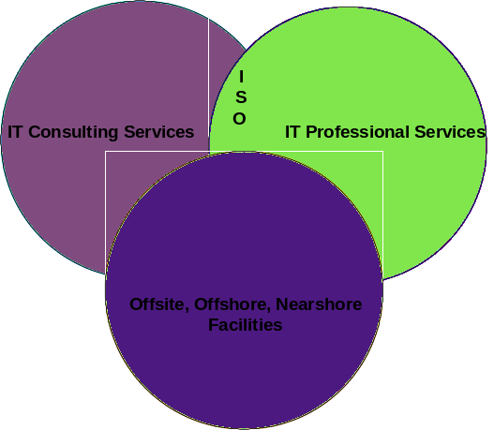

Ranging from our IT Consulting Services to our IT Professional Service offerings, Ajilon Consulting’s solutions were conceived to address the most prevalent challenges our clients face. Additionally, Ajilon Consulting has the capabilities to delivery its solutions either on or off client premises.

IT Consulting Services
Ajilon Consulting provides IT consultants to clients on a contractual basis. Taking direction from client management, Ajilon Consulting’s consultants possess IT skills to augment internal client resources during workload peaks, when expertise is lacking in-house, and when in-house staff is needed on mission critical projects. Examples of the types of positions held by our professionals include:

Network Administrator | Data Base Analyst | Senior Programmer
Senior Analyst/Programmer | Software Engineer | Tester
Senior Application Development Specialist | Technical Writer | Systems Analyst
Systems Engineer | Technical Analyst | Project Manager
Quality Assurance Analyst | Web Developer | Business Systems Integrator
Help Desk Analyst | Security Specialist | Web Architect

Ajilon Consulting can provide a single resource, multiple resources, or a bundled, group staffing solution.

IT Professional Services
Ajilon Consulting assumes responsibility for the delivery of an IT solution using formalized, yet continually evolving, processes to deliver strategic consulting IT services. Currently, Ajilon Consulting offers the following IT Professional Services:
- Outsourcing – Through the implementation of the methodologies, tools, and best practices contained within our Outsourcing Practice, Ajilon Consulting Project Management directs an Ajilon Consulting Project Team in the planning, implementation, measurement, and reporting of maintenance activities in support of an organization’s existing computer applications. Specifically, Ajilon Consulting’s Outsourcing Practice has the capability to deliver emergency quick fix of failing application software components, maintenance of application portfolio code, enhancement to application portfolio code, and second level support. Daily Project Team activities include receiving maintenance requests, estimating resource requirements, maintaining and enhancing application programs, testing, etc.
- Help Desk Services – Ajilon Consulting’s Help Desk services allow our clients to free personnel from non-critical business functions, effectively support external product customers, and/or enhance productivity of the IT user community. Specific Help Desk Services include: Help Desk, where Ajilon Consulting outsources the management and staffing of a help desk and customer support functions including desktop support, and Deployment/Migration where Ajilon Consulting deploys new or upgraded hardware and/or software to the clients’ desktops.
- Systems Development & Integration – Ajilon Consulting’s System Development and Integration Services are based on the implementation of a set of "best practices software development methodologies". The combination of these methodologies is the basis of Ajilon Consulting's Enterprise Application Framework (EAF). The EAF is a four phased software development life cycle that includes Business Requirements Definition, System Assessment, Component-Based Application Development, Data Warehouse, and Software Quality Assurance and Testing. These methodologies provide detailed activities, tasks, techniques, and deliverable definitions necessary to develop functionality within existing applications, develop new applications, integrate applications (EDI, B2B, API), rewrite existing applications, or re-platform applications (Migrations from one system to another, i.e., Mainframe to Web Application).
- Software Quality Assurance – Ajilon Consulting’s Software Quality Assurance (SQA) practice encompasses software testing, quality assurance, and process improvement. Our methodology is based on industry best practices and is unique in it’s “business-first” approach. Whether developing and executing test plans, verifying adherence to standards or improving a software development process, Ajilon Consulting’s SQA practice aligns with our client’s business goals. This methodology can be applied to all phases of the software development cycle and is scalable to accommodate organizations at various maturity levels. Ajilon Consulting evaluates, designs, and implements test strategies, including test automation, for standalone and multi-tiered software applications at client sites or in our test laboratory in Nashua, NH.

Specific service offerings within each service offer are depicted below:

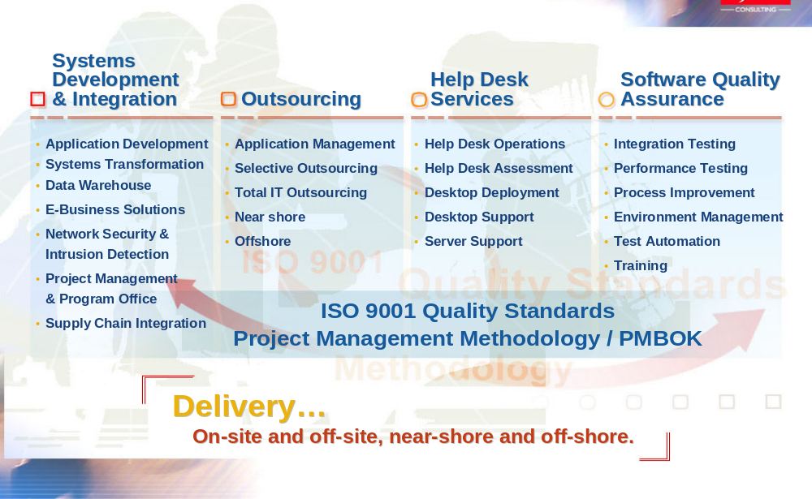

Although our delivery methods are formalized and represent years of best practices, flexibility was a primary design criterion. Ajilon Consulting’s approach to successfully deliver our IT Professional Services is three-fold. First, Ajilon Consulting develops an understanding of client expectations and requirements. Second, Ajilon Consulting employs its time-tested methodologies that are customized to meet client objectives. Finally, Ajilon Consulting staffs the project with highly skilled, objective, and focused project management and staff.

Nearshore, Offshore, & Offsite Capabilities
In addition to delivering its solutions on client premises, Ajilon Consulting can also accommodate offsite delivery options such as:
- Nearshore Outsourcing – Ajilon Consulting maintains two Canadian off-site facilities in Toronto and Montreal. These centers are governed by Ajilon Consulting's high quality standards and can deliver savings from 25-40%, depending on the size, duration, and technical requirements of the project. With our nearshore outsourcing services, our clients feel secure in receiving: world class infrastructure, communications, and technical talent, matching language, culture, time zones, and skill sets, low geopolitical risk, and a business model sanctioned by the North American Free Trade Agreement (NAFTA).
- Offshore Outsourcing – Through our partnership with a leading global software development services provider, Ajilon Consulting provides offshore outsourcing services at savings ranging from 40-65%, depending on the size, duration, and technical requirements of the project. To deliver the most innovative solutions for our clients, we utilize the latest technologies, methodologies and tools at two development facilities in Russia. The combination of Ajilon Consulting's on-site project management expertise with the offshore development efficiencies of our partner is an ideal solution for cost-effective outsourcing.
- Software Quality Assurance Test Laboratory – Ajilon Consulting’s Software Quality Assurance Test Lab is a state-of-the-art, facility in which dedicated, experienced, software professionals thoroughly test and demonstrate the functionality, scalability, and performance of a wide variety of testing engagements including web-based, e-commerce, client/server, functional, regression, load, stress, and reliability testing.
- Off-Site Facility Development – Ajilon Consulting has developed off-site facilities for clients in Denver, CO, Detroit, MI, Dallas, TX, Harrisburg, PA, and Tampa, FL. Ajilon Consulting’s approach to off-site development and associated implementation employs a structured planning methodology - Facility Planning and Requirements Analysis, System/Technology Requirements, System Administration and Development Design Requirements, and Site Build-out. The result is a set of design and process documents created to ensure reliable system integration and on going support.

It is important to note that security is of utmost concern to Ajilon Consulting. For each of these options we have not only taken great steps to ensure the physical security of these facilities, but also taken steps to ensure the availability, integrity, and reliability of client data and information.

Additional Service Delineation
Ajilon Consulting’s approach to successfully delivering project-based solutions is three-fold. First, Ajilon Consulting develops an understanding of client expectations and requirements. Second, Ajilon Consulting employs its time-tested methodologies customized to meet client objectives. Finally, Ajilon Consulting staffs the project with highly skilled, objective, and focused project management and staff. More specifically, Ajilon Consulting has expertise in delivering the following solutions:

Enterprise Project Management Office (EPMO) – Ajilon Consulting's Enterprise Project Management Office (EPMO) ensures that appropriate IT resources are allocated to high priority initiatives and that IT projects meet end-user requirements, meet pre-established milestones, and are completed on time and within cost budget. Our project management covers project consulting and assessment, project methodology mentoring, tool selection and implementation, training, and project management staffing services.
- Systems Development & Integration – Ajilon Consulting’s System Development and Integration Services are based on the implementation of a set of "best practices software development methodologies". The combination of these methodologies is the basis of Ajilon Consulting's Enterprise Application Framework (EAF). Ajilon Consulting’s EAF is a multi-phase approach that incorporates both concurrent activities and iterative development techniques to develop the business vision, understand the business processes, and transform and deploy the System. The following briefly describes Ajilon Consulting’s Systems Development & Integration Offerings:
- eBusiness – Ajilon Consulting’s eBusiness services help you leverage web-based technologies, resulting in a more cost effective and outward facing business model. Our eBusiness services include strategy consulting, architecture design and implementation, application development and B2B integration, Backend host application integration, network and application security, and supply chain integration (B2B).
- Systems Transformation – Based on a dual premise, our systems transformation services convert outdated systems into systems that provide a competitive advantage. First, we created our systems transformation services so that you can leverage your company's previous investment in application development when adopting new computing technologies such as client/server, intranets, and data warehousing. Then, we transform systems so that they evolve over time and provide clients with incremental value over a 6-8 month period, thus providing incremental value to the business and stakeholders. Ajilon Consulting's approach encompasses application development and redevelopment (any architecture), major enhancements to existing applications, application transformation to new technologies and architecture, current system assessment (applications & architecture), and future state system requirements (applications & architecture).
- Data Warehousing – Knowledge is power and the basis of knowledge is data. With the exception of people, data may be the most important asset an organization possesses. All too often, much of this data is either difficult to access or not in a usable format. Data warehousing provides access to more meaningful enterprise information, makes an organization's information more consistent, and provides the foundation for decision-making. Our data warehousing services allow organizations to view their operations in new and much more detailed ways, and include data warehouse design and implementation, data warehouse template selection and deployment, data warehouse project management, database conversions, business requirements definition, and legacy system integration between data warehouse and backend systems.
- Software Quality Assurance – Software Quality Assurance – Ajilon Consulting’s Software Quality Assurance (SQA) practice encompasses software testing, quality assurance, and process improvement. Our methodology is based on industry best practices and is unique in its “business-first” approach. Whether developing and executing test plans, verifying adherence to standards or improving a software development process, Ajilon Consulting’s SQA practice aligns with our client’s business goals. This methodology can be applied to all phases of the software development cycle and is scalable to accommodate organizations at various maturity levels. Ajilon Consulting evaluates, designs, and implements test strategies, including test automation for standalone and multi-tiered software applications at client sites or in our test laboratory in Nashua, NH. The following briefly describes our SQA Services:
- Integration Testing Services – Our integration testing services are tailored to client needs from industry best practices to ensure that the software works in the intended environment. Manual or automated, our testing is focused on your critical business scenarios to mitigate risk through effective software testing that includes: functional tests, regression tests, legacy systems tests, systems and enterprise level tests, installation and interoperability tests, technology migration tests, and compliance and acceptance tests.
- Performance Testing – We customize our performance testing services based on client requirements and industry best practices to provide an accurate assessment of software’s real performance under real conditions. Performance testing includes: load testing, scalability testing, and stress testing.
- Environment Management – Our environment management services provide clients with development and configuration management of test and production environments. We assist our clients in planning, building, controlling change, and reporting environment configuration to ensure that precious testing time is spent validating software, not the test environment. Environment Management services include environment requirements and configuration plans, configuration item identification, environment audit and reporting, and baseline and change control.
- Process Improvement – Our process improvement services provide clients with a comprehensive context from which to better manage and understand both the business and technical implications of software testing and quality assurance practices. Using the Capability Maturity Model® for Software (SW-CMM®) guidelines and the Project Management Institute's Project Management Body of Knowledge (PMBOK®) along with a rigorous Software Development Life Cycle (SDLC) taxonomy, we assist clients in meeting spot needs as well as strategic goals through test process assessments and process improvement.
- Software Publication - In addition to testing services, Ajilon Consulting manages and controls the administrative and technical aspects of complex software releases. These services, performed in conjunction with more traditional testing and laboratory services, provide clients with a seamless, disciplined and traceable process for moving their software to market through consolidation and distribution management services, registration services, release testing and control services, and version management and control services.
- Training – Ajilon Consulting regularly delivers testing and quality training to and on behalf of clients on topics such as introduction to software testing and advanced software testing. We can even develop customized courses.
- Ajilon Consulting Labs – As a totally independent software quality assurance and testing organization, Ajilon Consulting Labs uses the leading commercially available test tools to provide our clients with the appropriate automated testing solution. We also specialize in developing custom testing tools when change rates render existing commercial tools inappropriate. Our full time consultants are experienced in a variety of operating and application environments, languages, and systems.
- Outsourcing - Ajilon Consulting’s Outsourcing Services allow Ajilon Consulting to take responsibility for one or more of our clients’ application portfolios. Through the implementation of the methodologies, tools, and best practices contained within our Outsourcing Practice, Ajilon Consulting Project Management directs an Ajilon Consulting Project Team in the planning, implementation, measurement, and reporting of maintenance activities in support of an organization’s existing computer applications. Daily Project Team activities include receiving maintenance requests, estimating resource requirements, maintaining and enhancing application programs, testing, etc. Specifically, Ajilon Consulting’s Outsourcing Practice has the capability to deliver:
- Application Management – Ajilon Consulting brings more than three decades of application management experience and best practices to your organization. We consult with you to quickly gain an understanding of your application environment. Then we present a solution to help lower the costs of managing, maintaining, and enhancing your existing systems.
- Production Scheduling, Operations, and Administration – Along with application management, or as a separate activity, Ajilon Consulting can take responsibility for production scheduling, operations, and administration. Because our business is IT, we provide the necessary management and technical resources to minimize costs while keeping your operations running efficiently.
- DBA, Systems Programming, Systems Administration and Technical Services – Ajilon Consulting's outsourcing experience and processes can be applied to support the technical environments of various architectures, including the management and enhancement of the operational environments that make up your IT infrastructure. Ajilon Consulting's technical outsourcing keeps processes efficient, environments stable, and costs down.
- Business Process Outsourcing – Ajilon Consulting can take responsibility for specific business or IT functions by bringing together the best management, staff, processes, and infrastructure. We customize support for these processes and ensure that they adapt to your environment.
- Total IT Outsourcing – Ajilon Consulting has developed its total IT outsourcing solution for small to medium size organizations that are more comfortable with our collaborative, client-involved approach. Ajilon Consulting assesses your current IT structure and provides an efficient, total outsource solution, freeing you to focus on your core business. To further reduce costs and tap into advantages afforded by various geographic locations, Ajilon Consulting maintains several off-site facilities located in the United States and Canada. Additionally, we can provide offshore outsourcing services. From any of these facilities, Ajilon Consulting supports any and all of its outsourcing services.
- Nearshore Outsourcing – Ajilon Consulting can deliver outsourcing services more economically than traditional arrangements through our two Canadian off-site facilities in Toronto and Montreal. These centers are governed by Ajilon Consulting's high quality standards and can deliver savings from 25-40%, depending on the size, duration and technical requirements of the project. With our nearshore outsourcing services, you can feel secure in receiving world class infrastructure, communications and technical talent; cost-savings of up to 25-40%; matching language, culture, time zones, and skill sets; low geopolitical risk; and a business model sanctioned by the North American Free Trade Agreement (NAFTA).
- Offshore Outsourcing – Through our partnership with a leading global software development services provider, Ajilon Consulting can provide offshore outsourcing services at savings ranging from 40-65%, depending on the size, duration, and technical requirements of the project. To deliver the most innovative solutions for our clients, we utilize the latest technologies, methodologies and tools at two development facilities in Russia. The combination of Ajilon Consulting's on-site project management expertise with the offshore development efficiencies of our partner is an ideal solution for cost-effective outsourcing.
- Help Desk Services – With the explosive growth of IT innovations, effective systems support has been elevated to a business strategy. More and more companies are seeking assistance with their help desk, desktop and server needs to control costs, increase productivity, improve performance and adapt to changing needs and requirements. Ajilon Consulting has a proven history of providing customized help desk, desktop and server solutions to clients from a variety of industries, thus we are well positioned to address your demands.
- Help Desk - Ajilon Consulting’s help desk model allows a single phone call to initiate an escalation process that results in 100% resolution of your problem or request. We manage it from A to Z using procedures based on internationally recognized best practices that are tailored to your unique operations. We can leverage your tools at your location, or we can use our tools and our location. We work with you to determine the best method for your business. And to ensure that you get the reports you need when you need them, we customize the reports and their distribution. Our help desk services offer 24x7/x365 support for all packaged software, proprietary mainframe/midrange applications, desktops, laptops and PDA’s, servers and printers, all operating systems, and all email systems. Our team can manage your help desk on- or off-site. In addition, our Canadian near-shore and our offshore help desk solutions can reduce your current help desk costs by up to 65%.
- Help Desk Assessment - Ajilon Consulting’s collaborative approach to defining your help desk needs allows our team of technical and project management professionals to customize a solution that supports your business goals and organizational structure. We initiate every help desk engagement with a needs assessment, and also offer our help desk evaluation, customer satisfaction review and cost assessment as stand-alone services for analyzing existing support services. Ajilon Consulting can focus its assessment on any business function that you request.
- Desktop Deployment – Ajilon Consulting deploys new desktops, software, applications, and connectivity on a local, national, or worldwide basis. Our comprehensive desktop deployment service features: centralized command center, customized deployment plan, post deployment support, services agreement, site survey, staging, training, and vendor management.
- Desktop Support – Ajilon Consulting’s desktop support services deliver a full-service solution to your computing requirements with general technical support, global on-site support, hardware maintenance, move, add and change services, network troubleshooting, proactive solutions, advice and consultation, remote tools to reduce costs, software and hardware installations, and training. Our proven desktop support policies and procedures repository makes it easy for us to leverage our proven processes in your organization.
- Server Support – Ajilon Consulting supports the routine administrative, monitoring and troubleshooting tasks of your organization’s email, Unix, Microsoft or NT servers. Our support can be located on- or off-site. We provide the following services: 24x7x365 support, proactive solutions, root cause analysis, server maintenance and monitoring, statistic reports, trend reports, troubleshooting, and utilization of appropriate tools.

Methodologies

Structured Methodologies

Ajilon Consulting has significant experience in the use of structured development methodologies. In fact, Ajilon Consulting has developed its own proprietary methodologies:
Systems Development Life Cycle – Ajilon Consulting’s proprietary Systems Development Lifecycle Methodology (SDLC) addresses all phases of systems development including:
- Feasibility Definition – Ajilon Consulting analyzes, develops, and presents sufficient information to identify and define the actual scope of the development project. Ajilon Consulting presents client management with an overview of the proposed development project to facilitate their determination of the project’s economic, technical, and operational feasibility and the amount and type of resources.
- General System Design – Ajilon Consulting establishes measurable system objectives and general and specific plans for all remaining SDLC phases. This phase allows for further refinement of the problem definition including performance criteria, and assessments of economic, technical, and operational feasibility. Also developed, at a high level, are the external system specifications, database design, and sub-system interfaces that are contained in the Systems Requirements document.
- Detail System Design – Ajilon Consulting develops and documents the required functionality of the system. Specifically, Ajilon Consulting develops and documents system specifications, database/file design, report layouts, system testing and operations plans, final detailed hardware plan and the programming phase plan. Additionally, Ajilon Consulting begins to develop all user documentation including user guides, reference, and training manuals.
- Program Development – Ajilon Consulting develops and documents the program design specifications. Ajilon Consulting codes the application modules and programs. Ajilon Consulting also tests the resultant code as units, programs, and jobs based on how they interrelate with each other and the total system. Finally, we prepare and/or finalize the system documentation including all program documentation, user procedures, and training aides.
- Implementation – Ajilon Consulting implements the system into “live” production mode. Ajilon Consulting trains all user personnel, monitors and tracks the “burn-in” process, and documents all problem areas along with recommendations.
Ajilon Consulting’s SDLC methodology addresses all activities inherent for the completion of all systems development projects, regardless of size. A testament to the comprehensiveness and effectiveness of our methodology was the achievement of a Level 2 rating according to Software Engineering Institute’s (SEI) Capability Maturity Model by the Center for Systems Management on behalf of one of our major clients, Verizon. The audit was a condition of the maintenance of our preferred vendor status.
Project Management Methodology – Ajilon Consulting’s proprietary Project Management Methodology (PMM) was developed by experienced project management personnel and was modeled after the Project Management Institute’s (PMI) Guide to the Project Management Body of Knowledge (PMBOK). Specifically, Ajilon Consulting’s PMM tasks include:
- Project Planning – This phase produces a baseline project plan defining an approach encompassing all management, administrative, and quality processes to enable the successful project delivery.
- Project Operations And Control – This phase involves the ongoing management of the planned (and sometimes unplanned) project activities such as daily management that includes supervising and delegating work, reviewing progress, and developing and motivating the project team. Additionally, Project Management monitors and controls the development activities of project deliverables, supports the communication process, and applies and implements the Quality Program.
- Project Closure - This phase ensures a proper and orderly closure of a project that has run its course as intended.
In support of our PMM, Ajilon Consulting utilizes a variety of tools for planning and tracking the project life cycle including Microsoft Project.
Service Specific Service Delivery Methodologies – Ajilon Consulting has developed service delivery methodologies (SDM) for each of our IT Professional Services that ensure the successful and complete delivery or a project-based solution. Each SDM guides project personnel in the development of a plan to identify the critical path to achieve solutions and thereby achieve client objectives.

Ajilon will provide a Change Request Form if BATO does not already have a similar form.
Ajilon will provide a Project Deliverable Acceptance Form if BATO does not already have a similar form.
Ajilon will provide a Final Project Approval Form if BATO does not already have a similar form.

